Day 1 Home Farm – Portsmouth
The day dawned fair, if anything too fair, with afternoon temperatures forecast to be in the high 20’s. I had to get to the ferry in Portsmouth that leaves at 2130 and docks in Ouistreham, the seaport of Caen, at 0645 the following morning. So no great hurry to start and I dealt with a few admin issues before strapping the panniers to the Boardman 8.9E adv, checking carefully that this year I had a passport and it was in date. I’d packed my bags a few days previously making use of the spreadsheet that has helped me for the last couple of years so am confident that I have all the essentials. I said goodbye to the nearest and dearest and was on my way on the dot of 12. The drivetrain of the bike has been completely rebuilt following an incident where the derailleur fell off and was mashed by the back wheel. But this was something of a trial journey and unfortunately the indexing of the gears was awry and I was having trouble getting into the lowest gear. Eventually I stopped and rang chief mechanic Rob to check which way to turn the adjuster. It’s better but still not spot on and I shall have to do a bit of fettling when I ride from the ferry to Caen train station tomorrow. I’ve got plenty of time as my train doesn’t leave until 1128. Hopefully I can get it right before the major climbs in the Pyrenees.
This is my fifth attempt at the journey to and from Portsmouth. I went to and from in 2015 when I cycled down to the Med and back, from coming back from Sicily in 2017 and to last year on my slightly ill-fated trip to Berlin. The route is not especially hilly but it is almost 80 miles which in temperatures up to 26 degrees made for an enervating journey. I made reasonable time and was passing Salisbury Cathedral at about three o’clock.
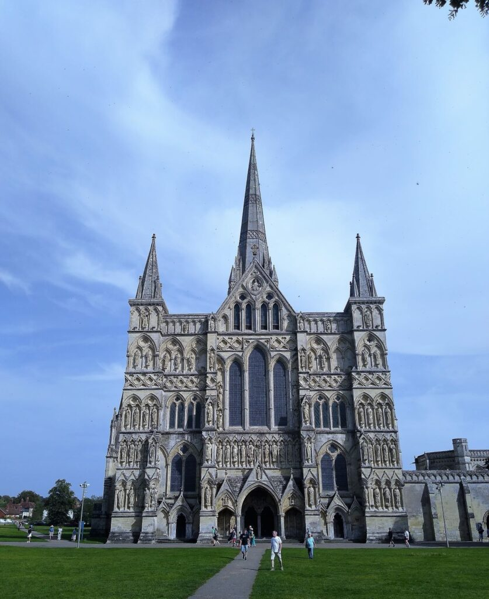
I stopped to take an unusual photo of the west door with the magnificent spire, the tallest in Britain, barely visible above it. The Close was busy with tourists and I weaved my way past walkers who weren’t really paying attention, blipping the bell in warning.
Onwards over the downs towards Southampton, not much traffic on these back roads until I joined the main road at Romsey. There’s a neat little cycle path that misses the centre of the town but after that it’s main roads all the way through Southampton until joining the A27 that takes you all the way to the ferry terminal. I was able to avoid the queues of traffic by taking to the pavement, some of it shared cycle path, some illegal but I try to be sensible and give way to walkers. Anyway it saved a good deal of waiting and I was at Lidl four miles from my destination by 6.45pm for much needed supplies as I hadn’t eaten since breakfast. Lights on for the last few miles and I dropped into the Terminal building to make use of their power points to recharge phone and Garmin for an hour or so before boarding. I didn’t bother with the bike battery as I’d only used about 50% and I’m unlikely to use any tomorrow on the 10 mile trip to catch the train in Caen and 4 miles between Parisian stations. That can wait until I’m in my hotel in Toulouse.. Now I’m on board I find charging points freely available, a bonus from last year.
I jumped the car queue to check in and joined several other cyclists as we were corralled ready to board before the main traffic. Traffic was held up as police painstakingly searched all vehicles looking for an escaped prisoner. They didn’t seem to think that I was hiding him in my panniers and waved me and several other cyclists through
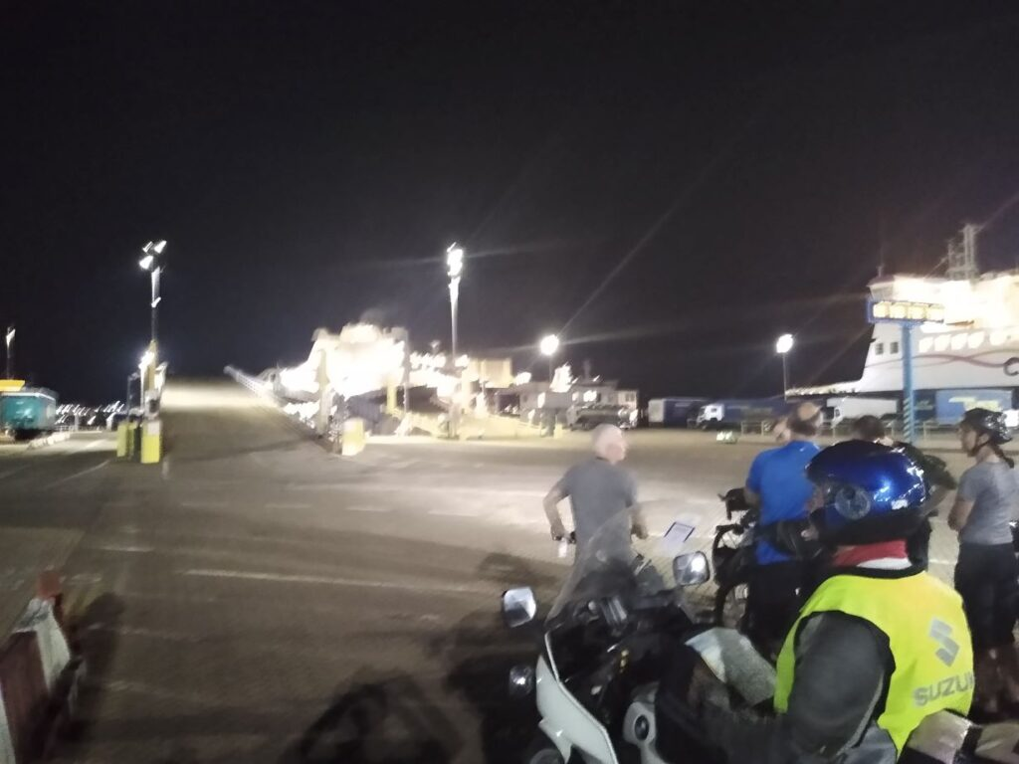
I’m not over impressed by the way the bikes are lashed together and I trust that I’ll still have a working derailleur when I collect it in the morning. There must be at least 30 bikes on board, many more than I have seen in the past. Hopefully I’ll get some sleep but the seats aren’t especially comfortable so at best it’ll be a bit of a doze. At least this year I’m on the overnight ferry and not sleeping on the streets.

Day 2 – In training
The ferry docked at 0645 local time leaving me with over four hours to kill before the train from Caen to Paris. I had toyed with the idea of trying to catch the 0758, giving me a bit of time in Paris but I’m very glad that I didn’t because, unlike previous years (probably because there were so many of us) cyclists were last off and by the time I’d got through border patrol I wouldn’t have stood a hope in hell of making it. The morning was foggily wet and my glasses were soon covered in water. I could scarcely see Pegasus Bridge 50 metres from the excellent cycle track that joins Ouistreham to Caen but by the time I passed under the motorway Bridge over the Orne, nicely decorated with graffiti,
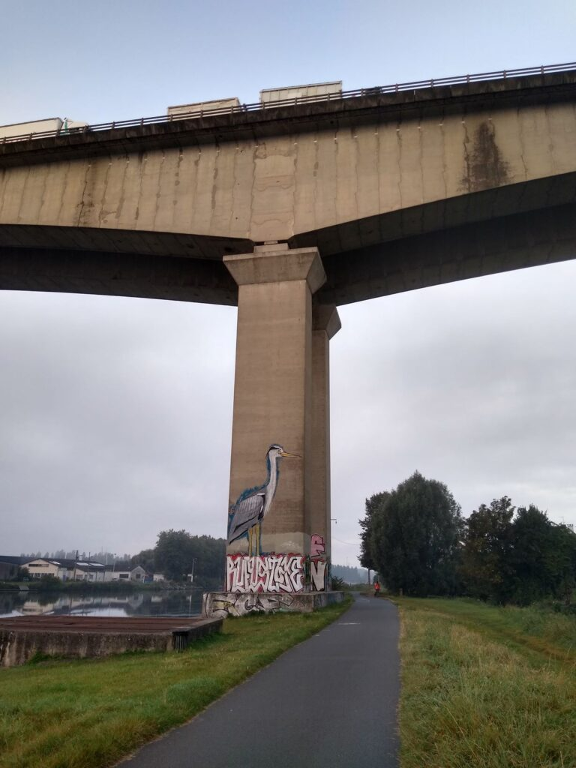
the sun had started to break through and by the time I reached the station it was a cloudless sky with the temperature rising fast.
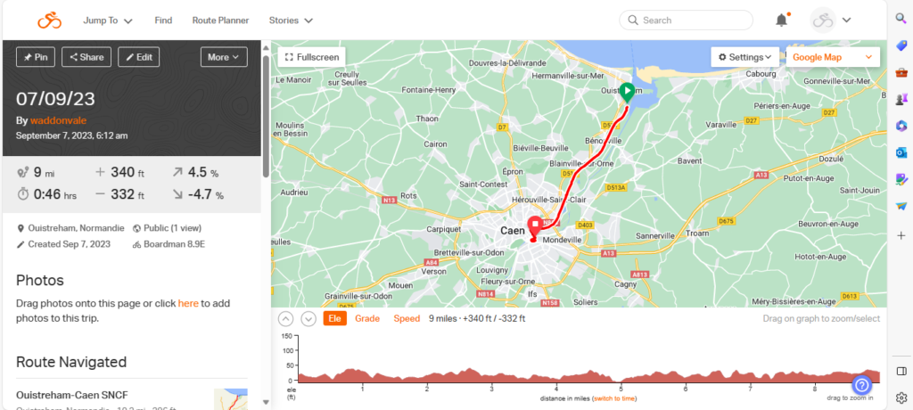
I had a cup of coffee, most of which I managed to spill all over the floor, and a pain au raisin and then set about sorting out the indexing for the gears. It was a long slow process adjusting quarter turn by quarter turn, made even more difficult by the panniers which made mounting and dismounting difficult but I seem to have managed it. There may still be some tweaking to do tomorrow but I’ve got all day to cycle 68 not very taxing miles. I sat in the waiting hall, people watching until 1145 came round and I made my way down under the main station by way of lifts to Quai G where I boarded the non stop train to Paris. The rolling stock looks new, built by Canadian firm Bombardier and all the trains that I saw were double deckers. Bikes travel free and having hung it up by its front wheel I went upstairs and enjoyed the Norman countryside, heavily wooded and green as we made our way east. Once we reached the Seine the scenery deteriorated to industrial mishmash and rail yards, no different, I suppose, from any other conurbation,
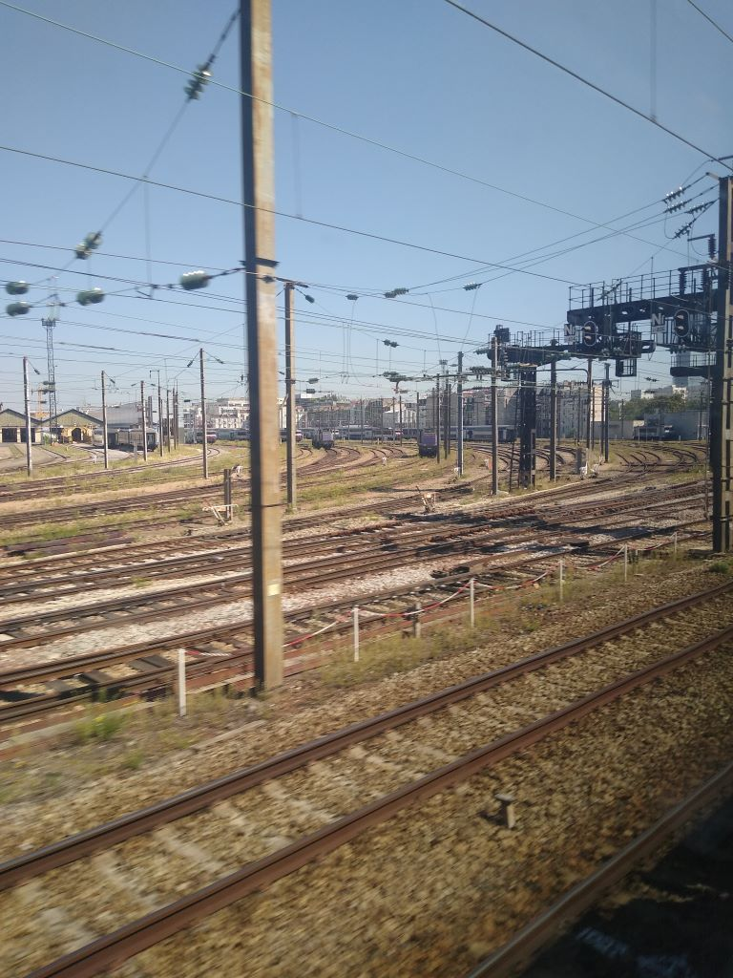
We arrived at Paris St Lazare on time and I set off to find Gare Montparnasse, the departure station for Toulouse. I’d plumbed the route into both Garmin and phone
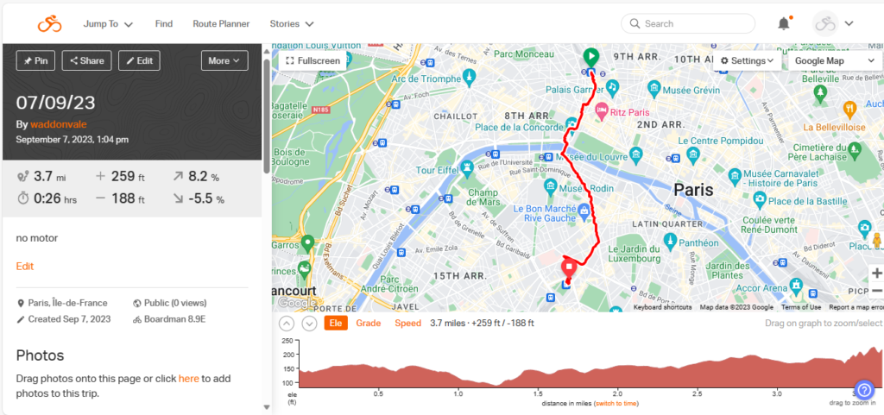
but was having trouble hearing the directions. I headed south towards the Seine, passing through heavy traffic in the Place de la Concorde where there was lots of tentage and stands for the Rugby World Cup
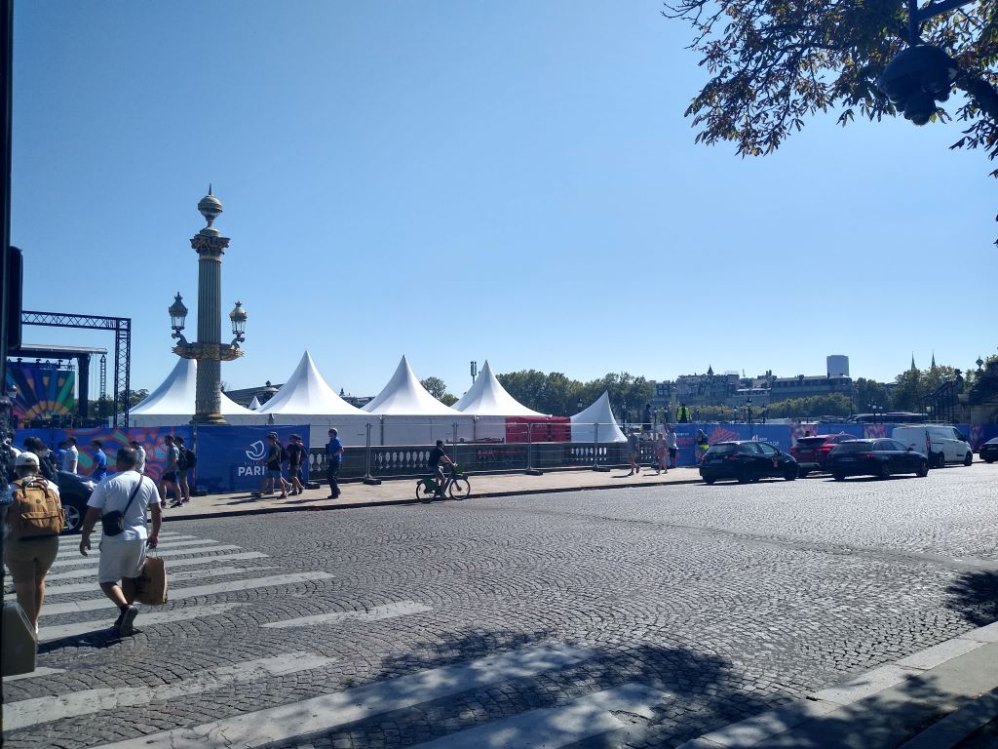
and stopping to take pics of the Champs Elysee
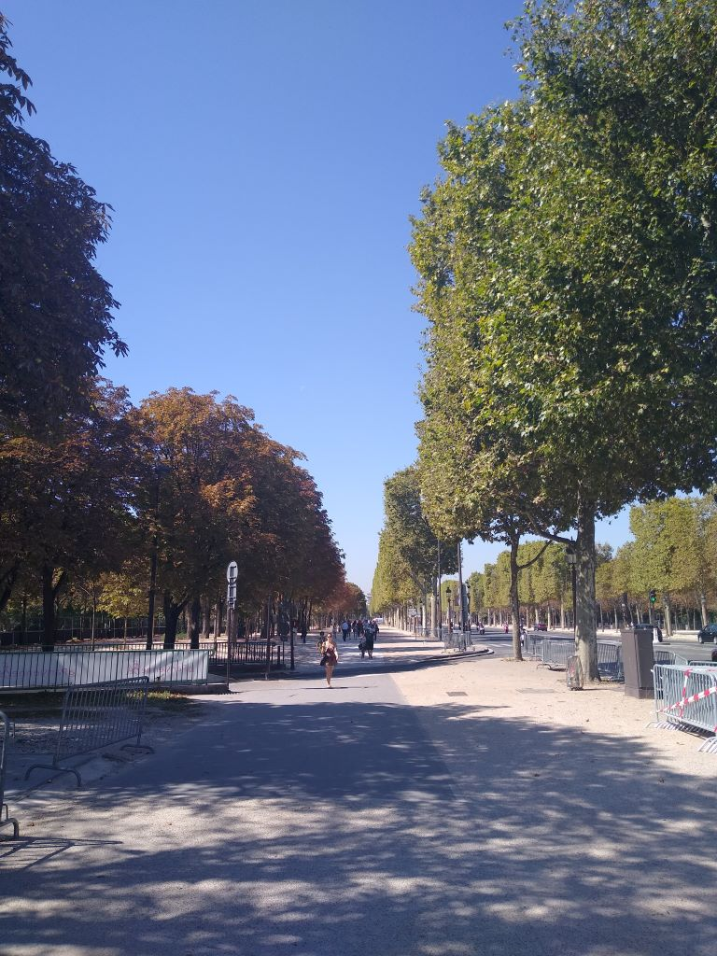
and the Seine as I crossed it, managing to neatly blot out the Eiffel Tower!
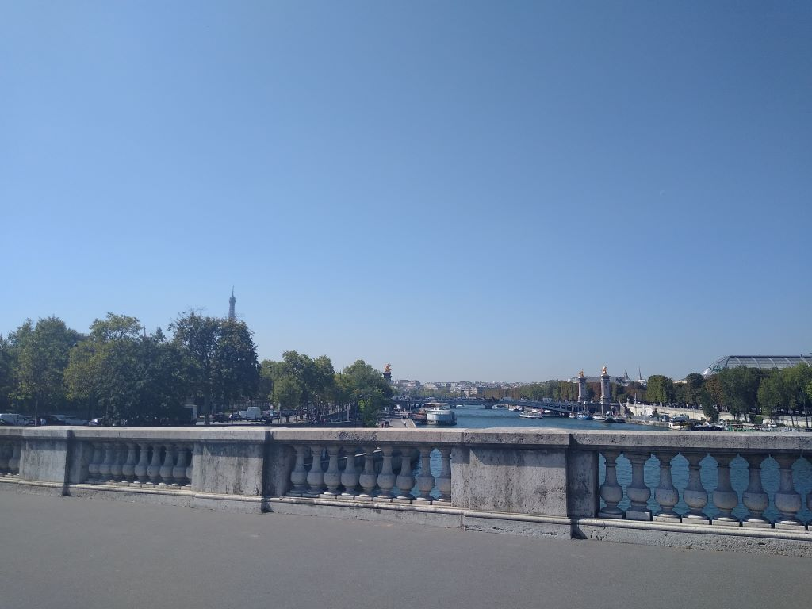
I went a bit off course towards the end but arrived in plenty of time to board the train, this time TGV non stop to Bordeaux and then on to Toulouse. Bike provision on TGV is poor despite having to pay 10 euros for the doubtful privilege. There is not enough luggage space so, although bikes take priority, baggage is piled around and on top of them
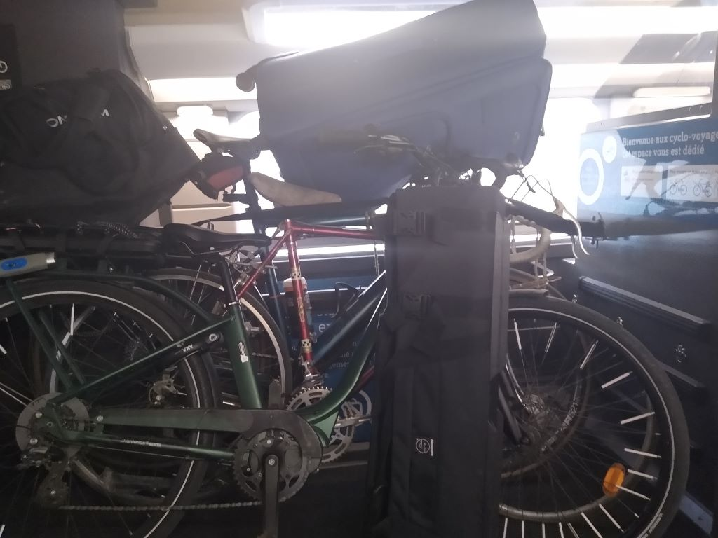
I feared for my derailleur but all was well and everything seemed OK as I rode to my hotel from the grand Matabiau station
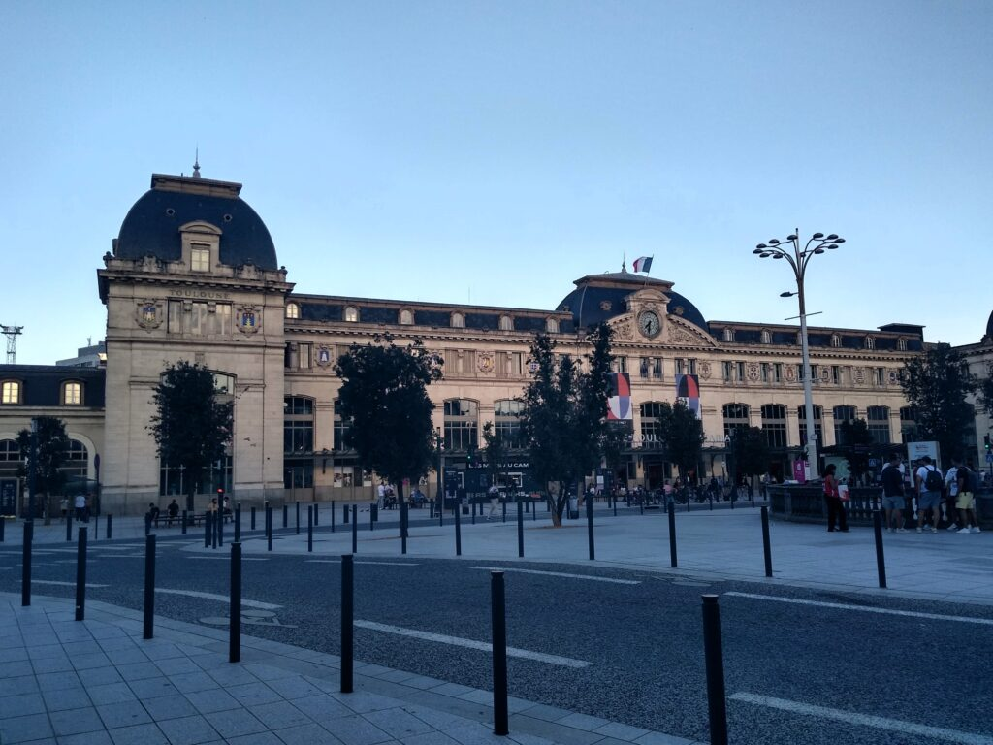

Day 3 – Heading for the hills
Last night was a first for me, dinner in an Ethiopian restaurant. It was just around the corner from the Hotel and looked good from reviews. In the event I found it a bit so-so. An Abyssinian Beyaynetu proved to be a couple of pancakes with various small portions dotted around the plate. There was egg, beef, chicken and various vegetables. To be a true Ethiopian you need to eat with your fingers but I requested a fork to help me. It was tasty enough, rather Indian spicy, and I was content. The Ethiopian beer was excellent
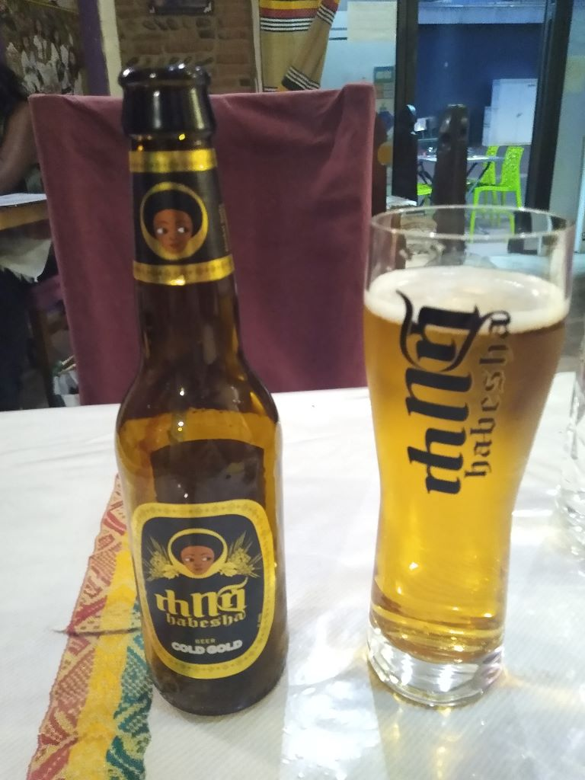
and I departed to compose the blog.
Breakfast this morning was something of a surprise, not because of the content which was typically French with the addition of some ham and cheese – excellent croissants – but because of the waiter Hugo who is British but was schooled in France from the age of 7 when his parents brought him to live in Normandy. He used to spend quite a bit of time in the UK but since Brexit has become more or less a full time resident in France, though he has not become a citizen. It came as a surprise to hear him speaking English without a trace of accent but, as he said, they only spoke English at home when he was growing up.
Hotel Riquet is pretty seedy, needing a good uplift for its rooms although the outside looks quite grand and well tended.
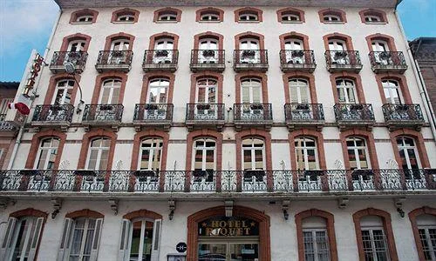
The lift was very slow and there were cockroaches in the bathroom. To cap it all the building site opposite the hotel started work at 0500 so sleep after that was impossible. However 80 euros B&B in the centre of Toulouse is probably not too bad.
I was packed and on the road by 0900 and, typically for me set off in the wrong direction. A couple of circuits of the centre
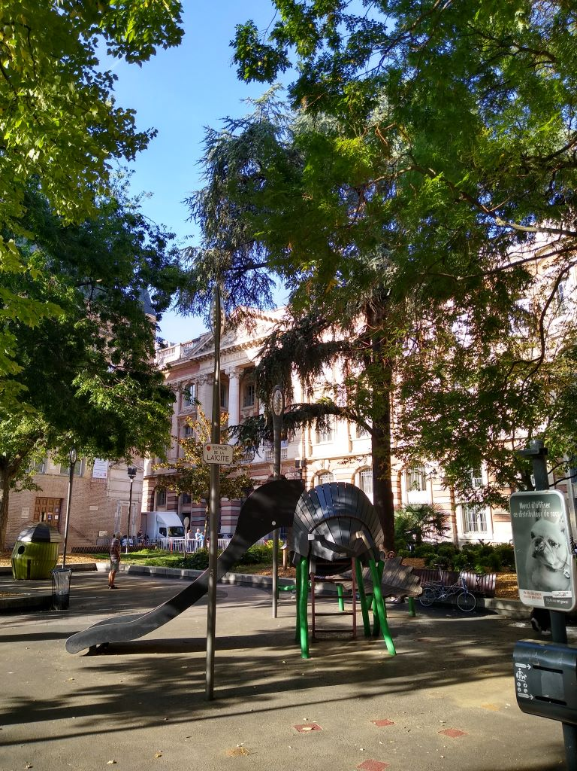
eventually found me by the Garonne
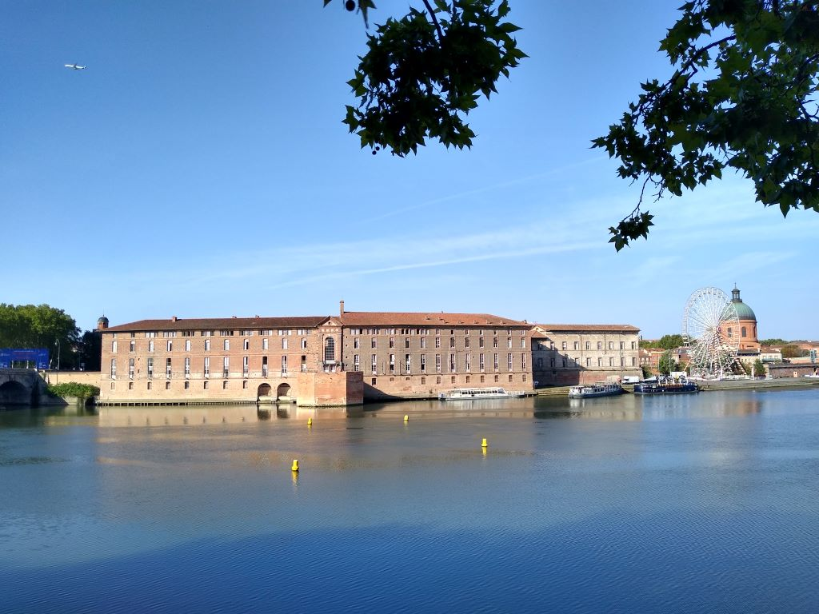
which I crossed and went through a park which will be the centre of World Rugby when it comes to the city. The cycle path followed the river upstream and I was blessed with well surfaced cycle paths for much of the day. It didn’t stop me from making several wrong turns and cursing my new Garmin Explore which seems significantly worse than my old Garmin. The main problem is the lack of battery life. I could get 90 miles out of the old Garmin as long as I didn’t use the maps too often, the new one seems to be significantly worse and I virtually ran out in the 70 mile journey today despite putting it in battery saver mode. Fortunately good old Rita on the phone is reliable and frugal. I can only blame myself for a lot of the wrong turns, missing important spoken cues.
About two miles out of the city I came across a memorial to those who died in the explosion of a chemical plant in 2001. It killed 31, injured many more and caused great damage – two thirds of the city windows were broken and twisted steel girders were found a mile away for the site.
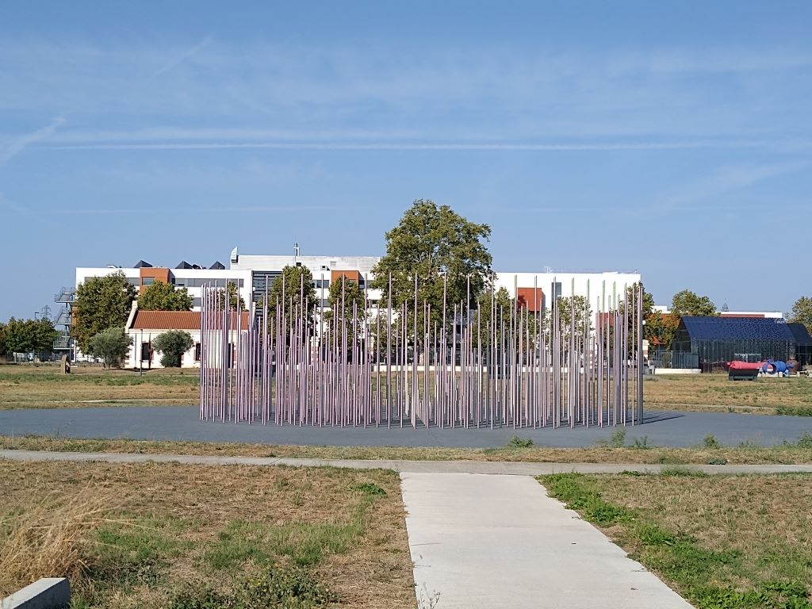
It sits close to the Teleo cable car that crosses the river and joins the two halves of the city. Surprisingly, given the number of ski resorts in the country, it is the longest cable car in France and, as such projects do, has come in for criticism for costing too much and being under used.
My journey continued, following the Garonne upstream, climbing impercitibly which made for hard work in 28 degrees of heat. There was no rest at all, I had to keep pedalling for most of the day and, towards the end was stopping quite regularly. I had filled both my bidons at the Hotel and stopped at an Intermarche to buy a further 1.5 litres which, gratifyingly, cost only 55 cents and by the end of the journey I was empty of water and energy.
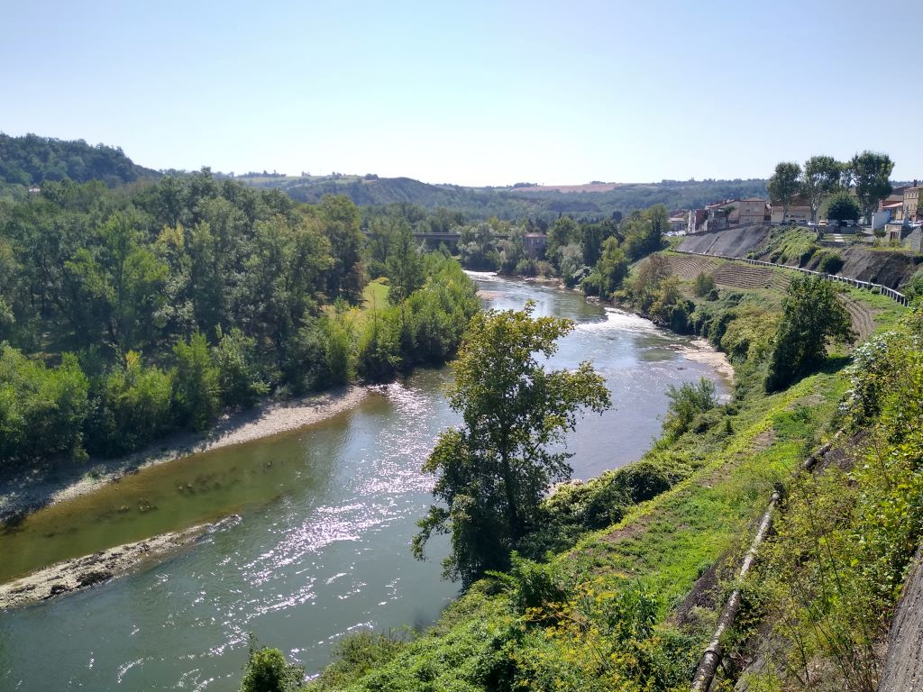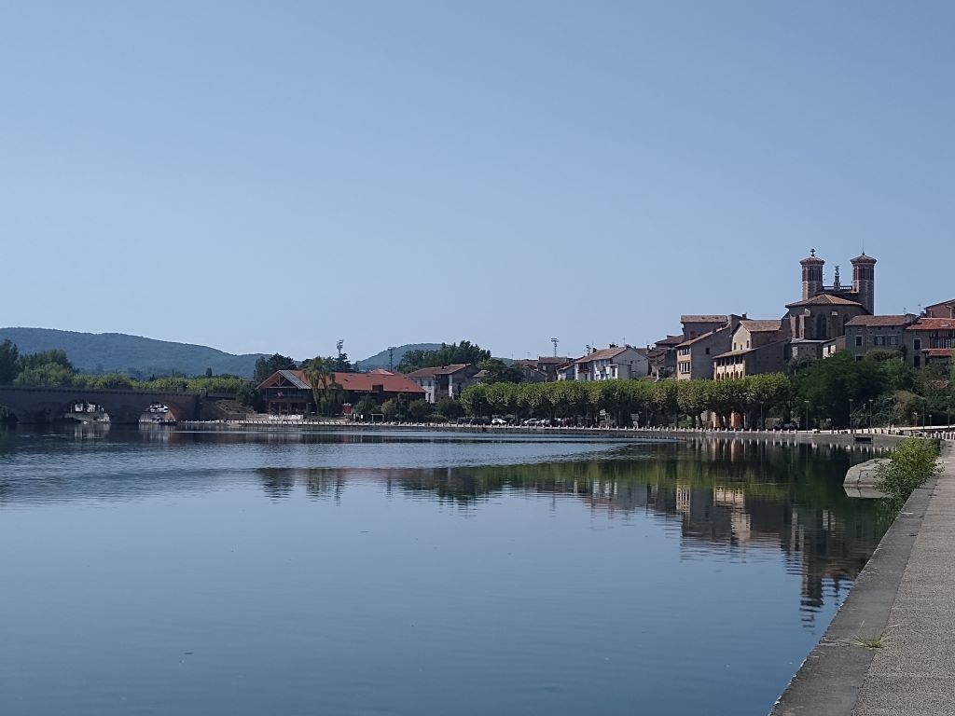
At Roquefort-sur-Garonne I left the eponymous river and followed the River Salat up to my destination, Saint Girons. There was a hard cycle track for the last 18 miles from Mazeres where I came a cropper when, concentrating on my Garmin, I missed seeing a barrier across the path: fortunately it swung when I hit it but I still ended up in the fence, luckily without damage to me or the bike. The cycle paths have been excellent, well tended and traffic free.
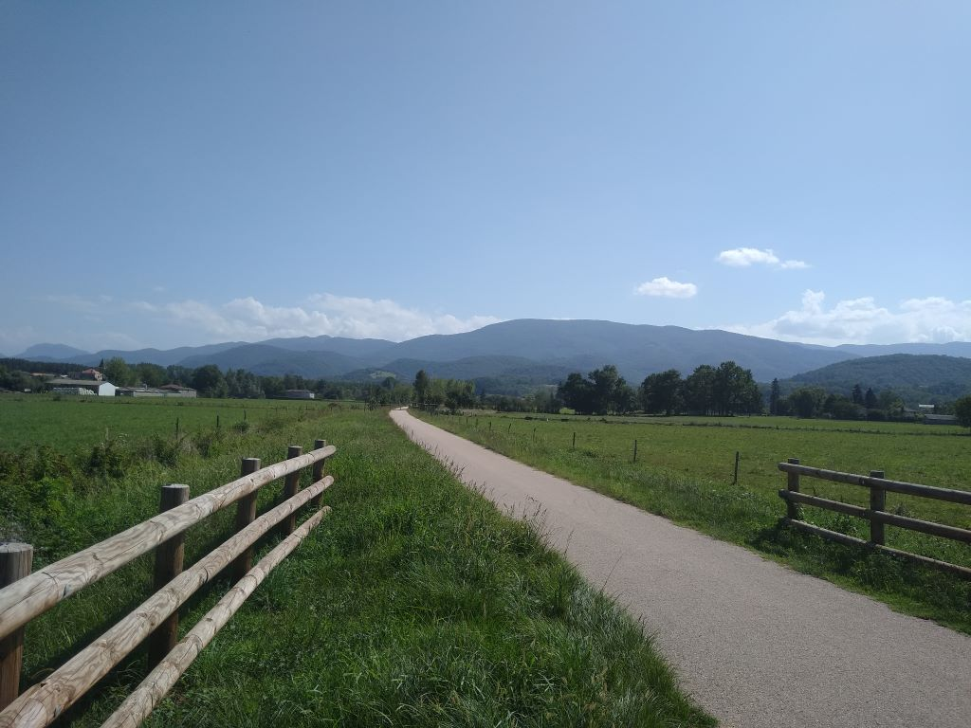
I’m staying in a 3 bedroomed flat which has a washing machine so I’ve been able to wash everything used so far. There’s no breakfast but for the remarkably low price of 45 euros, it’s a bit of a snip. I’m cycling about 50 miles tomorrow, a lot of it seriously uphill but with the downhill sections it still shouldn’t take more than 5 hours so I’ll take my time in the morning and visit the Saturday morning market to make my breakfast.
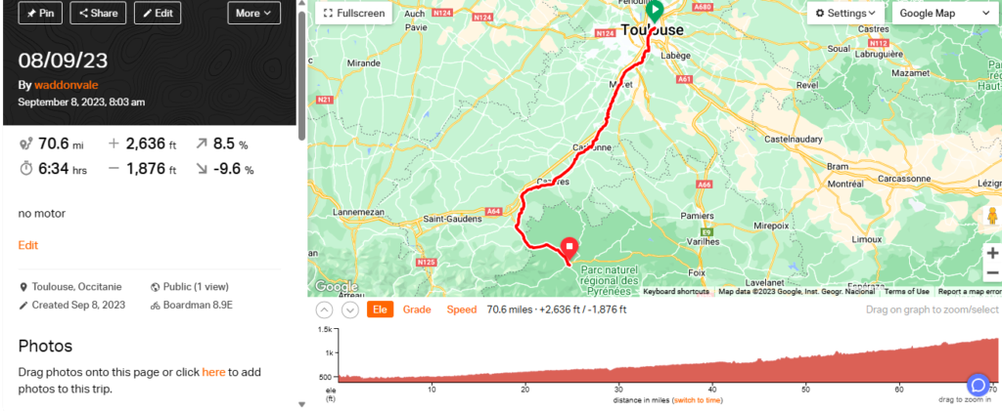

Day 4 – Hill climbing
When I arrived in St Girons last night I collected the keys as instructed but found the flat had not been prepared. A very apologetic young man knocked on the door and set to work making the bed and clearing “stuff”. It was apparent that nobody had been in the flat for a while as the sofas were very damp but shutters and windows opened soon remedied that and I was left with some coffee for the morning as a peace offering. I wasn’t too bothered and brought the bike into the flat and did the usual offices before wandering out into the town. Saint Girons is built on two sides of the River Salat but both sides are well serviced with restaurants: I chose Thai and it was very good. By the look of it a frenchman had acquired a Thai bride and they were making a living together. I wandered down to the river after my meal and took some pictures.
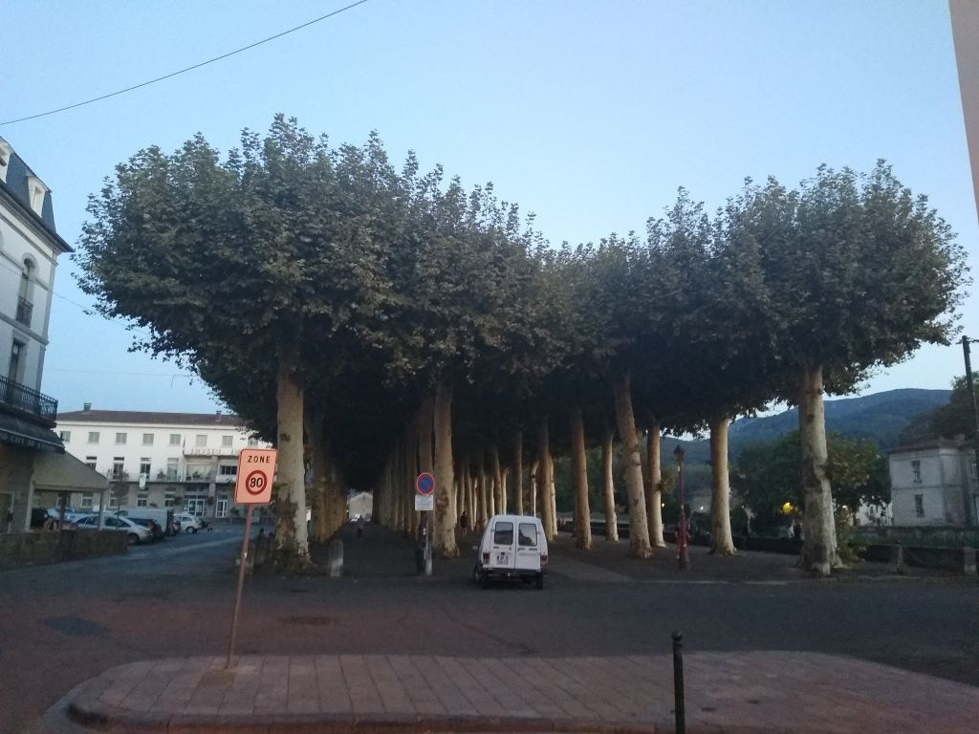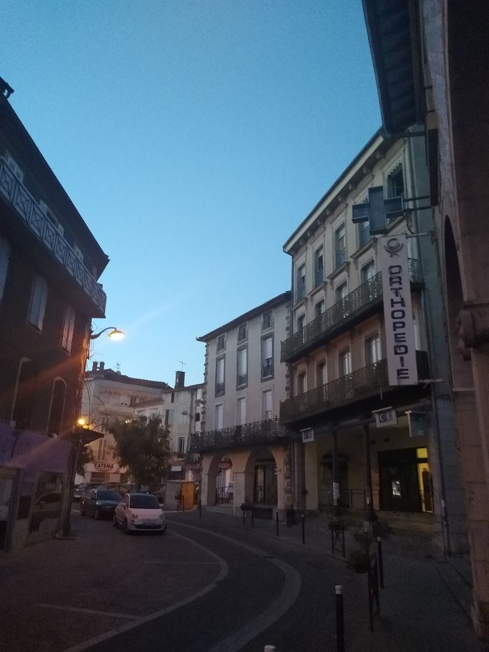
Back to the flat to write the blog and watch the last 20 minutes of the French rubbing Kiwi noses in the dirt to start their world cup campaign on a high.
This morning was set fair again and, as it was Saturday there was a market in town.
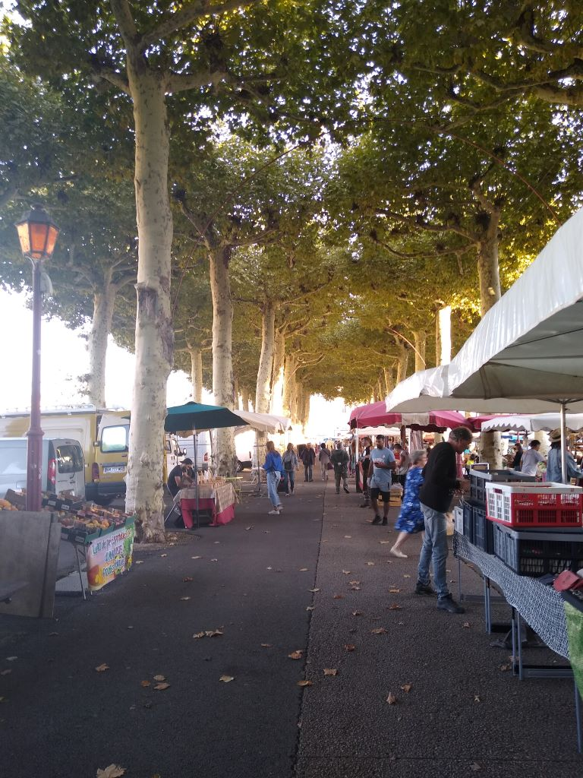
It was extremely busy full of produce stalls with a particular emphasis on Bio dynamic vegetables and cheeses of all shapes and sizes. I bought a croissant, pain au raisin and a bacon roll and added a small round of washed cheese and took it back to the flat where I enjoyed it with a pomelo I bought in the fruit shop and a cup of Earl Gray. A good start to the day.
As I was packing up to leave at 1030 the owner of the flat, a very elegant lady turned up to apologise for the mix up on arrival. She was originally from Lille but had moved to St Girons to be near her sister and enjoyed the good weather so much that she had stayed and acquired the flat for a bit of income. She took my picture alongside the bike and, no doubt, will tell her friends about the mad 74 year old Englishman who stayed in her apartment. It was nice to chat but I needed to be on the road for a hard days climbing before I could book into my next hotel at 5pm.
The first twenty miles were a steady climb up the valley of the Salat river and I did not use the motor at all. Just a good steady rhythm made for easy cycling through the tree clad valley.
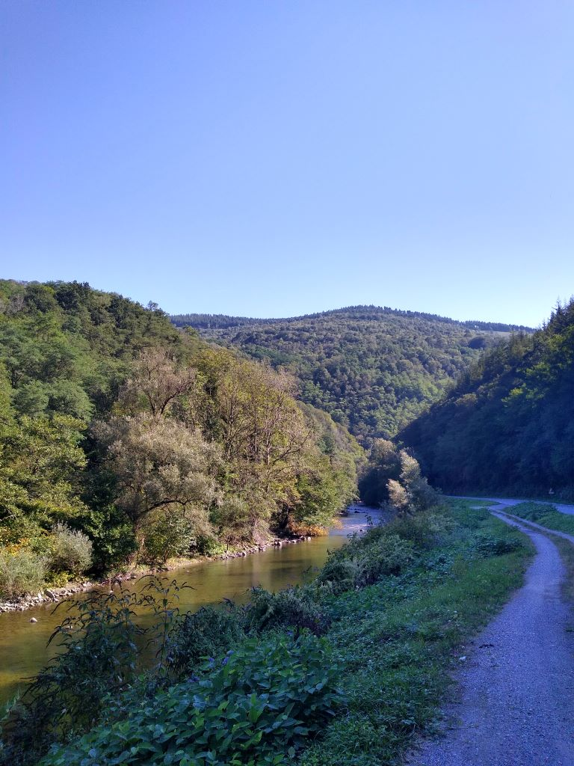
and it wasn’t until I stopped for a drink and, on resuming, nearly took out an unexpected cyclist approaching from behind that I blipped the motor button. The climb grew steadily steeper and I had the motor going at minimum level all the way to the top of Col Agnes at 1580 metres. I passed a herd of cows playing a bucolic symphony on their bells. They looked extremely well and the young calves with them had great shape.
On the way to the summit I passed the Etang de Lers a curious little mountain lake that is apparently home to the Pyrennean desman, a small endangered rodent
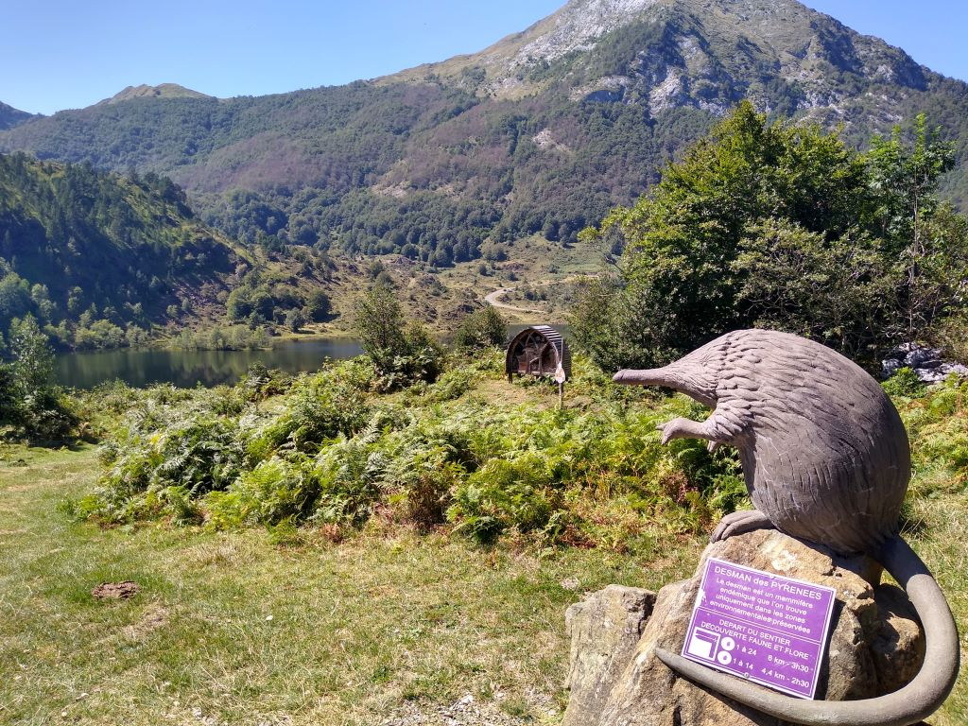
There were a lot of visitors at the cafe above the lake but I moved on after a brief look for water to top up my bottles. I stopped beside the lake and a Dutch couple who are travelling by camper van offered to take my picture with a back drop of very healthy looking cows.
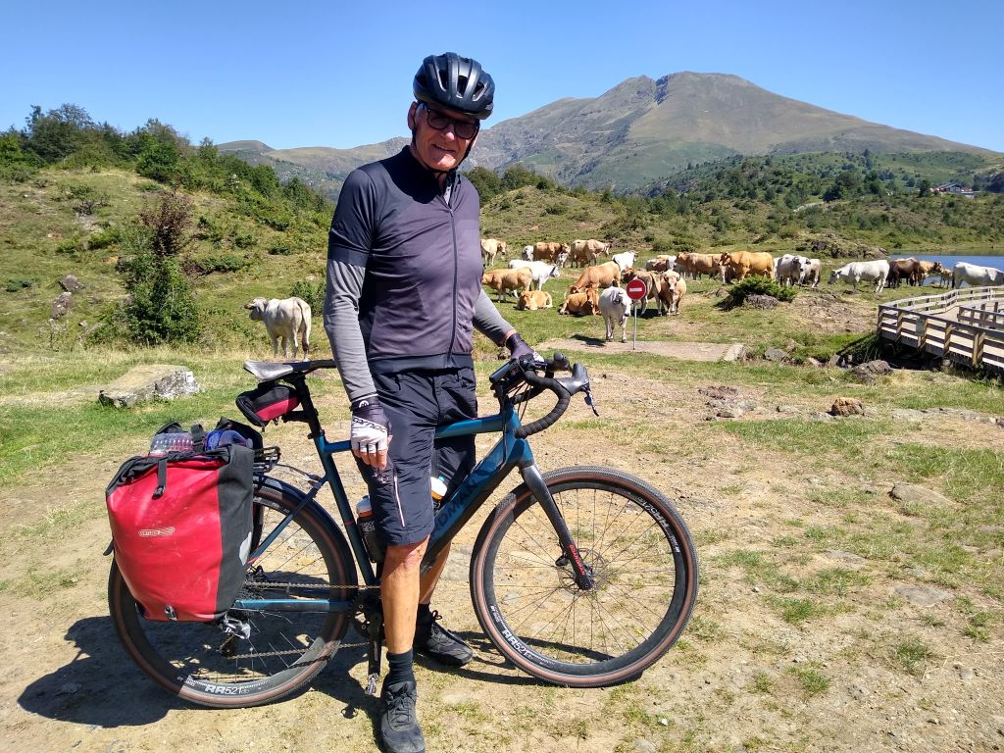
From the lake there was a hard 300 metre climb to the top of the pass and I was very glad of the motor, although, even on its lowest setting, I was eating up the battery. I only used it for about 30 miles but there was barely 20% left by the end of the journey. The next three days will test it further but hopefully I won’t run out at any point.
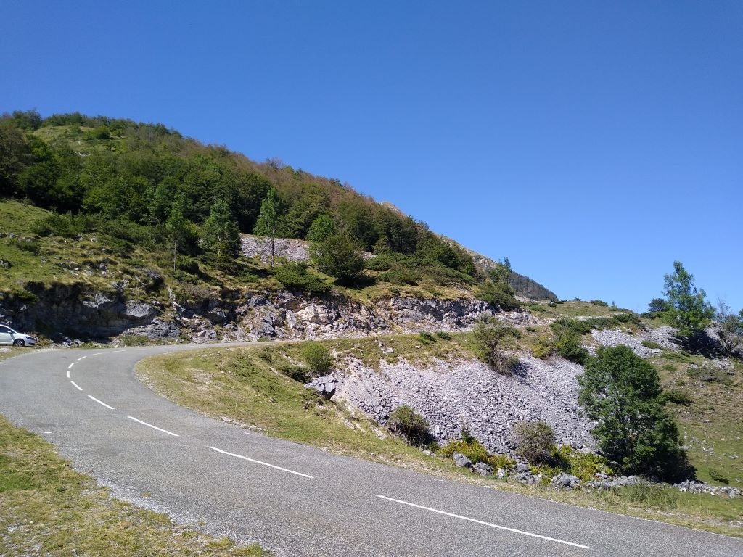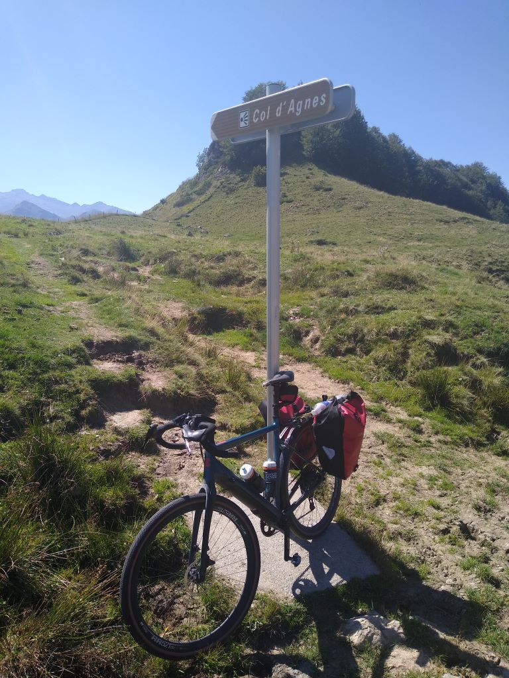
The view from the top is spectacular and strangely reminded me of the Blyde River Canyon in South Africa because of the way the ground dropped away. Pictures don’t do it justice but here’s one anyway
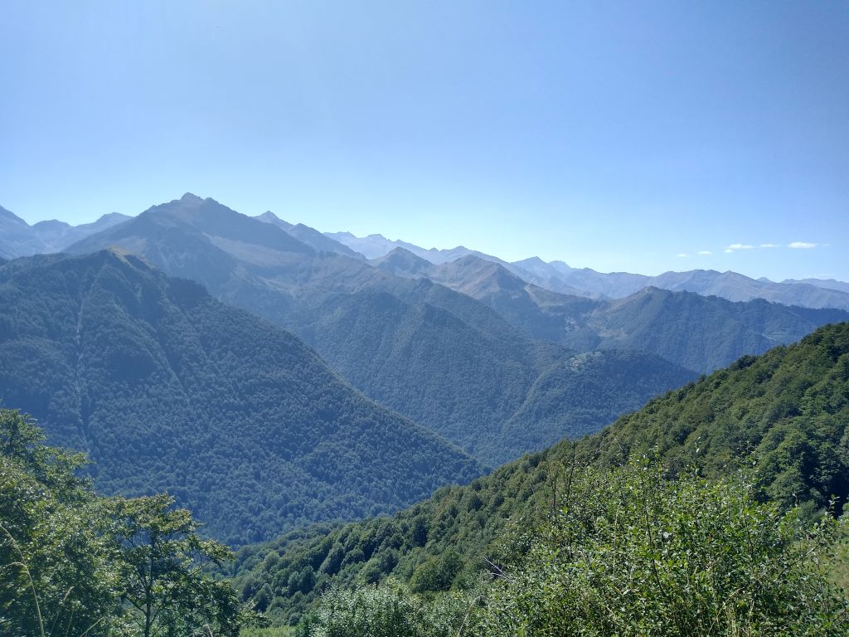
The descent was fast and hard on the brakes which were beginning to smell by the time I reached the village of Aulus-les Bains, a thermal resort 7 miles below that sits at about 700 metres. I followed my erstwhile Dutch pals down, keeping up with them all the way to the village.
The climbing wasn’t over: I still had to negotiate the Col de Latrape a further 365 metres over a distance of 5 kms. It was thirsty work and I was glad to have found a fountain in Aulus to fill my bottles.
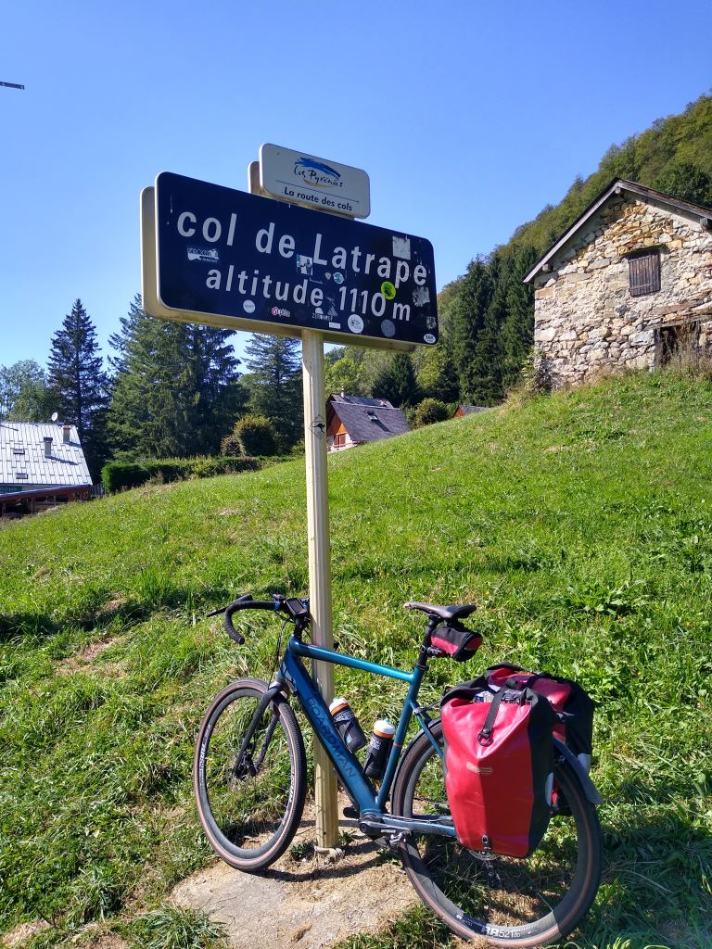
Climbing over for the day I whizzed down the other side pausing to take a picture of the fork in the road leading up to the Ski resort of Guzet Neige where I skied on a couple of occasions with friends who have chalets there.
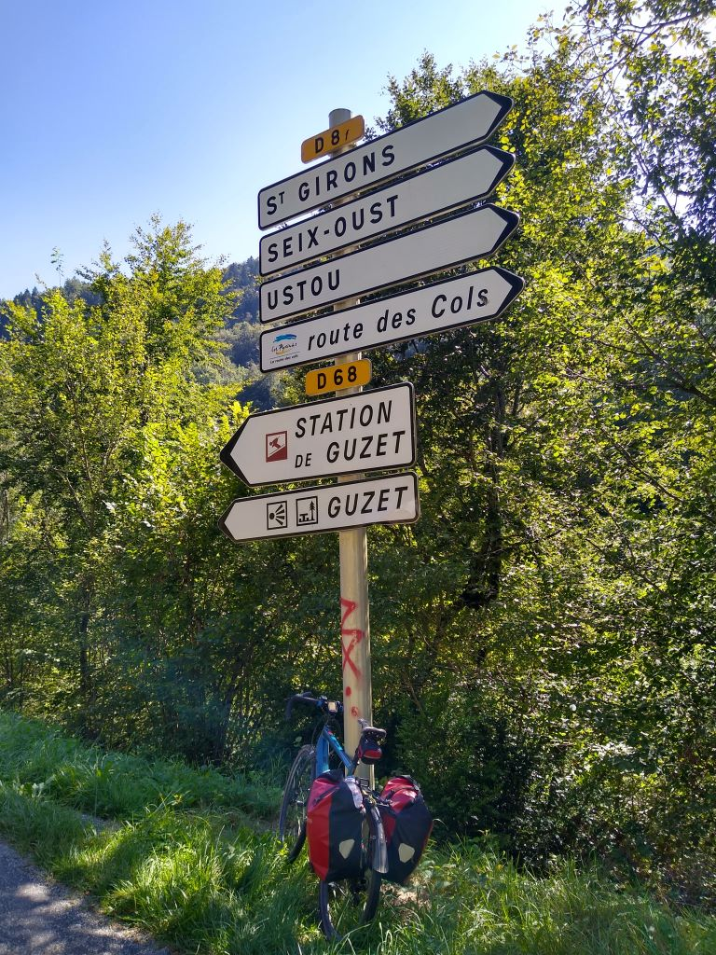
It was now about 5 miles to my final destination the Auberge du Haut Salat in Seix and I arrived there at about 4.30pm. The bar was doing brisk business and I booked in and sorted myself out. Lots more climbing tomorrow but tonight a couple of beers some food and a good nights sleep.
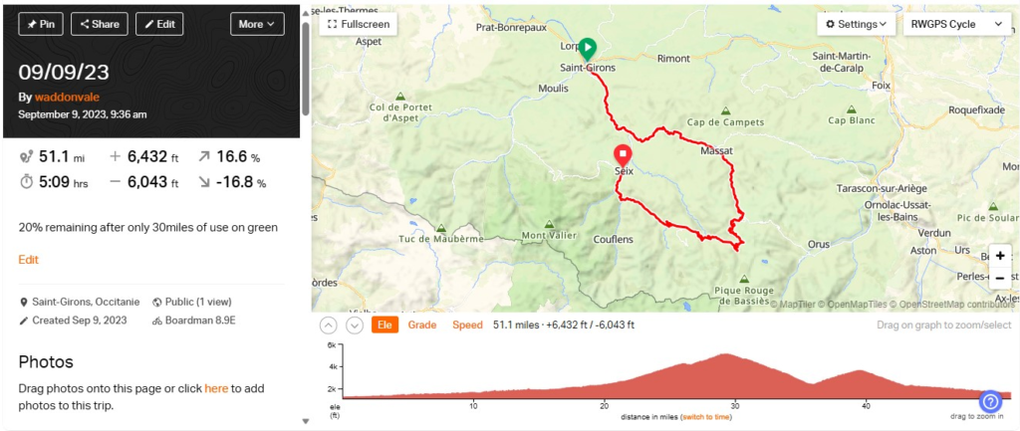

Day 5 – West through the mountains
The Auberge Haut Salat, as its name suggests sits beside the Salat river in the market village of Seix. There’s probably 80 odd houses, a couple of shops, at least one bar and a couple of restaurants, so a sizeable community for the Pyrenees. The Auberge Haut Salat has a bar that was humming when I arrived and continued to be quite busy until 8pm. They serve Tapas style food with the drink but I decided I wanted something more substantial so went next door to Les Deux Saveurs which had an acceptable looking menu.
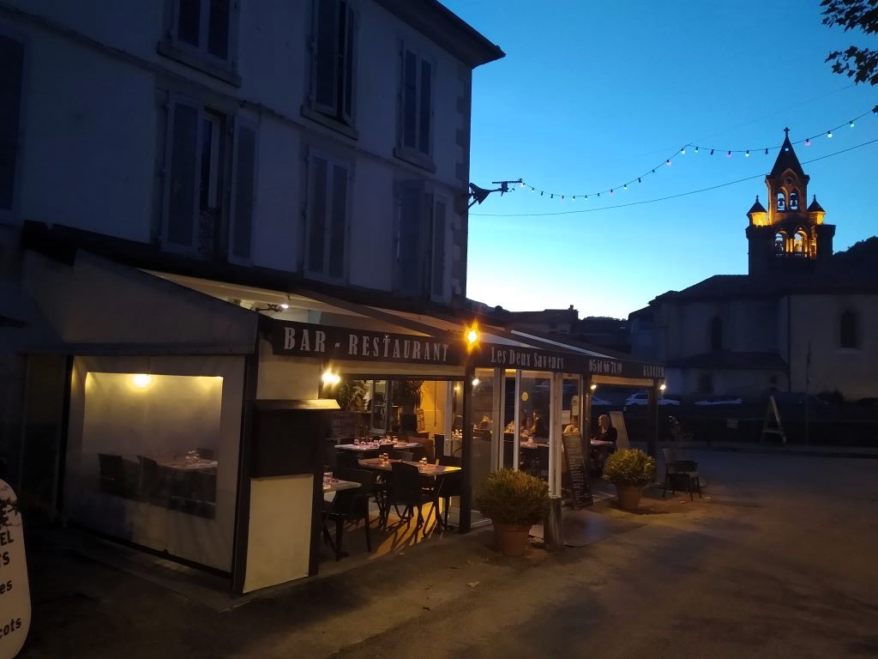
Saveur translates as flavour or taste and I couldn’t quite work out why only two of them – maybe it was a reference to food and drink. I didn’t ask. I started with a salad Bergeres which was a substantial melange of salad veg with local cheese and ham and a bit of melon thrown in. It was well dressed and tasty and I polished it off with a pint of Kronenburg. I haven’t eaten a steak for ages but decided an entrecote was the right choice and I was very glad as it was cooked á point as ordered and had a pepper sauce. More salad and some extremely good chips filled the plate and having polished that off I decided I’d finish with creme brulee. It was a good if somewhat expensive meal and I went off to the blog feeling full.
Breakfast at the Haut Salat majored on local produce. There was apple, butter, cheese and ham all locally produced, The croissant and bread from the local baker. It was substantial and good though expensive at 13 euros. The room was very rustic with wooden furniture but was large and the shower room was modern with an effective shower and the bed comfortable although I slept badly probably because of a late supper.
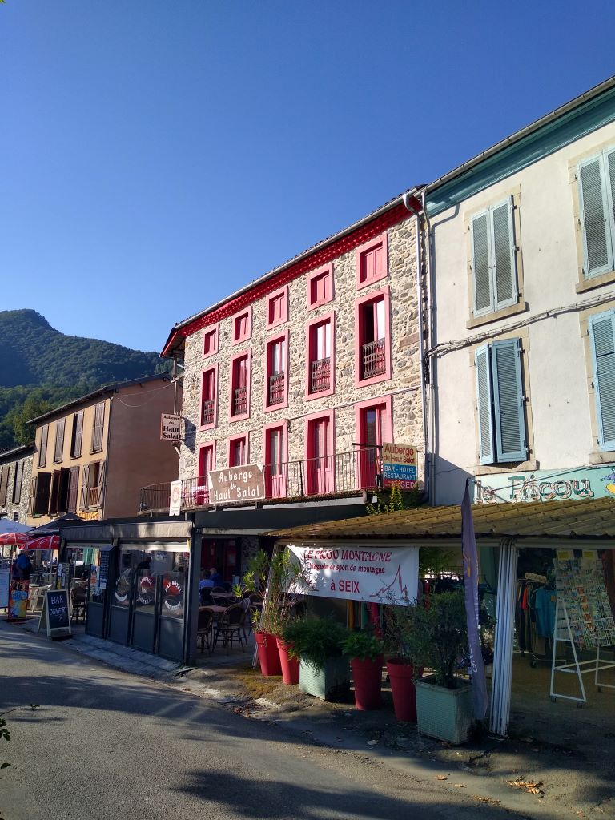
I was packed and away by 0936, as the Sunday morning market was being set up in the Square opposite the hotel, with two full bidons and an extra 1.5 litre bottle of water which straps neatly to one of the panniers. It was forecast hot and, with the climbing I was about to do, it seemed wise. I was immediately into some substantial climbing. I used the legs as far as I could but after a couple of miles the motor went on until I reached the Col de Catchadegue, about 5 miles into the journey.
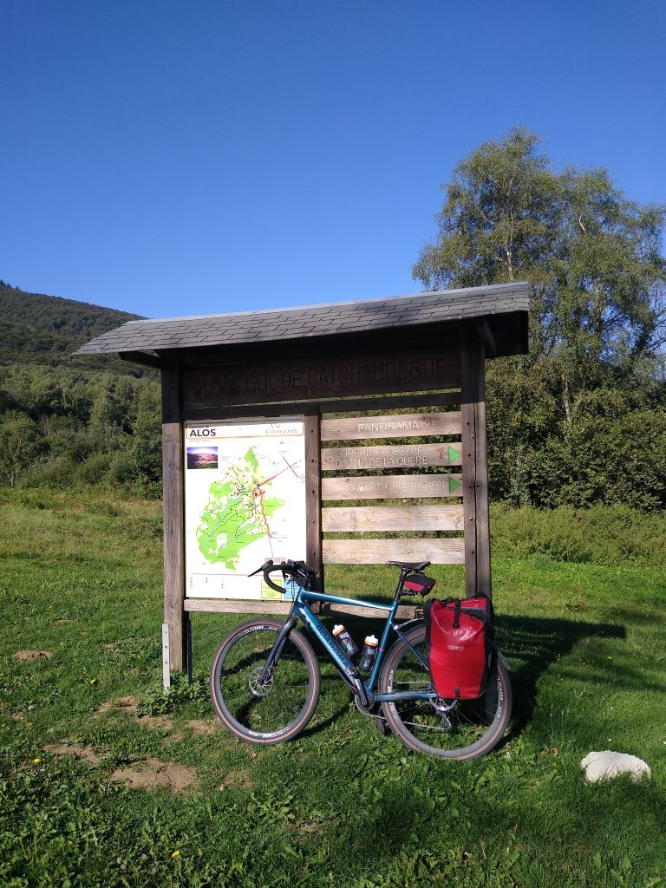
It had been hard work but the views looking back down the hill made it worthwhile: unfortunately the sun was directly in my face so the pictures were not worth publishing.. Rapidly down through the forest and into the next climb up to the Col de Portech, about 10 miles into the journey, not quite so steep but I still needed the motor.
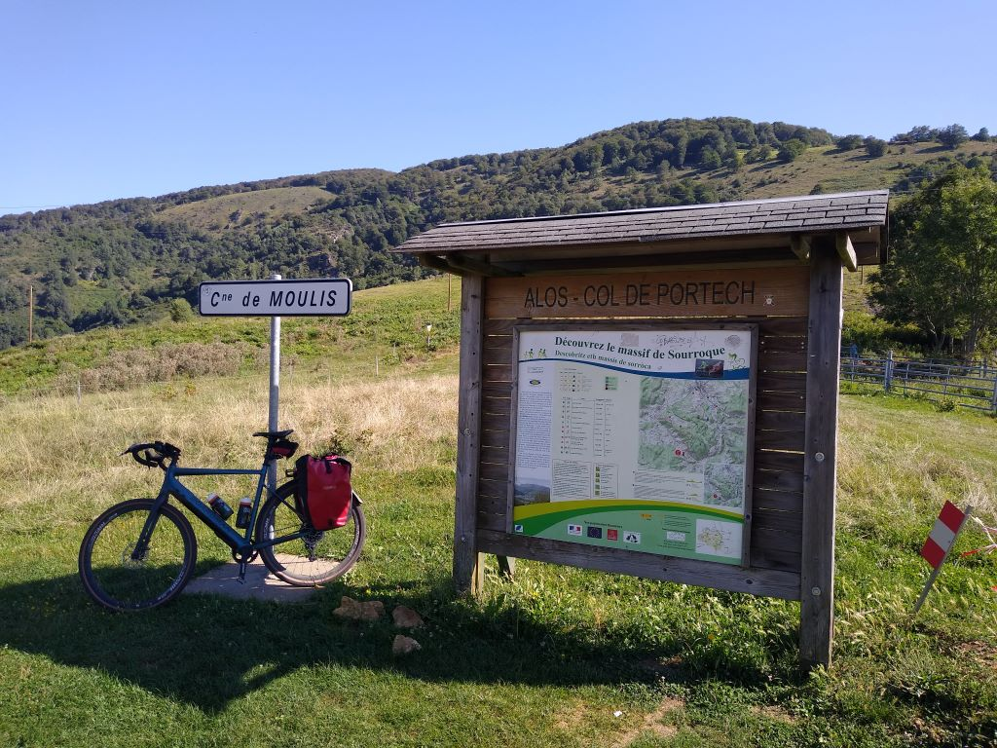
Five miles of steep descent down to the valley floor at Saint-Martin where I crossed the River Lez and joined a more major road for about five miles. There was a steadyish incline for the next ten miles which needed a blip on the motor every now and then. I looked forward at what I would probably climb later in the day.
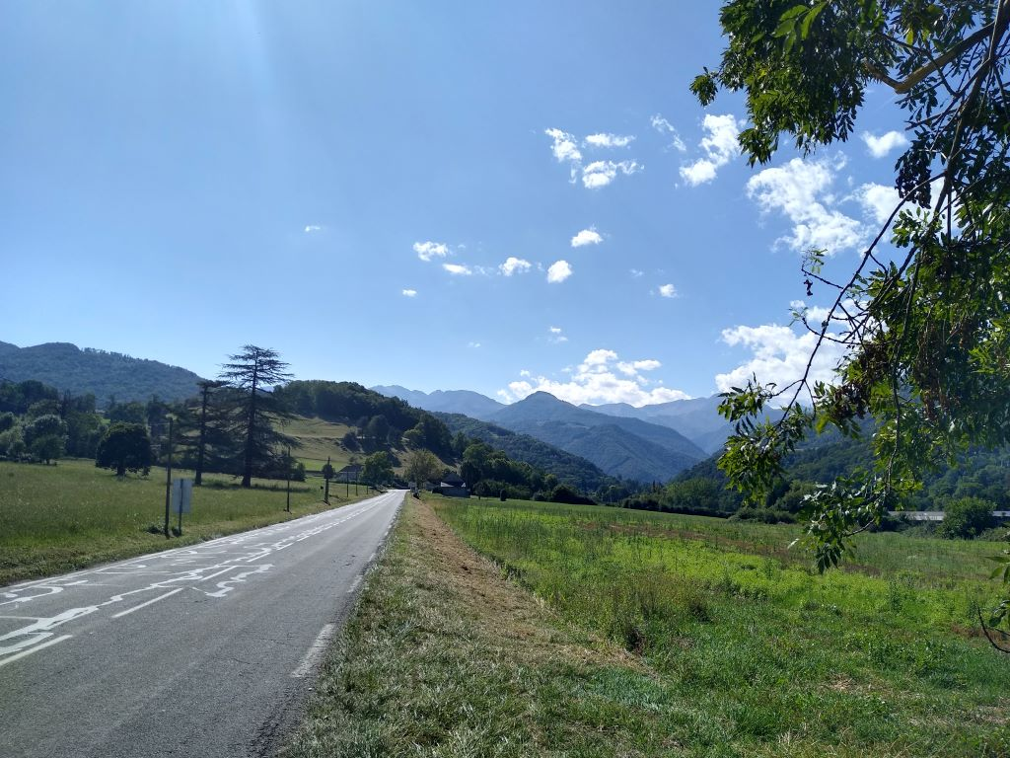
At St Lary the proper climbing started.
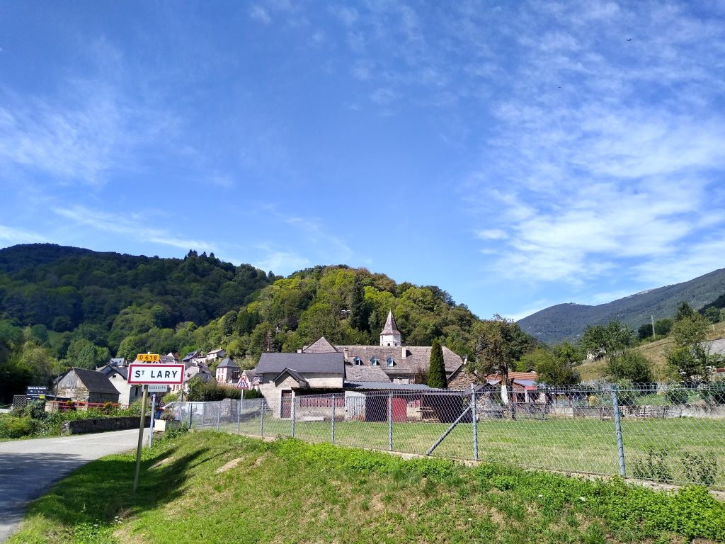
This was the foot of the Col de Portet Aspet, a climb that has been used more than 30 times in the Tour de France. I found a fountain at the foot of the climb and filled the bottles with cold clear water. It’s about four miles from base to summit but is relentless and the motor stayed on all the way, although I kept it in its lowest setting. I stopped a couple of times to drink and rest the legs but I still felt pretty shattered at the top.
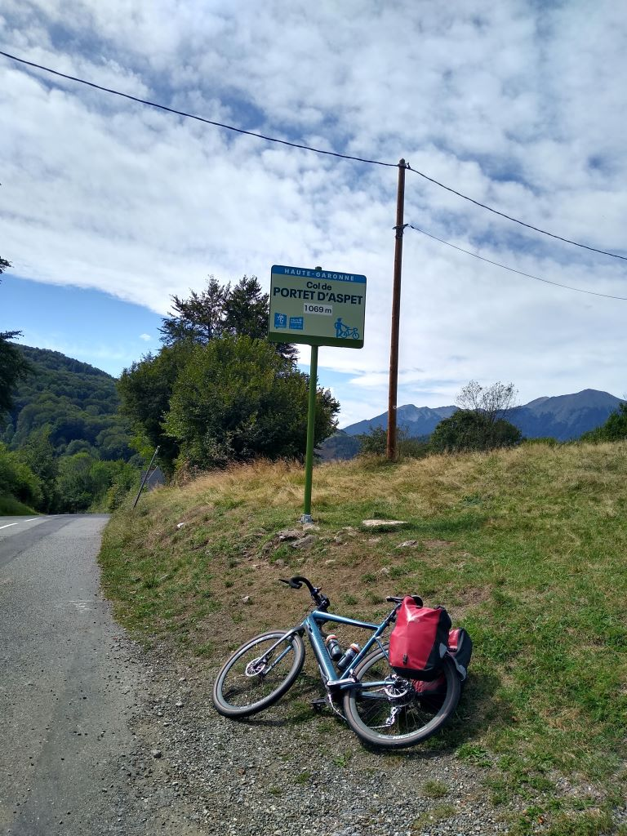
My admiration for professional cyclists increases daily. It has taken me about 11 hours over two days with a bike with a motor, to travel as far as they would do in a single five and a half hour day, over the same terrain, and they do it day after day for three weeks with only a couple of rest days.
The Col de Portet d’Aspet has an unfortunate notoriety in the history of the Tour: in 1995, 25 year old Italian, Fabio Casartelli, the last amateur winner of the Olympic Gold Medal for the road race in Barcelona crashed on the descent and died of head injuries before reaching hospital. There has been much conjecture since as to whether or not he would have survived if he was wearing a helmet, which was not then mandatory as it is now. Close to the scene of the crash is a marble monument.
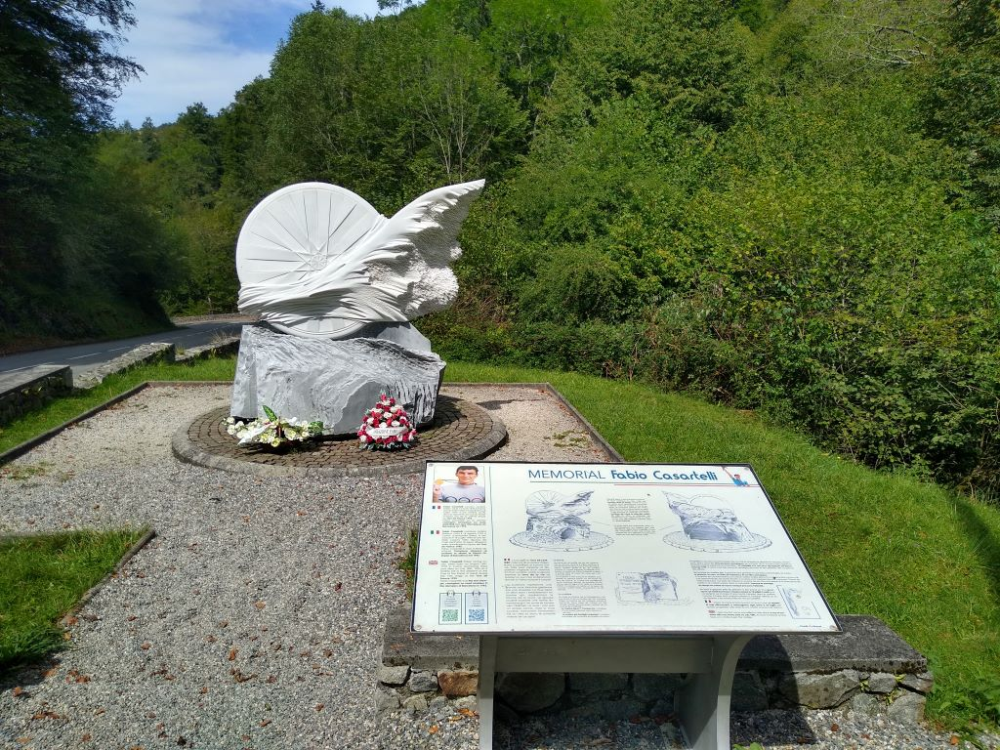
I can quite understand the number of crashes there have been on the descent. It is quick and wide enough to make riders take risks and in wet weather it must be hair raising. There were occasions on my descent when I was hard on the brakes to steer around some of the tight bends but exhilarating at the bottom.
A bit more work along the valley floor and I was into the final 4 mile climb of the day. The battery was looking dangerously low and I wondered if I would make it to the top of the Col des Ares. It is not particularly steep but it seemed to go on for ever and I was mighty glad when I got to the summit with one bar left on the read-out.
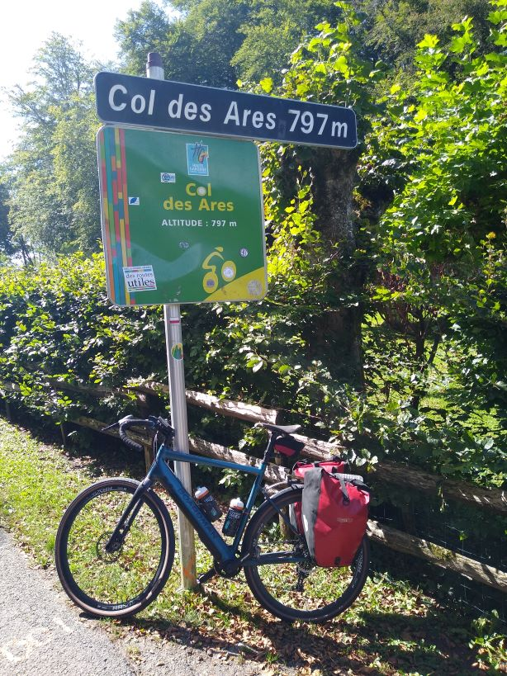
It was now a question of getting down to the valley floor for the five mile ride to my destination in Cierp-Gaud. It was another long sweeping descent and at some point I missed a turn which left me in a temporary quandary as, for some reason, I couldn’t get maps up on my phone to tell me where I’d gone wrong. In the event I got back on my route by chance so all was well. My Garmin has been behaving abominably all day. To start with it wouldn’t show my speed. Every time I reset it, it stopped recording the journey so it was next to useless. I hope that I can work out how to improve it otherwise it’ll be going on ebay when I get back home. Although my old Garmin had some quirks it was a little more reliable and, as I’ve already said, the battery lasted much longer.
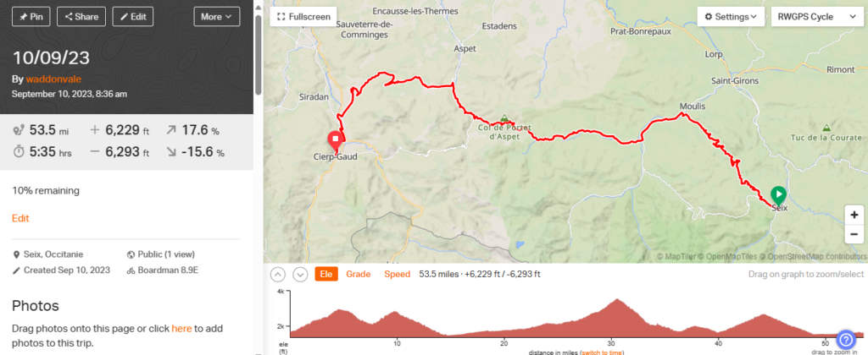

Day 6 – Tour double
I tipped up at Les Deux Rives in Cierp-Gaud at about 4.30 as I had promised my host Ed earlier in the day. Ed and his sister Louise are Brits who bought Les Deux Rives as a shell about 6 years ago. It only took them 5 months to turn it into a B&B and since then they have entertained over 2000 guests. Louise has moved on to buy and convert a former nunnery further north leaving Ed to run Les Deux Rives on his own. As it was a Sunday I was worried about finding somewhere to eat but Ed provided an excellent three course meal, a simply delicious mozzarella and basil starter, chicken cacciatore and a very nice pear tart tatin to finish. A couple of beers and a glass of Merlot washed it all down. Also staying the night were a couple from Devon who were walking the GR10 – no, I didn’t know anything about it until last night – but, apparently, it is a recognised walking route the length of the Pyrenees that should take up to 55 days although it has been done in as little as 12. They have been on the go for about 4 weeks and have covered roughly half, staying in mountain refuges, hotels and B&Bs en route. They’ve run out of time and are shortly on their way home. Talking with them, it’s not something I could do, particularly descending serious inclines on foot – my knees wouldn’t take it. Anyway we had a pleasant chat whilst eating supper and then I went and got the computer and wrote the blog.
Ed provided an excellent breakfast – french in essence but with the addition of local cheese and ham and, unusually, a softish very well boiled egg, English breakfast tea and orange juice gave a good start to the day and I was on my way with full water bottles by 0908.
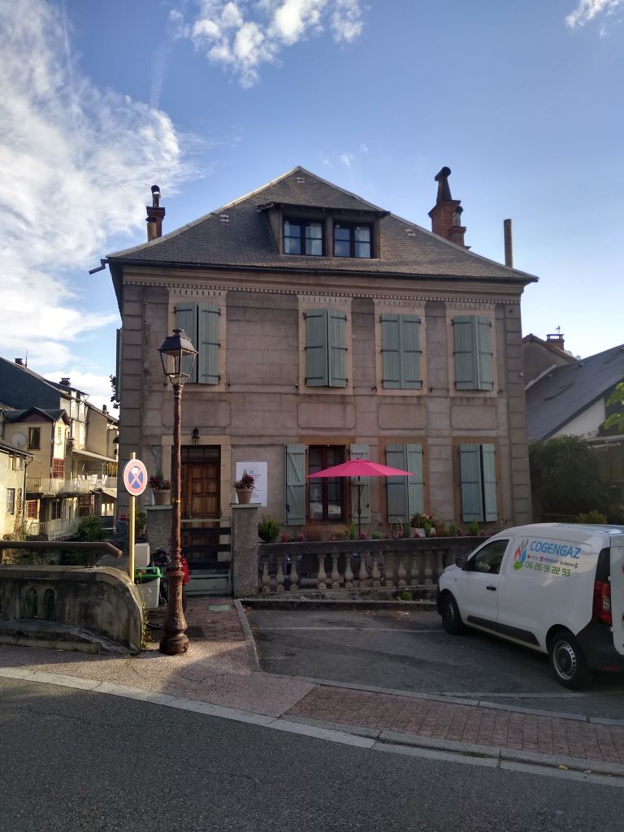
There was a 10 mile ride down the valley to Bageneres- de-Luchon to warm me up. Unfortunately instead of staying on the not very busy main road I diverted into a climb that needed engine assistance. I knew that it was going to be touch and go as to whether or not my battery would last the day so I could have done without that. Anyway I had to trust to luck.
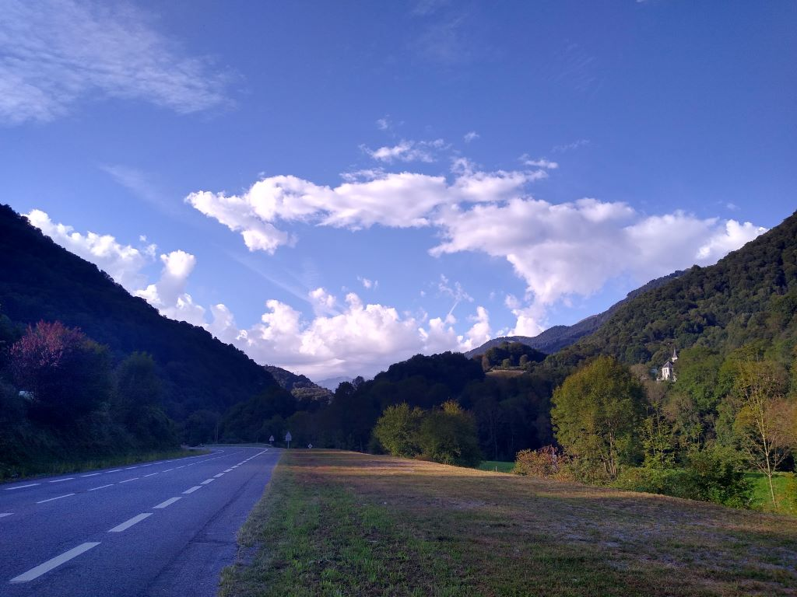
As you can see the weather was changing: clouds in the sky and promise of thunder to come over the next couple of days. At Bagneres-de-Luchon my route turned west and the road rose enough to need the motor again. I was heading for the Col de Peyresourde, one of the iconic climbs in the Tour de France. It takes you in the direction of Peyragudes, one of the premier ski stations of the Pyreneees. Unfortunately the change in climate has led to a very short ski season in recent years: Ed informed me that it was now as short as four weeks, which hasn’t done much good for his winter bookings.
I came across this penny farthing sculpture that framed the climb to com.
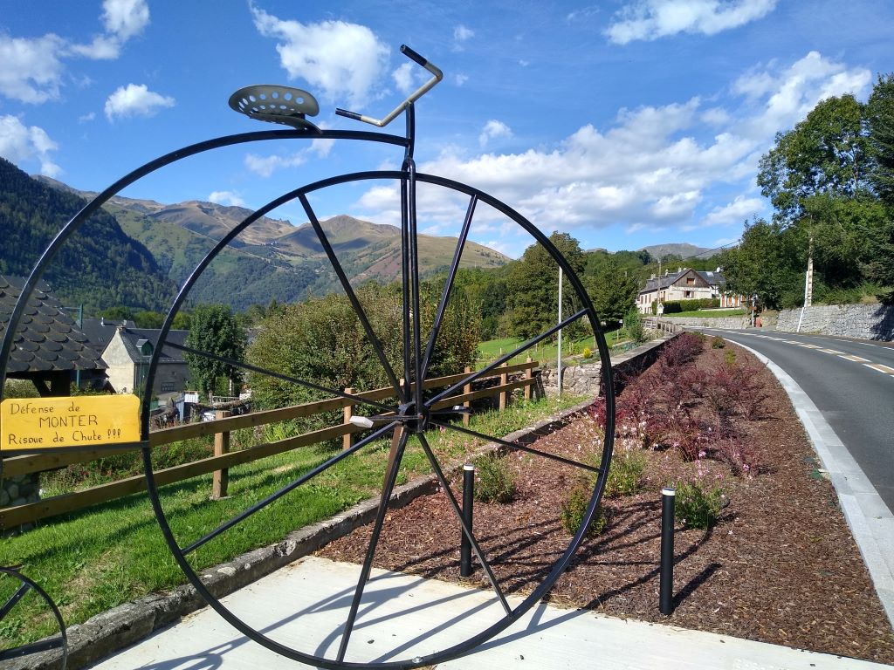
The road was now steep enough to keep the motor going and I hoped that I would reach the top of the climb with, at least, 50% remaining to take me over the Col d’Aspin later in the day.
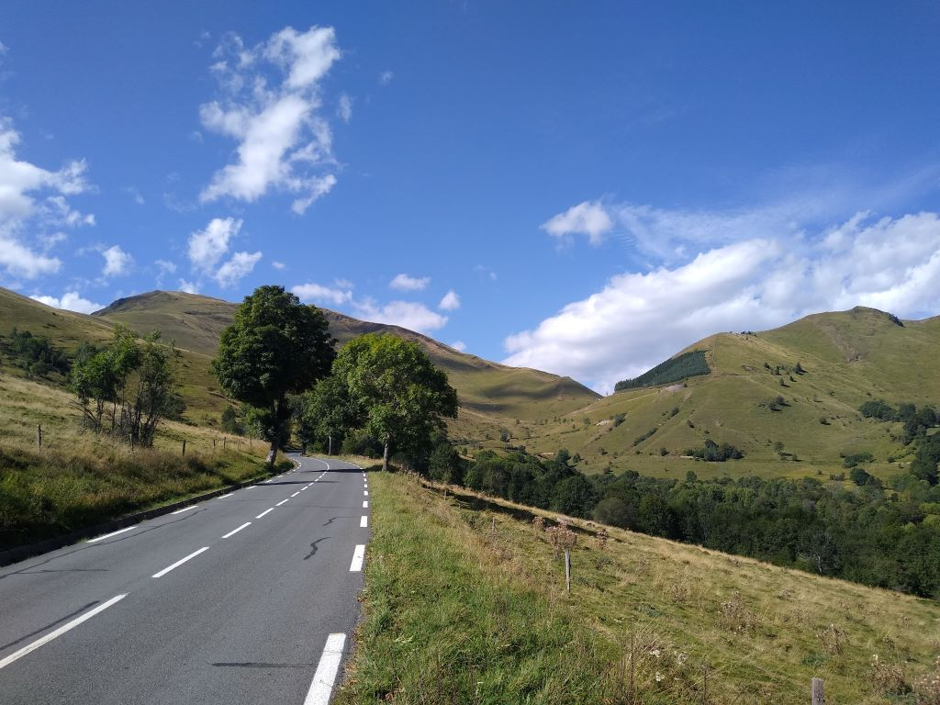
In the event I had about 60 % left by the top of the climb which gave me some reassurance.
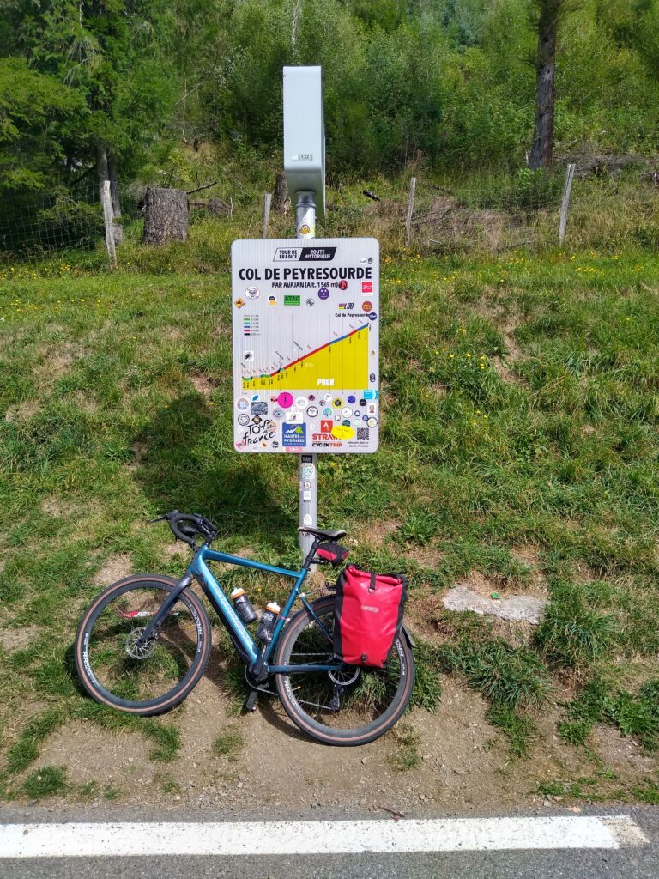
It’s a TDF classic having been crossed almost 70 times. The road is wide and well paved and is not horrendously steep but I had to keep the motor running for comfort. The descent is easy, wide and without many sharp bends, joyful after the hard climb.
The descent takes you to Arreau, a thriving and pretty commune with plenty of bars, shops and restaurants and there were loads of tourists on the day I was there.
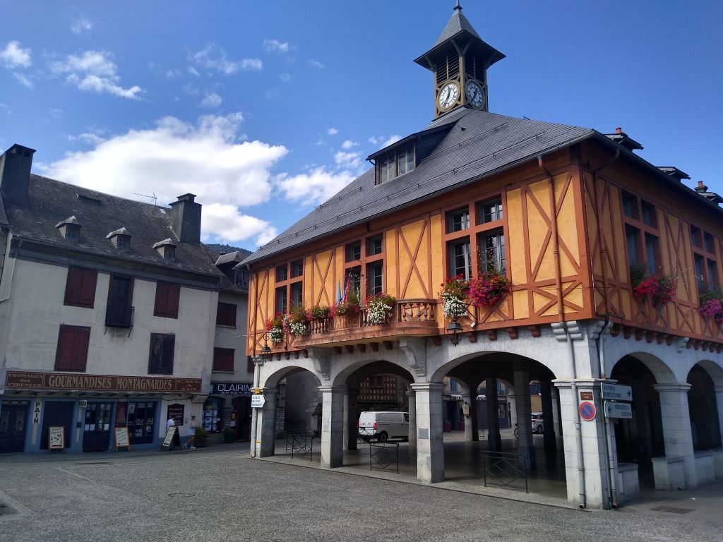
I stopped in Arreau to fill my water bottles; there is a rather ingenious system that I find hard to explain. There is a green hydrant with a handle on top that you wind and almost miraculously water appers from a spout. I imagine water is flowing through the system all the time and winding the handle diverts it to the spout. Whatever: I ended up with three bottles of cool clear water.
The next objective was the Col d’Aspin, again many times crossed in the TDF. I was ahead of time so, having experienced quite a lot of brake squeal I thought I would investigate before the descent of Aspin and, tomorrow, Tourmalet. I had some spare brake pads so pulled off the road and went to work. The pads weren’t too bad but I changed them anyway. It took me about half an hour and I set off in the knowledge that I should be OK for the descents to come.
The ascent of the Col d’Aspin is easy. I was expecting to have to use the motor early but , in the event, I reckon I could have made it without using the motor at all. However I got bored and, as I had plenty of spare power used it anyway. On the way up I came across this rminder of the TDF
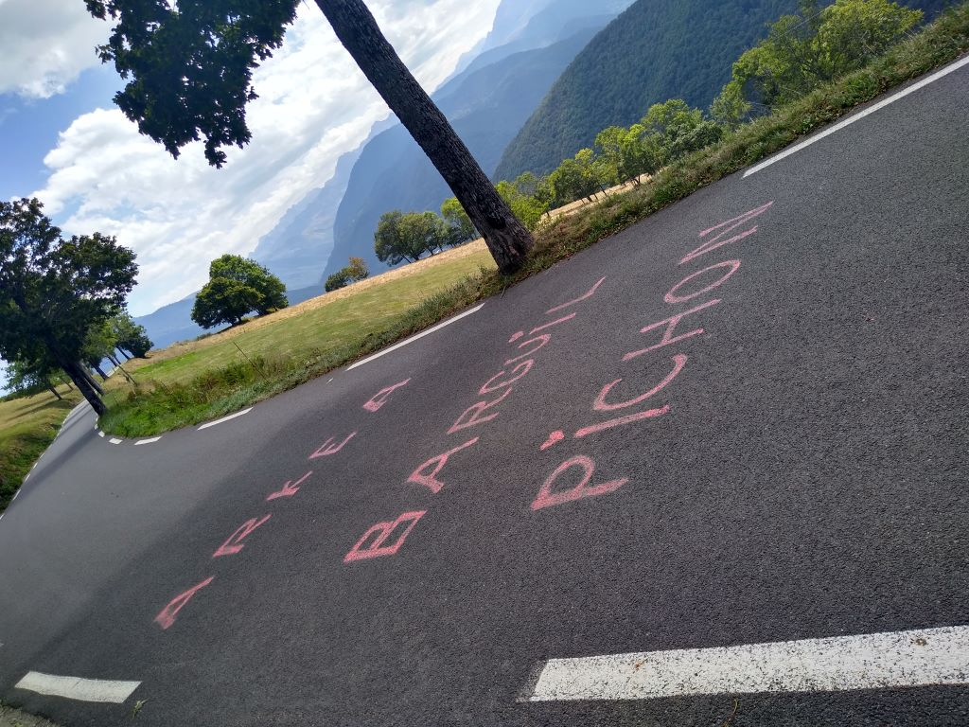
and, a little further on one that I could hardly ignore
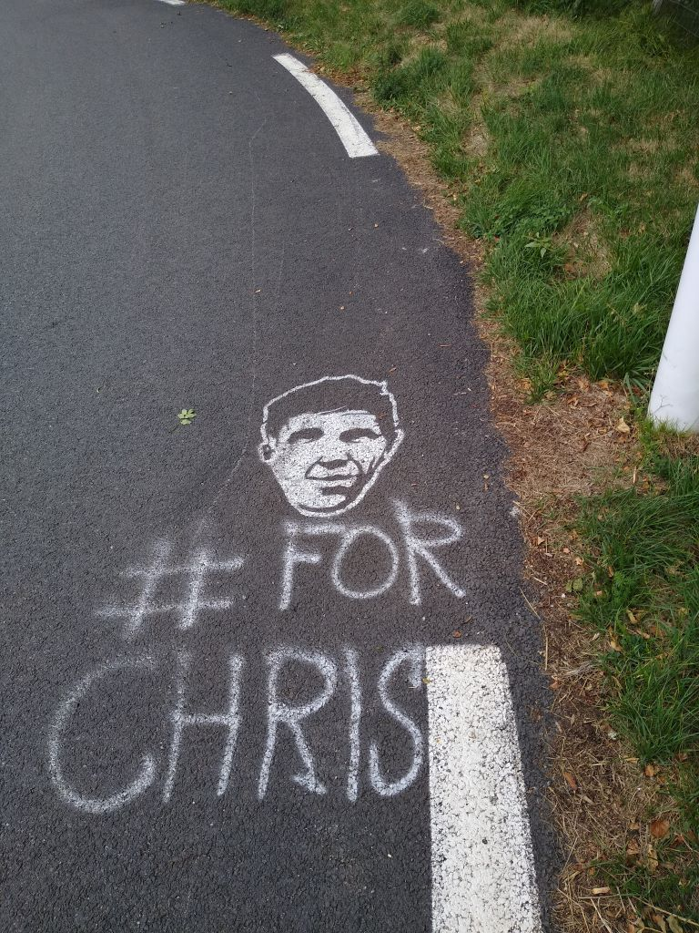
On my way up I was passed by a french grimpeur, I would guess in his 50’s or even 60 ‘s who kept ahead of me despite my motor: chapeau.
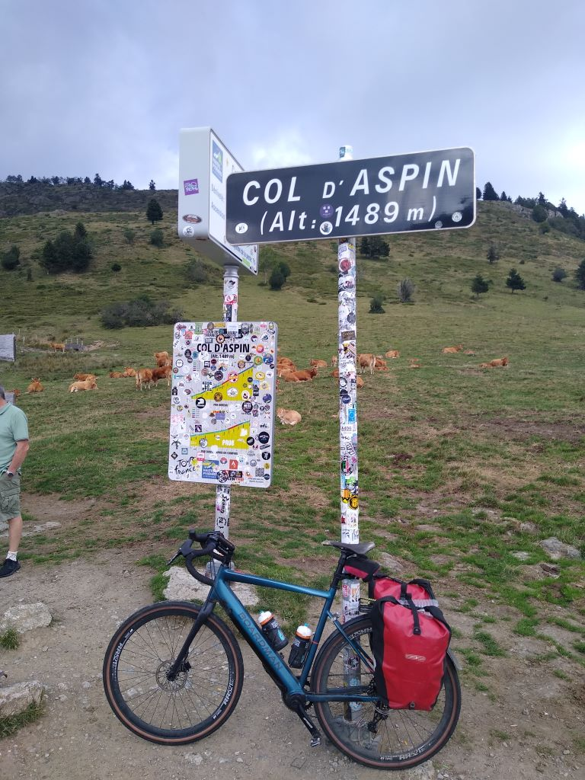
The sweep down to Peyrehitte, my destination for the night, was exhilarating. Safe in the knowledge of good brakes I pushed myself and arrived at my hotel before 4 pm. I’ve climbed more than I have ever done in a day before but I didn’t feel particularly tired. The legs are good and should get me over Tourmalet tomorrow before the forecast thunderstorms hit.
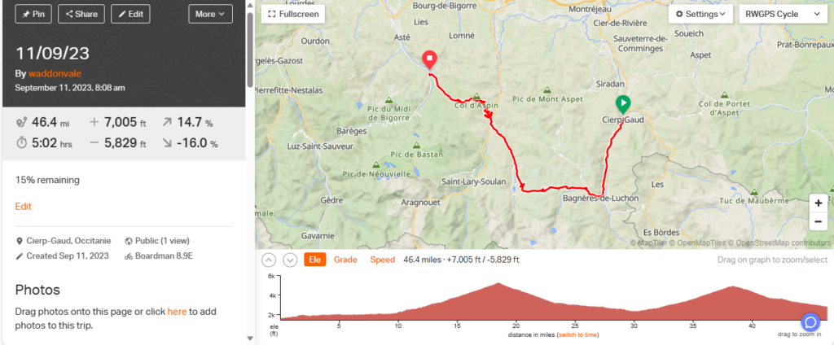
Day 7 – Trouble on Tourmalet
The Hotel2cols is so named because it sits between the Col d’Aspin which finished off my day yesterday and the mighty Col de Tourmalet which was today’s main objective. I was welcomed by a most efficient Madame who told me where to put the bike and showed me my room. It was on the small side but perfectly OK. The shower worked well and the windows opened wide so that I could get the washing dry. Supper, included in the deal, didn’t start until 7.30pm so I went for a stroll round the village of Peyrehitte. There’s not much to it but it holds a place in cycling lore because this is the place to which, in 1913, Eugene Christophe, leading the Tour de France, walked 10 kilometres down the Tourmalet with his broken bike so that he could repair it at the local forge and finish the stage. In those days you could not accept any outside assistance and Christophe was docked three minutes on the grounds that the blacksmith’s son had worked the bellows of the forge. In the event the penalty was meaningless in that he was way behind the other competitors but still finished 7th at the end of the race.
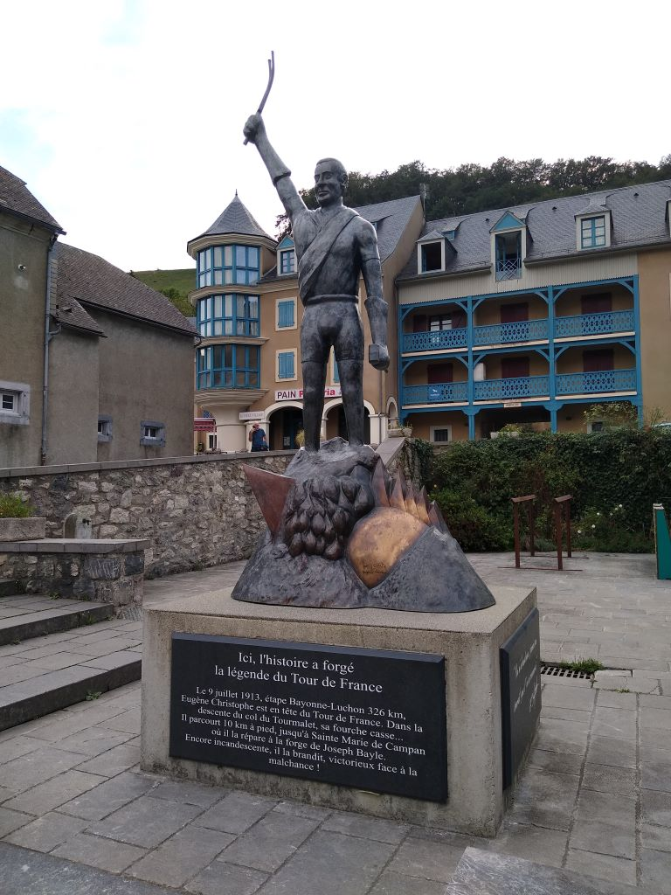
I dropped into the bar on the opposite side of the road for a couple of pints of Blonde beer before supper. It appears that what used to be a large beer is now known as a pint. Mine host was affable but his English was about as good as my French so the conversation was stilted and revolved mainly around rugby. He doesn’t think the French will win, favouring Ireland or South Africa.
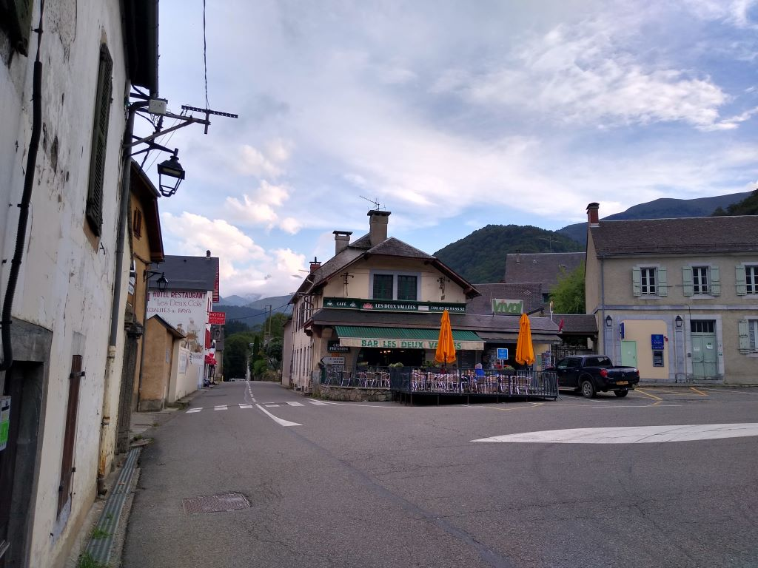
Back at the Hotel the dining room was filling up with all nationalities, many of them cyclists. The meal was excellent. A very good vegetable soup with a chicken stock base, a slice of quiche Lorraine to die for followed by beef stew with noodles, salad and roast potatoes. I chose caramel cream for pudding and had a bottle of house red that I took up to my room to finish whilst writing the blog. Really good home cooking without pretension.
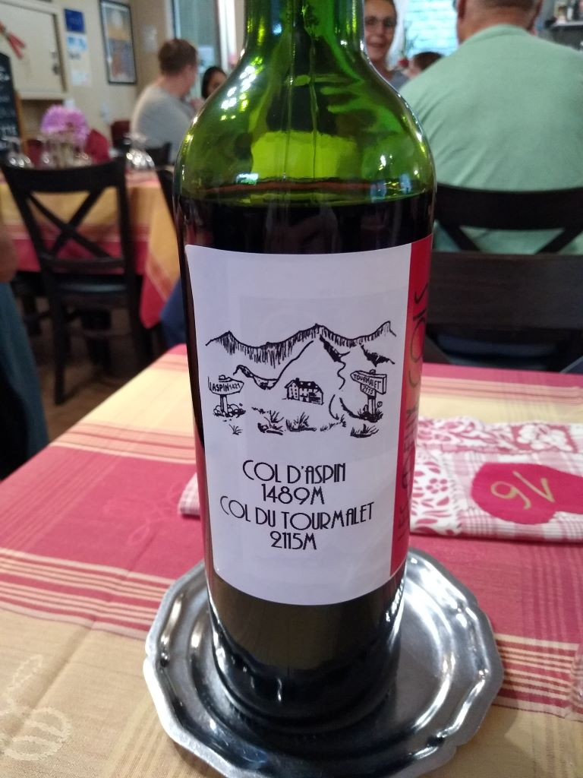
The washing was largely dry by the time I went to bed but stupidly I left it hanging in front of the open window as, in the middle of the night I was woken by thunder and lightning and the rain that came with it undid some of the good. I closed the window and by this morning only the cycling shorts were still damp and I wore them anyway. Breakfast was good french with the addition of ham and cheese which seems to have become a staple since I was last in France. The bill for Dinner Bed and Breakfast was a reasonable 96 euros including the bottle of wine. The Patron told me that the weather would be OK after the storm in the night.
I set off at 0857, with water bottles filled at the village pump, to climb the Tourmalet
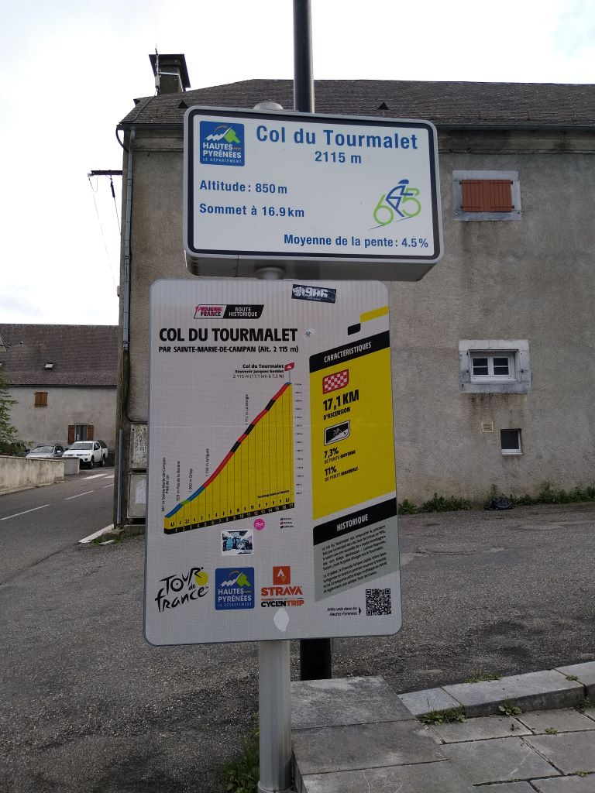
That’s what it looks like in cold hard facts, easy at the bottom with a few steep sections in the middle. As usual I tried to avoid using the motor until I was really stretched which came about 4 miles into the journey. I motored on in low and passed an old boy on an old style steel bike: he looked over eighty but was going along gamely. All was well until about five miles from the summit the motor suddenly gave up on me. I’ve had this problem before and It’s usually to do with poor electrical connections so I cleaned everything as best that I could. The tricky one is the union betwen the battery and the motor which is down inside the tube and hard to get to. No go: so on I went under my own steam thinking I can always get off and push if necessary. A kilometre later I suddenly felt the motor cut in again and all was well all the way to the summit. Big sighs of relief.
Unfortunately the whole climb was in thick low cloud so there were no views. I arrived in La Mongie, a ski resort about four miles from the summit.
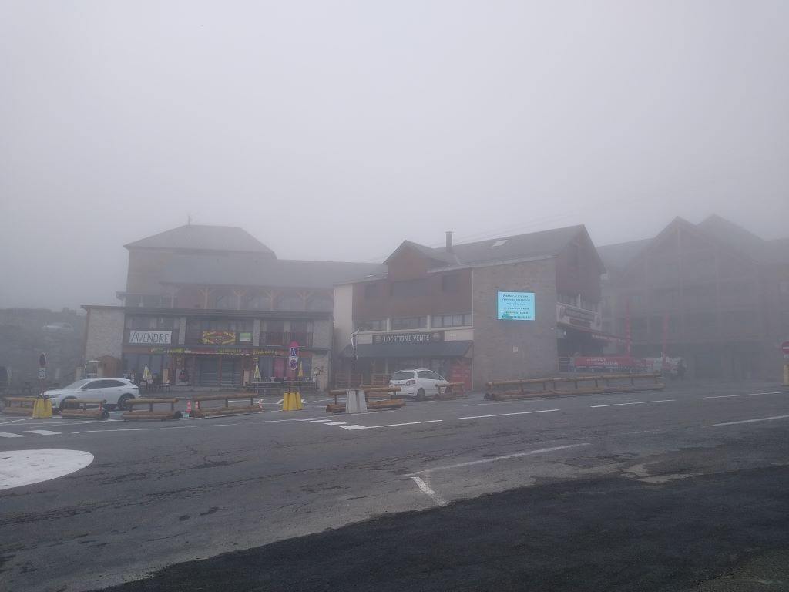
and kept plugging away. The cloud cleared slightly but never enough to afford any views. I looked ahead and the summit was still a couple of miles up some steep gradients
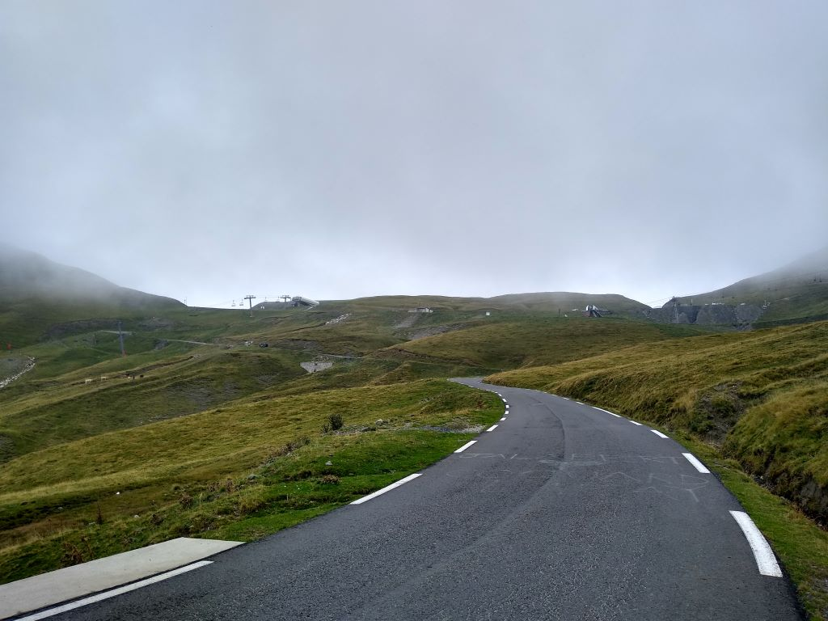
Anyway I made it having used virtually the whole battery and had my picture taken by one of the dozen Englishmen who had arrived from the other side. Not a vey good shot but it’s a record for my album
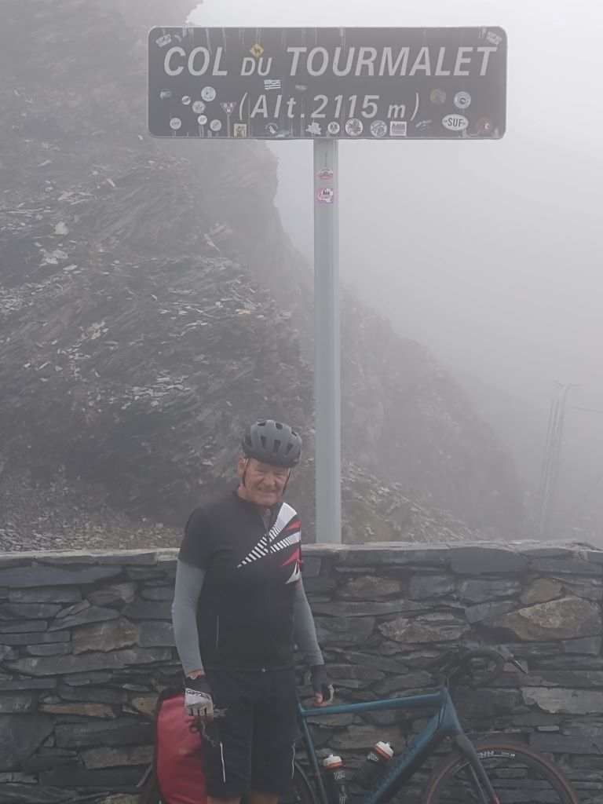
What would have been a glorious descent yesterday, was totally ruined by the lack of visibility. I followed three motorbikes being sensibly ridden and kept up with them for about 8kms when I pulled over for a drink of water. This is what it should look like.
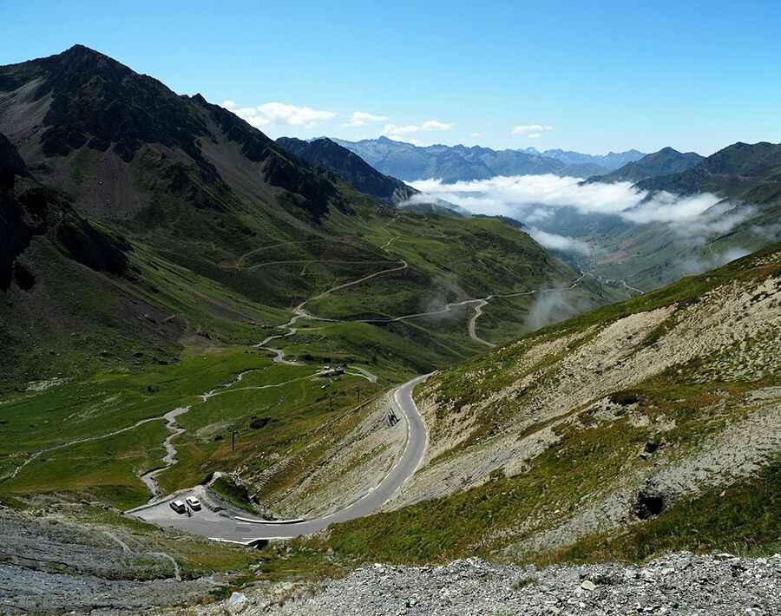
but sadly not today. The road drops down through the substantial base ski resorts of Bareges and Luz St Saveur, the latter quite busy with late summer visitors. I don’t imagine they do much in the winter so They’ve had to reinvent themselves with mountain biking and parapenting and white water rafting on the rivers Bastan and Gave de Pau. I’d put on two jackets at the top and was still feeling cold when I finally reached the bottom at Pierrefitte some 20 miles from the summit.
As is my wont I managed to get on the wrong road which ended up taking me onto a stretch banned for cycles. I was able to turn round and make my way across to where I should have been, and found myself on a delightful voie verte that followed the line of the old railway from Pierrefit to Lourdes. Nice easy cycling for about ten miles on a traffic free tarmac track (get the alliteration!)
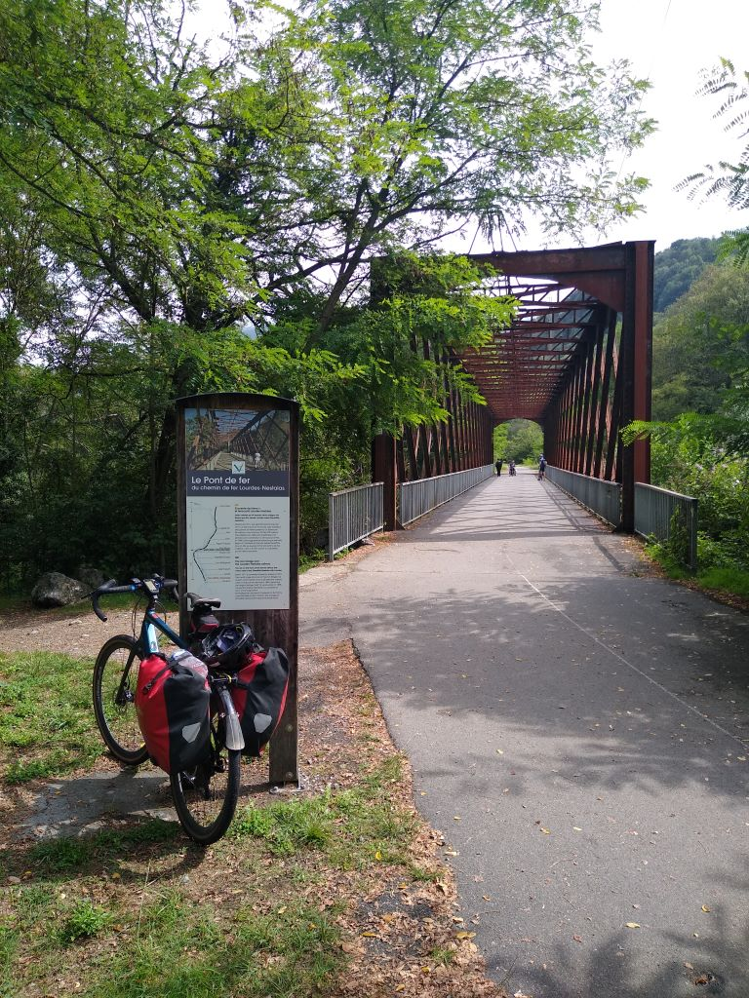
I thought it was a shame not to visit Lourdes whilst it was close to my route. I wish I hadn’t bothered. Never have I seen such an illustration of mammon. It has over 220 hotels, more than any other city in France apart from Paris and caters for 5 million people a year. There are hundreds of restaurants and gift shops catering to the credulous. Want to hire a wheelchair?, certainly Sir, that’ll be 30 euros. I thought I ought to see the grotto where Bernadette had her vision but no bikes allowed and nowhere to leave them. I took a snap of the Sanctuary and gladly moved on. Thinking about it as I rode along, it actually made me angry which is one of the seven deadly sins, so not a very Christian experience.
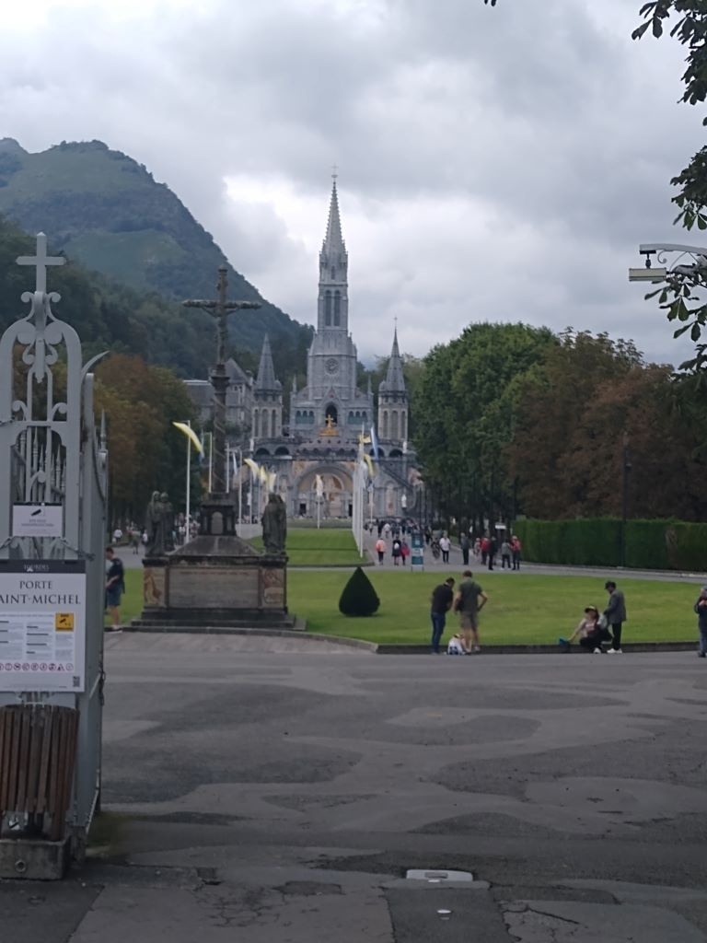
It was still about 25 miles to Pau where I was staying the night. The road is not very good, it’s main saving grace being that it is downhill all the way. There is a motorway that takes most traffic so the road I was on was quite quiet. It started to spit with rain and I pulled over and put back the jacket I’d taken off on the voie verte. The sky grew blacker and blacker and I was within 500 metres of my hotel when the heavens opened and I took shelter under a bus stop. It was 20 minutes before it had abated enough to move on and I was at the door of the Hotel Adour at about 5pm.
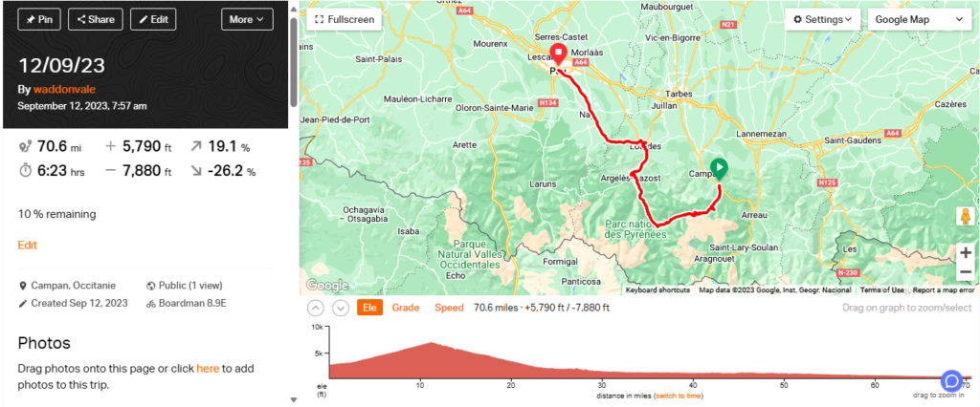
Day 8 – Heading for the Atlantic
Arriving at the Hotel Adour in Pau in a storm was not the best way to acquaint myself with the city but standing under a bus stop shelter for 20 minutes and watching people was interesting. There’s a Spanish look to the locals, swarthy and tanned. There were also, as in any city in France or the UK, plenty of African and Middle Eastern origin. There is an efficient hydrogen bus service called Fébus. Each of the Belgian manufactured vehicles can hold up to 125 people and it seemed a popular method of travel. The buses have their own traffic light system which allows them to take prority at junctions, stopping other oncoming traffic until they have passed. Once the worst of the storm had passed I carried on to the Hotel Adour which I had booked via Booking.com. The way that Booking.com operates varies from place to place. In this case they took the agreed payment for the room from my credit card last week so, this morning when I left I only had to pay for breakfast and local taxes.
When I arrived Marina welcomed me and showed me where to put the bike. I dripped my way upstairs to the room which was accessed by an open air balcony and washed and cleaned everything. There was an electric fan in the room which efficiently dried everything overnight and kept the air circulating. A comfortable double bed and a very good shower made it good value for the 60 euro cost.
I went searching for food and a bottle of wine to help inspire me for the blog. The latter, and a replacement toothbrush for the tatty one that has been in my spongebag for way too long, I found in Monoprix, a supermarket that seems to sell everything from fresh veg to shampoo at very reasonable cost. The bottle of local red cost me 2.99 euros and was perfectly drinkable.
Food I found at No Comment a brasserie majoring in burgers but with plenty more on the menu. I started with a Caesar Salad, enormous, with large chunks of bread-crumbed chicken and that really would have been sufficient in itself; but I was feeling hungry so I had fish and chips (yes, really) to follow and washed it down with a pint of Heineken which was marked down from 6 to 5 euros as it was a happy hour until 2000. I reckon the fish inside the excellent batter was bream, certainly not cod, and the whole dish was well presented and tasty. The efficient English speaking waiter asked me if I wanted any pudding but I was feeling like Mr Creosote and another waffer would have done for me I so waddled back to the hotel and blogged. Total cost 39 euros.
Even with the fan going it was sultry and I didn’t sleep all that well on a comfortable double bed but I was rested this morning when I went down for breakfast which cost an extra 9 euros for french fare, no ham or cheese, good orange juice and tea. The 7.50 breakfast at Les2 Cols looked very good value by contrast but it filled a hole and would keep me going until this evening.
I wasn’t in any great hurry to start as 69 miles downhill with little or no climbing seemed a doddle compared with recent days so I left at 0943 and took a couple of pictures of the city centre
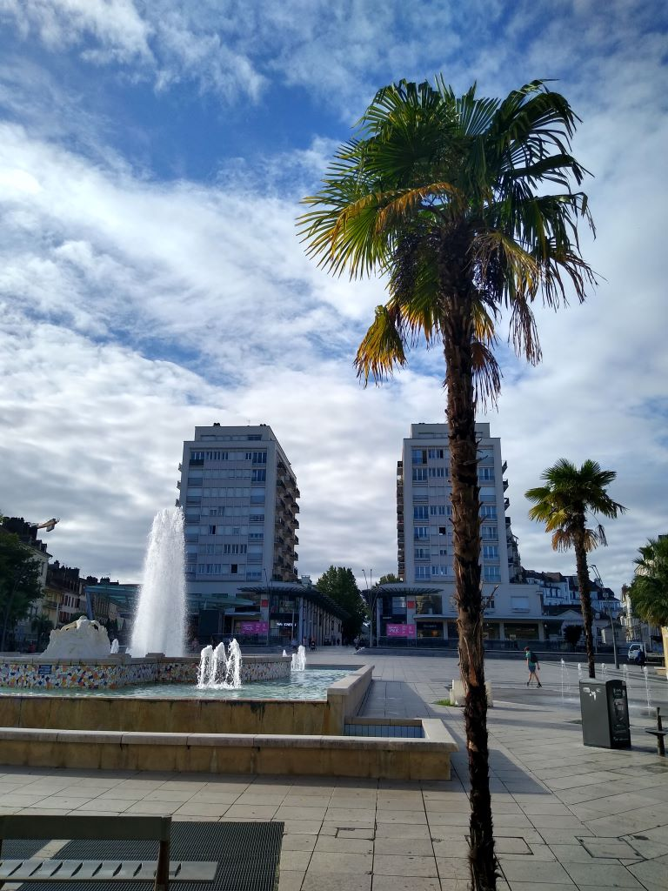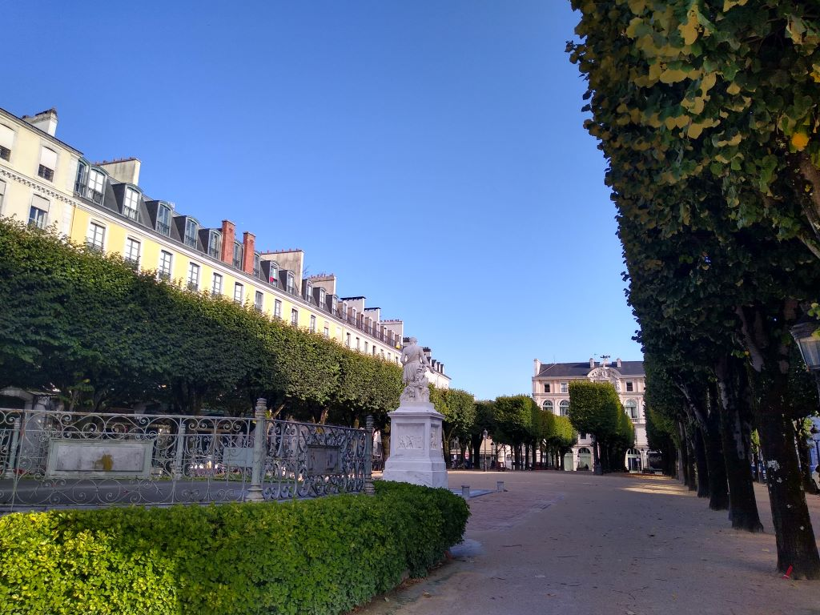
and a view from a belvedere of the distant Pyrenees to remind how far I’ve travelled
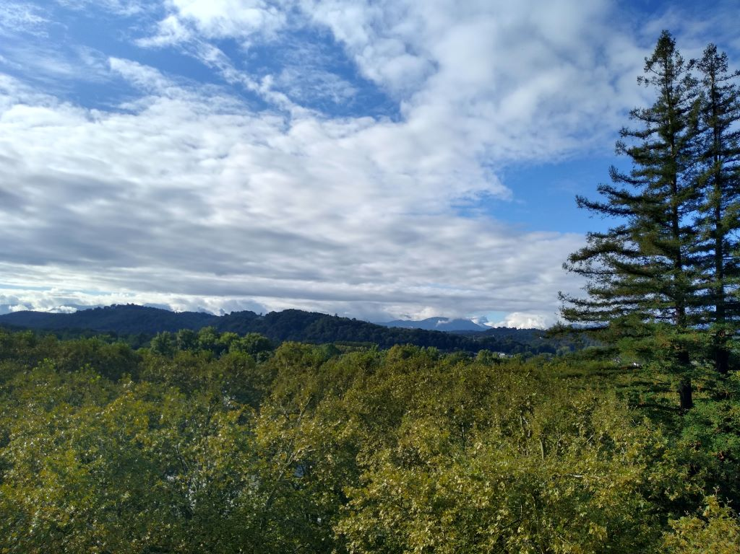
Pau is a city on two levels that are connected by a funicular that brings people up from the station. Built in 1908 it is a free ride
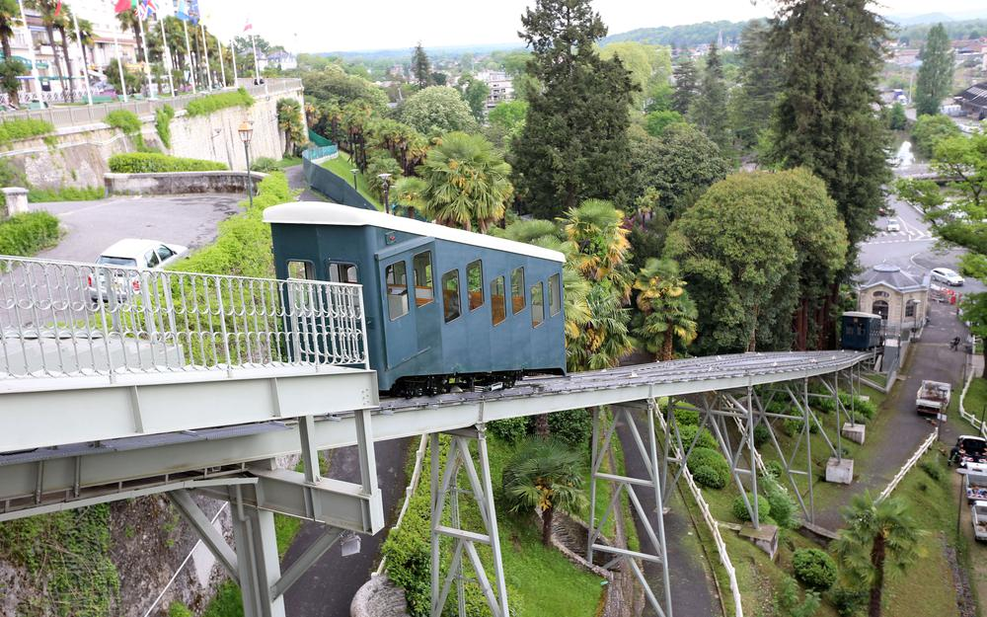
and I could have taken the bike down in it but chose, instead, to make my way down through the streets, before hitting a cycle trail by the River Gave de Pau, passing the smart Golf Club on the way. The cycle way was tarmac but with a lot of tree roots erupting which made for a rough ride. I was 8 miles out of the city before I waited for a cyclist coming the other way who told me that the way was Kaput, broken and that I wouldn’t get any further so he and I both hit the D2 which took us a dozen miles on a hard shoulder cycle lane – not much traffic so quite ok. I wasn’t feeling full of beans and it was quite hard to keep going but I had to persevere knowing there was a further 50 miles to travel. I was following the river, crossing back and forth.
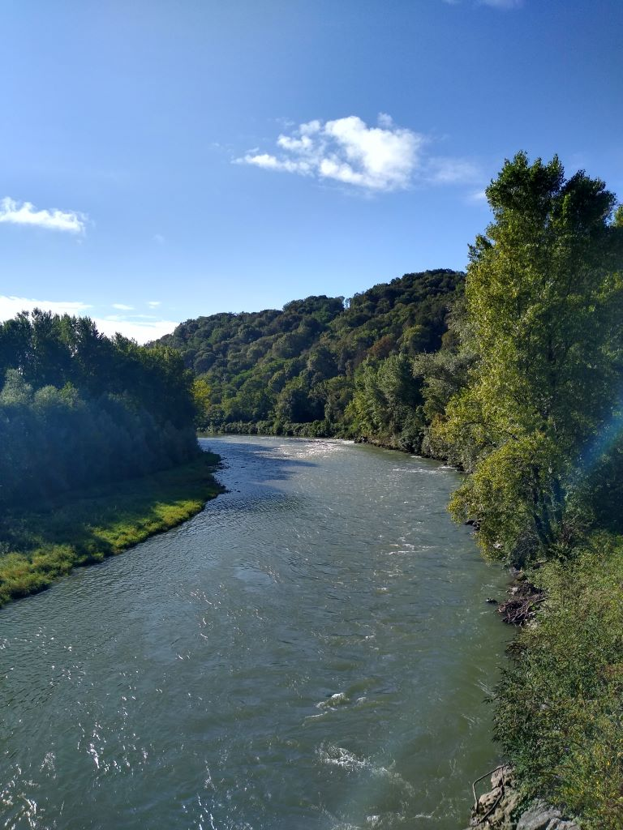
and just about half way was following Rita when I spotted a voie verte (Route 81) signed to Bayonne
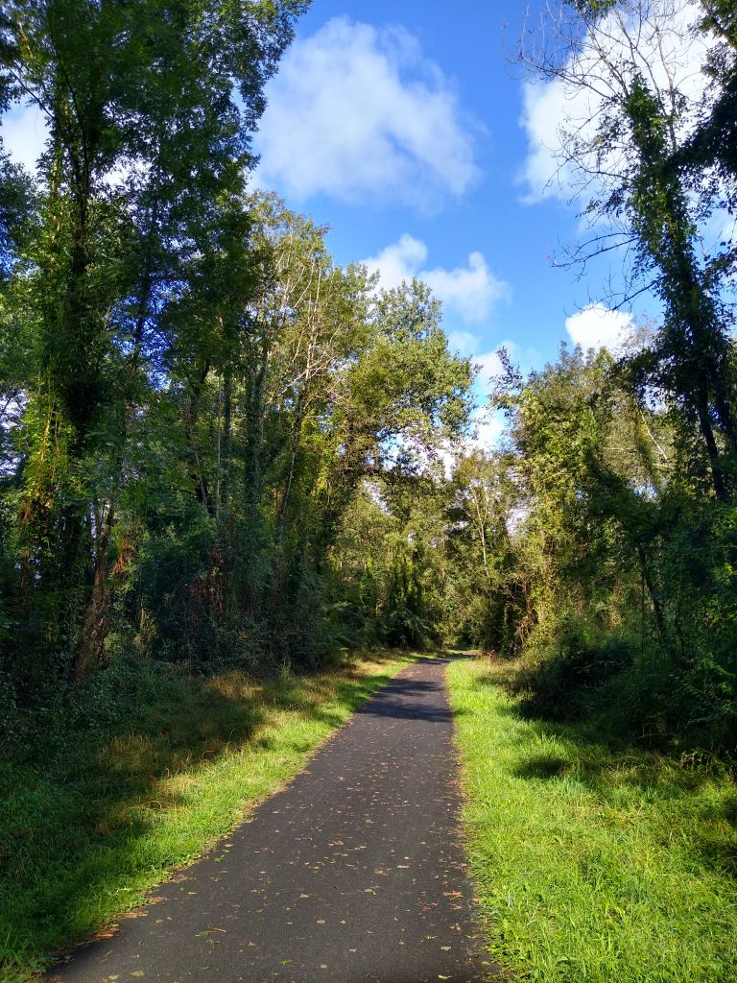
so I diverted without checking the map to see where it was going. It was a lovely surfaced road and, shortly after passing through an 850 metre tunnel that was lit in sections as I passed
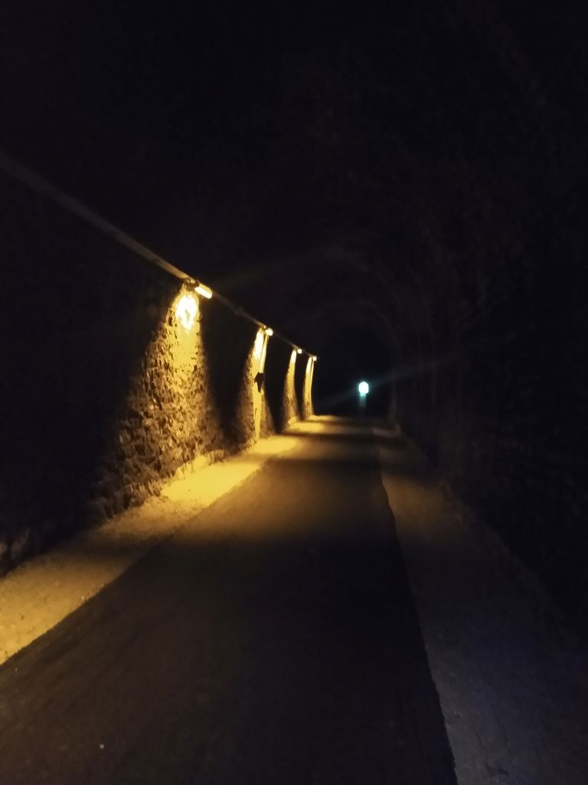
I thought all was going swimmingly, when I saw another sign on the track saying Bayonne 78 kilometres! Consternation, knowing that when I hit the voie verte I only had about 50 clicks to go on my pre-planned route. I did what I should have done at the start and consulted the map which showed I was being taken way south on a big loop. I found a road that would take me back to my route but it added about 10 miles to the journey, an extra that I could well have done without. However that galvanized me somewhat and I got back on track quickly on a good road and then followed the river closely for the final 20 miles. By now the Gave de Pau and the Gave d’Oloron had converged and, with the addition of the Bidouze formed the river L’Adour
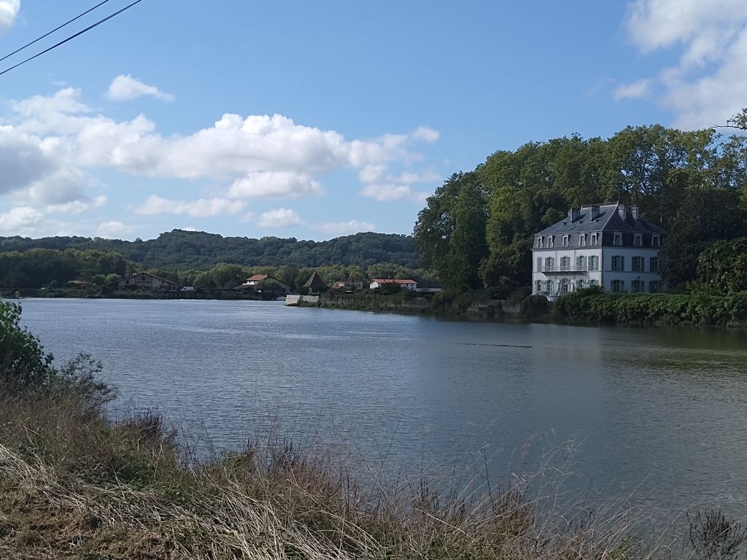
which flows into the Bay of Biscay about 6 miles north west of Bayonne
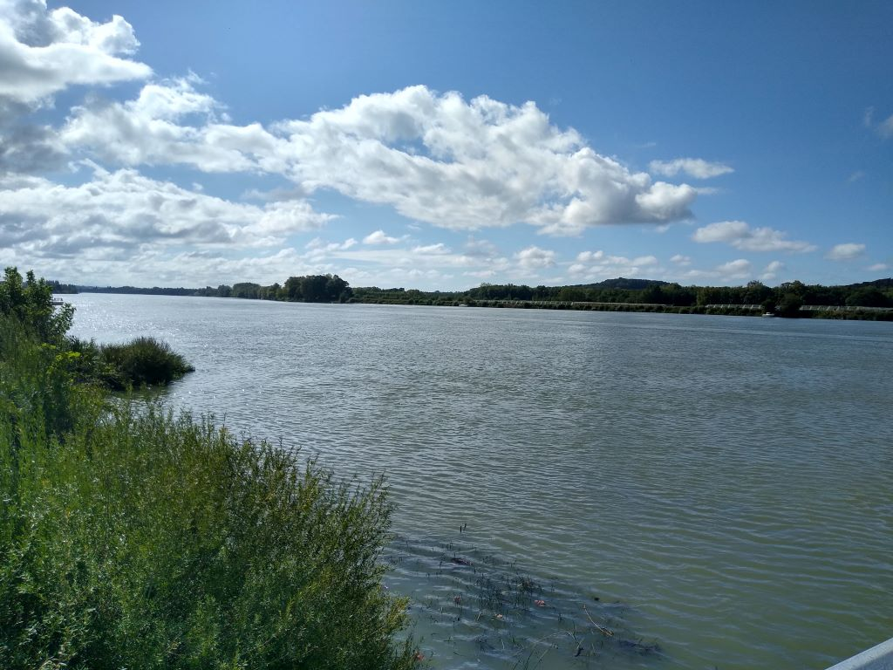
The last ten miles were really hard work, my bum was sore and I was looking for any excuse to stop, which I did several times on the cycle track that runs between the road and the river, but I finally made it to the Ibis Budget at about 1745.
It’s been a hard day with the route change and I’ve covered over 80 miles, albeit without much climbing, but I’m hoping for a more restful day tomorrow when I have about 60 miles planned, again on the flat, as I head north through the Landes Department, having taken a bit of a detour down to the Atlantic Ocean at Biarritz.
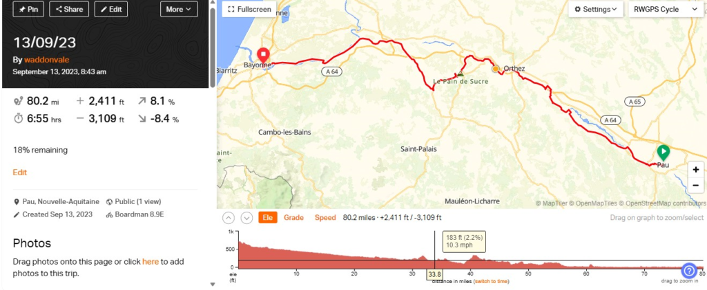
Day 9 – North through Les Landes
The Ibis Budget Hotel sits on a busy road just short of the Adour river. It is, unfortunately on the wrong carriageway for my approach by bike yesterday evening so I had to do an extra circuit before taking to the pavement so that I wasn’t trying to turn across three lanes of angry traffic. I was checked in by an english speaking young man who gave me a room on the second floor. As with Premier Inns, Travelodge and all the Accor group hotels the bike goes in the room with you so when I asked about a lift he changed my room to the one nearest reception on the ground floor: result. It was a room with an extra pull down bed so there was plenty of room for me and all my kit. The window opened wide onto a patio behind the breakfast room so my clothes were hung close to it and dried overnight.
In the same building was a Courtpaille restaurant. There was a three course deal including a small beer. I had a large one and paid the difference, starting with a summer salad on toast and then onto a very well cooked tuna steak and finishing with apple tart. A very nice meal for under 30 euros including the beer.
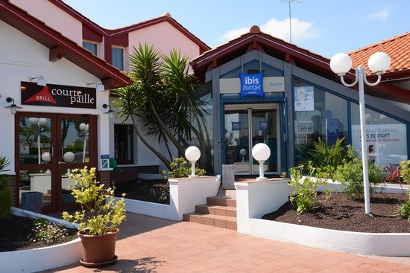
I’d paid for breakfast which had all the usual, including cheese, ham and boiled eggs and feasted well before leaving just before 10. Having left the room and posted my key at reception I realised I’d left behind my helmet and gloves. There was noone on reception but one of the maids cleaning the rooms was able to let me in. I was able to avoid the busy main road and make my way down to the river before crossing by a bridge with a cycle lane that took me into the old part of the town
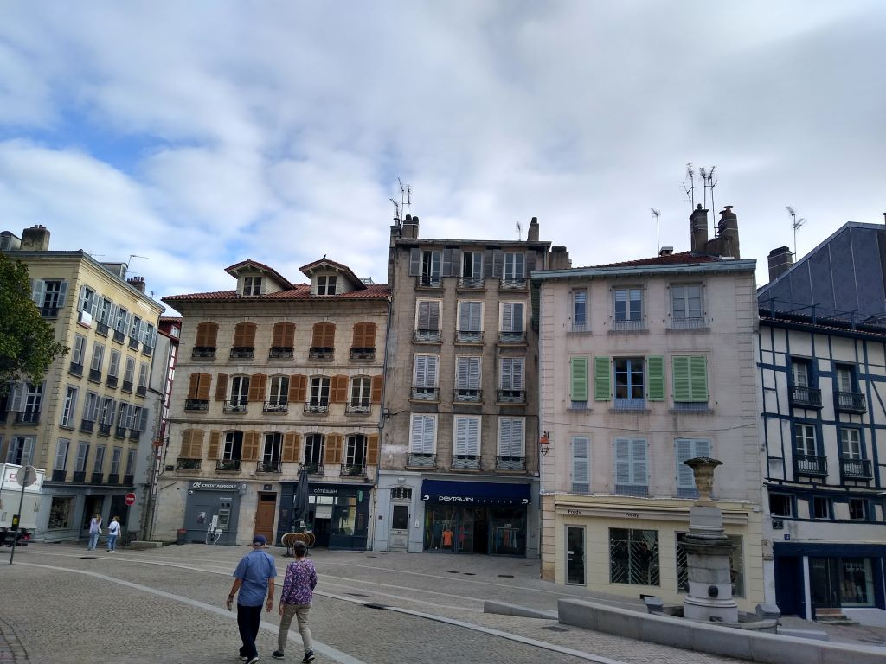
It’s an attractive old town with a cathedral that I didn’t go inside but which was started in the 13th century but not completed until the 19th. It’s on the Santiago de Compostela pilgrimage route so is well visited. I was heading for Biarritz for no particular reason except it seemed like a good idea. There was quite a substantial climb up from the Adour river before I dropped down into Biarritz about six miles on. There were cycle lanes everywhere down to the sea front where I had my first glimpse of the Atlantic Ocean.
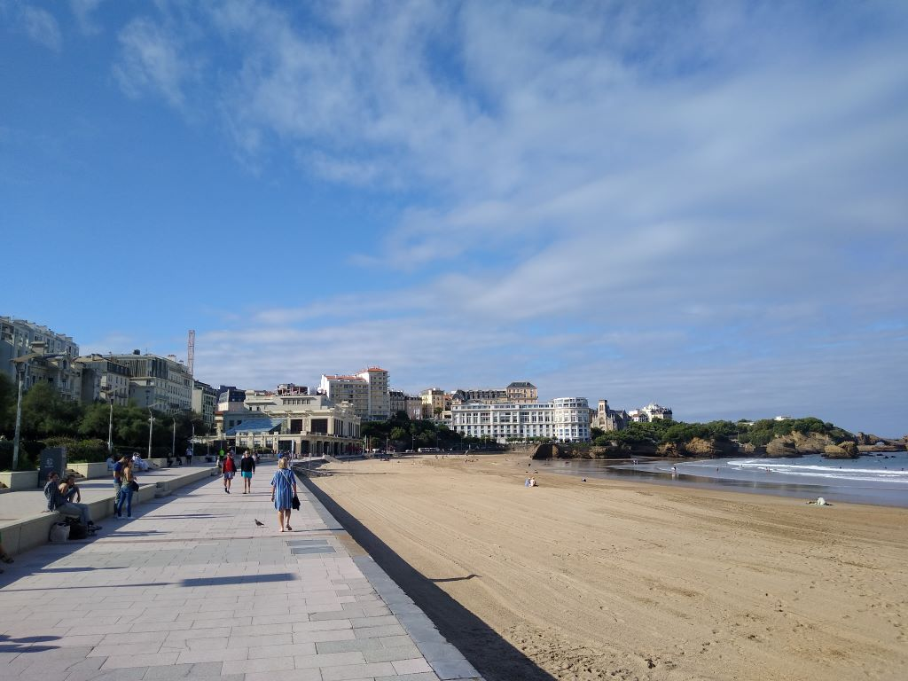
Unsurprisingly not very busy this early in the day and late in the season but there was an espadrille kicking contest on the beach that was causing much merriment. The challenge was to kick an espadrille off your foot as far as possible down a marked piste: whether or not there was any prize I didn’t stay to see. I carried on climbing up away from the sea past the grand Hotel du Palais, built as the summer residence of Empress Eugenie in 1855 – not a bad little pad!
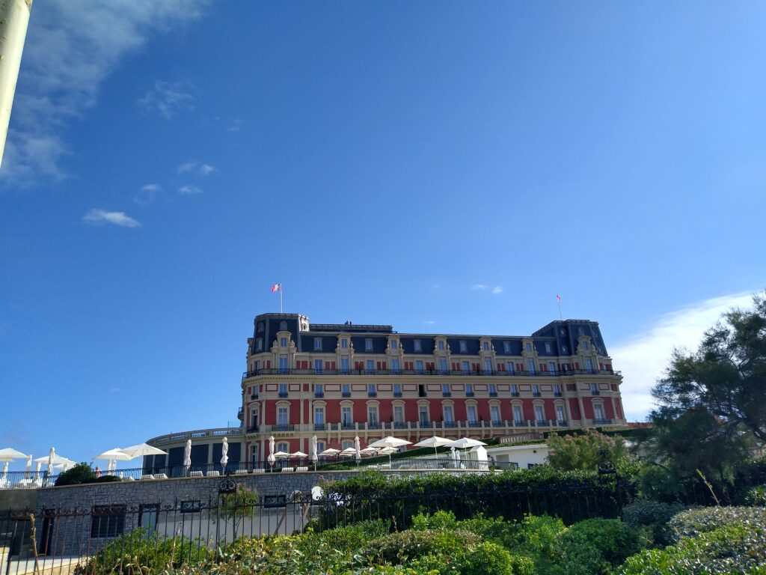
and the lighthouse before looking down on the surf rolling in from the Bay of Biscay.
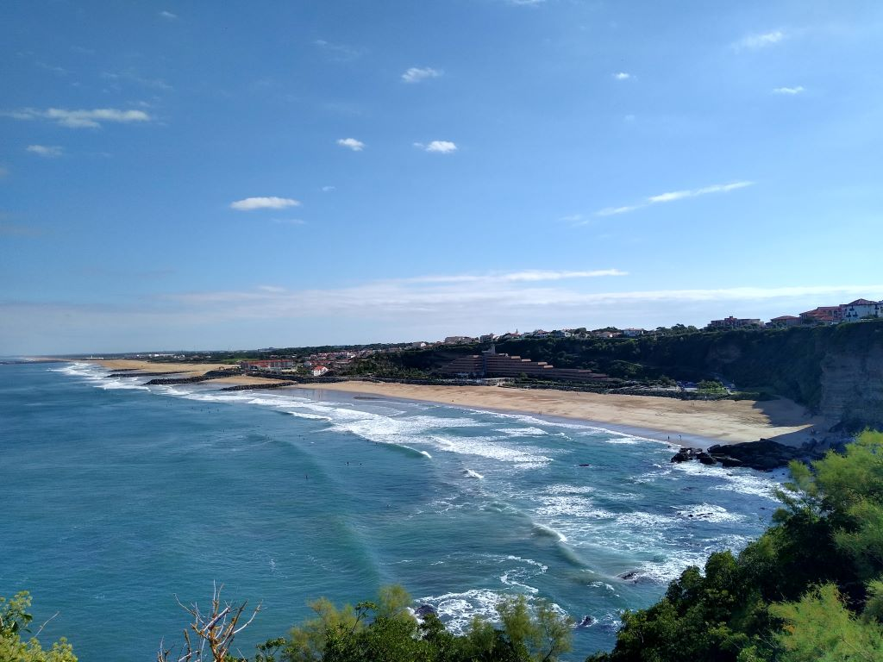
There were plenty of boarders out there waiting for waves and the conditions looked good in the late summer sunshine. I followed the coast round until I reached the mouth of the Adour river with the docks on the far side.
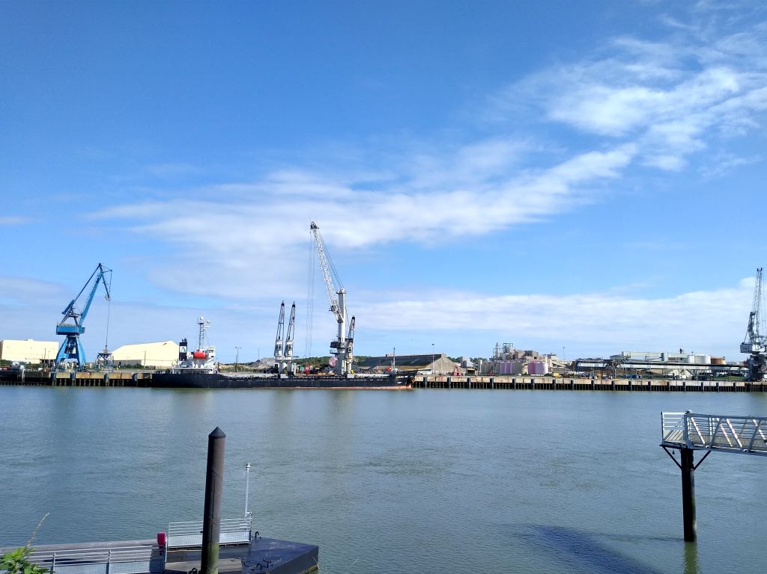
I completed my ten mile loop re-crossing the river by a different bridge, the furthest down-stream and continuing my way north through housing estates but always on cycle lanes or pavements with cycling allowed before I finally got out of town and onto the cycle roads that were the highlight of the day. Until the last ten miles of the journey I didn’t have to go on a road that didn’t have a cycle lane and many of the roads had proper cycle tracks alongside them. The Voie verte systems of France are amazing and today were being well used mostly by people with motorised bikes like mine though there seemed to be a number of what I would term motorised bikes that didn’t require pedalling.
I passed throuigh CapBreton and Soorts Hossegor with a smart marina surrounded by upmarket flats and restaurants that were doing good business at lunch-time.
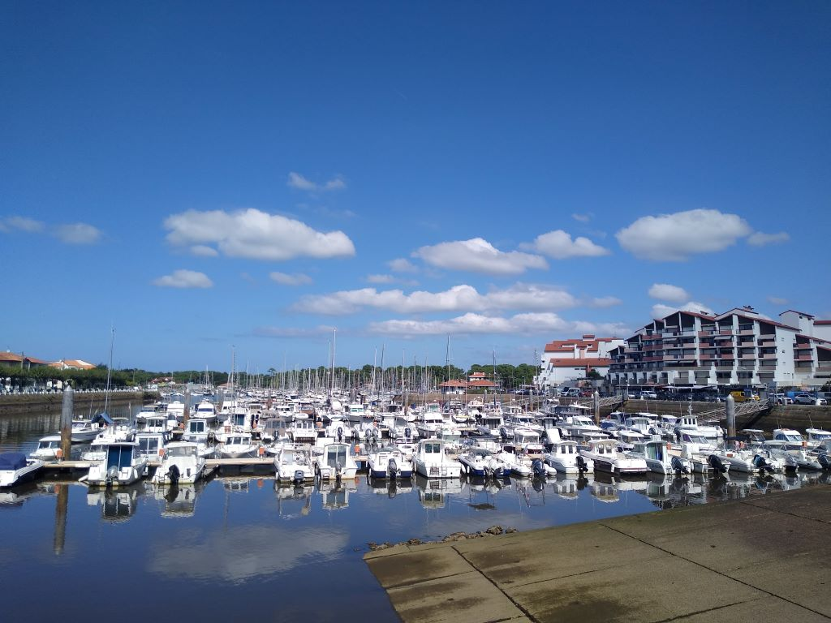
The cycle roads continued to Le Estagnots where I stopped at a surf shop for a very nice Poke salad and beer served by a German girl. As I was leaving, after my vegan ice cream!, an Aussie, who ran the surf shop came out to ask about my journey and seemed impressed by what I was doing. F—in’ ding dong mate.
I now had about 15 miles of voie verte with lots of people enjoying the sunshine as far as Berguin
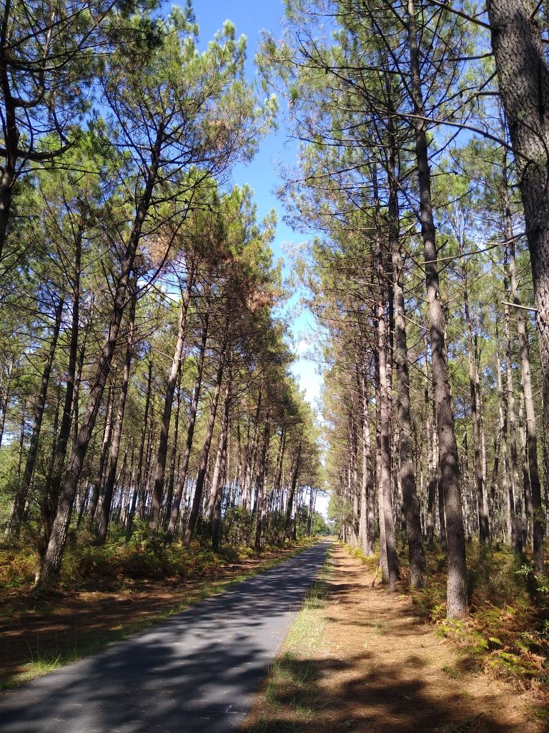
where the cycle roads ran out completely and I had to compete with traffic for the first time in the day. There wasn’t even a hard shoulder so not very pleasant at times. I can only imagine that there’s not much tourism beyond the Etang de Leon so they’ve not bothered with cycleways.
Anyway I reached my destination Lit et Mixe which obviously has quite a lot of tourism and am staying at the Club Atlantique which is almost closed this late in the season. The pool is turbid and there are very few punters around. I ate at lunchtime so I won’t bother tonight. It’s been a pleasant day of cycling with very little climbing although there has been quite a lot of minor ups and downs, probably because underneath it all are sand dunes. My northward journey continues tomorrow
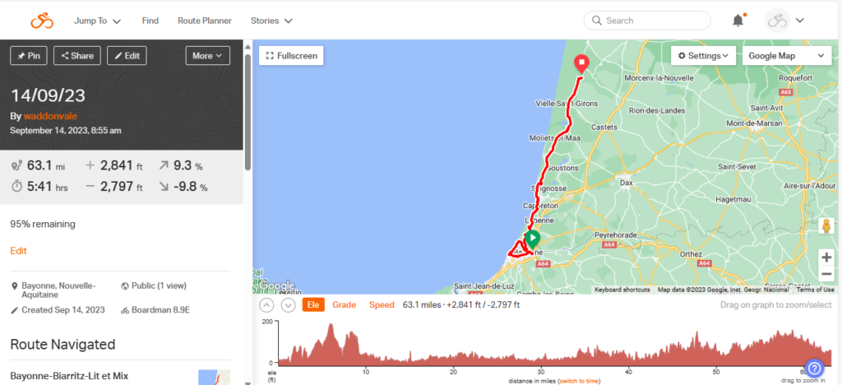

Day 10 – still in Les Landes
When I arrived at Club Atlantique in Lit et Mixe it looked pretty dead. After a brief wait Madame appeared from a back room and booked me in. Her English was worse than my French so we got by in Franglais and she showed me to Cabin 100 which had a double bed and a shower room. The whole site extends over 7 hectares with cottages that sleep up to 5 people but there were very few occupied at the moment. The first major problem was that the Wifi didn’t work in my room so I had no option but to take phone and computer to the poolside bar and write the blog there. The upside was that I met Stan(islas). I’m not sure of the hierarchy but he was either owner or manager and spoke pretty good English. I had a couple of small beers to wash away the journey and settled down to the blog which I completed in time to watch France v Uruguay in the company of Stan who was quite vociferous. I’d seen enough by half time and went back to the cabin thinking I might watch some of the second half on the TV in the room but after wrestling with the controls all I could come up with was this:
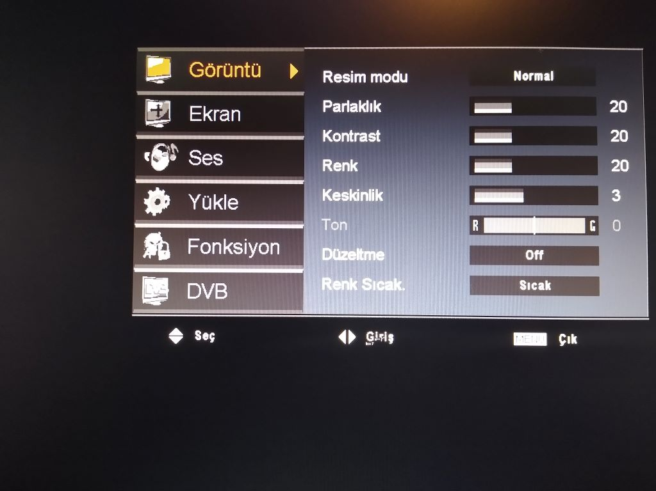
I think it’s Turkish but I’m not sure. Anyway it didn’t help me watch any tele so I went to bed and slept pretty well with my bike in the room. Breakfast was standard french with some slices of cheese and some yoghurt and apple. It was fine for the day ahead.
I bumbled about a bit getting ready to go and didn’t leave until 0930. I wasn’t sure what to expect as it’s a while since I planned the route which was across a part of France that is relatively tourist free due to it being the Landes Forest, the largest man made woodland in western Europe. It’s size is reflected in the fact that I shall still be in it all day tomorrow. It is heath land, basically sand with heather and bracken growing readily and the main timber is Maritime Pine (Pinus Pinaster) which is now used largely to make particle board although I came across sawmills during the day. A major storm in 2009 demolished a lot of the forest so there is substantial new planting. This is also Gascony home of D’Artagnan, foie gras, grilled chestnuts and Bordeaux wine but more of that tomorrow.
I made my way through the villages of St Julien-en -Born and Mézos before coming across the first problem of the day when my planned route took me down an unsurfaced track through the forest. I looked at the map and decided the alternative would take me out of my way and went for it past a local foraging for mushrooms.
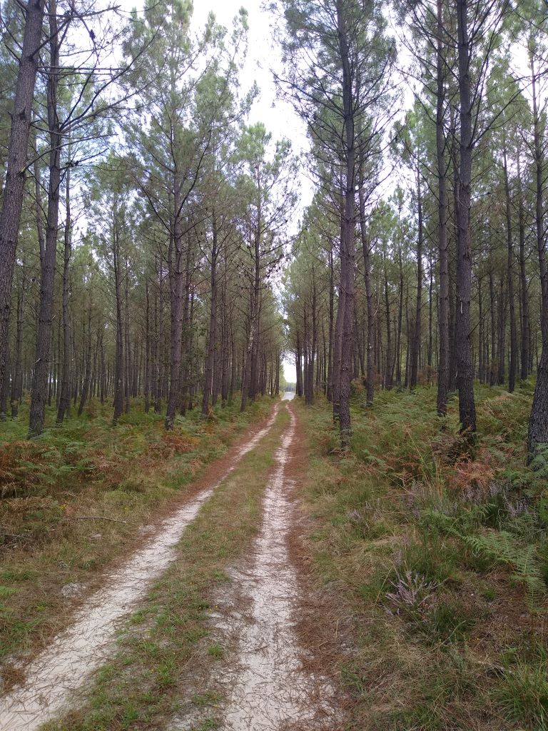
Not a good decision: cycling on sand is hard enough anyway but doing it on a bike with loaded panniers is suicidal. I got off and pushed, fortunately only for about half a mile before I came across a tarmac road.
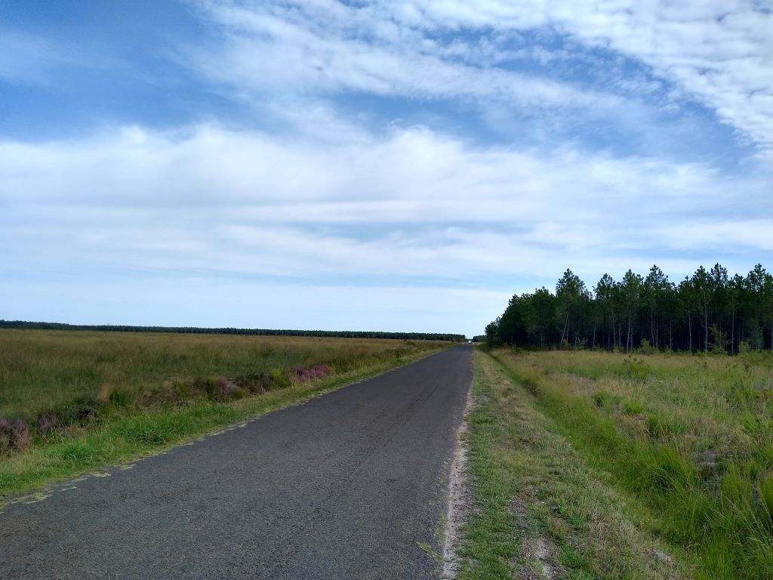
The rest of the morning was spent on straight, narrow single track roads. Fortunately not a lot of traffic but what there was travelled fast and I felt vulnerable.
I was about 30 miles into the journey at Parentis-en-Born and lunch beckoned. There is a street in the middle of town with four restaurants in a row. I settled on Chez Flo which was offering a Menu de Jour at 19 euros for three dishes.
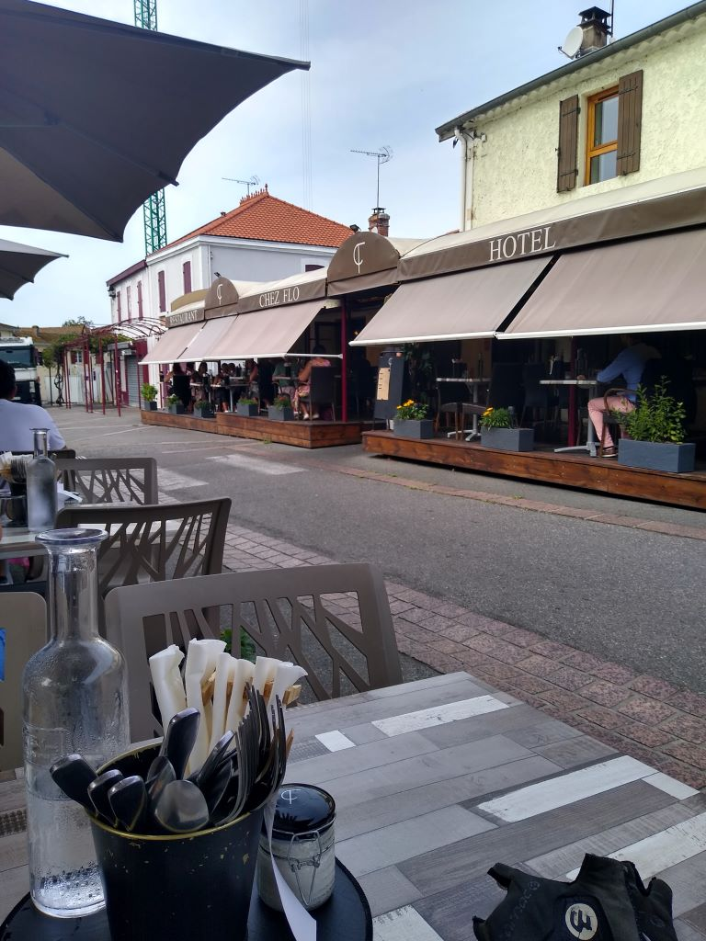
I was able to park the bike close to my table and enjoyed a small beer and a carafe of water whilst waiting for a very well dressed and tasty vegetable salad and an excellent dish of cod fillet on a custard tart with broccoli
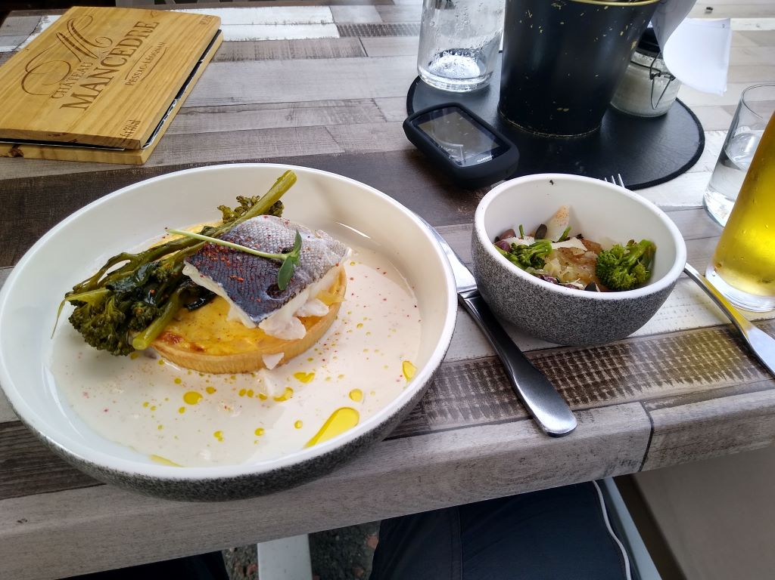
Pudding was a coffee cream with peaches and brandy snap. A very nice meal that will keep me going until breakfast tomorrow. Chez Flo and its surrounding establishments were doing an excellent trade.
Unfortunately for me the next 20 miles were on the same straight narrow roads that I had suffered this morning.
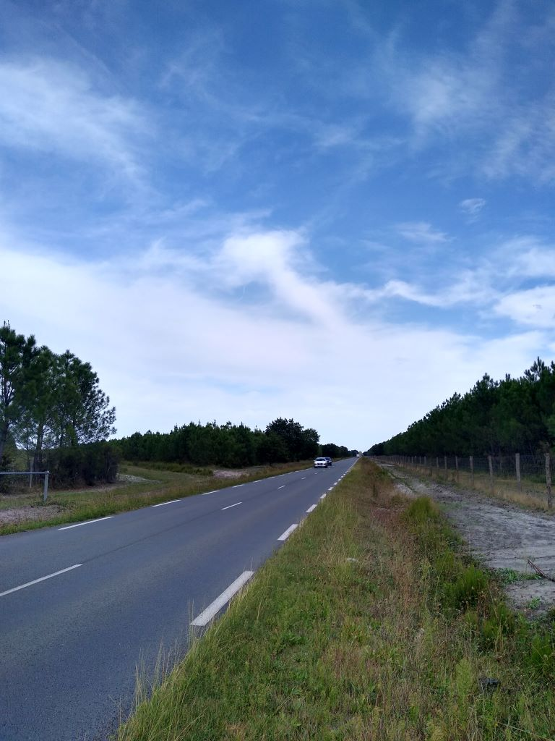
It is made harder because there is nothing to relieve the monotony. Even a large solar park didn’t help much and I was stopping regularly to drink. Finally 50 miles into the journey I found a cycle track at Mios that took me the rest of the way to Andernos. It was well used including a number of cyclists towing their dogs in trailers. I fancied a bottle of claret to enjoy whilst composing the blog (4.19 euros and very drinkable)
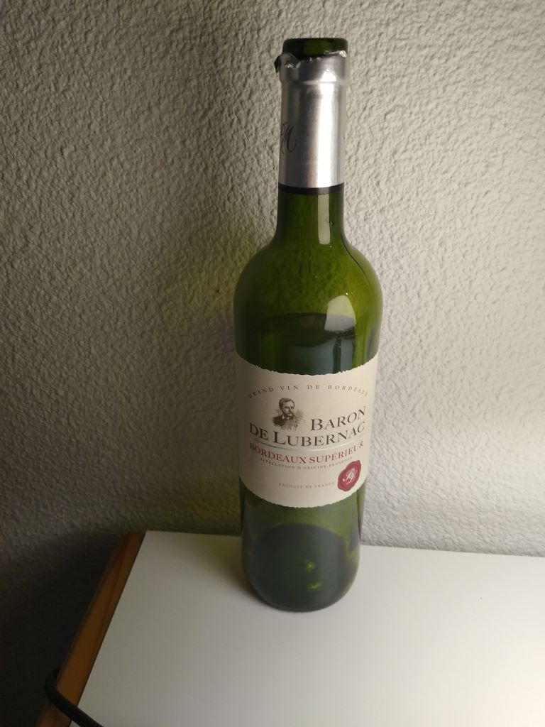
so stopped at a Carrefour about four miles from my destination which is on the Bay of Arcachon which extends about 8 miles inland from the open sea. It’s a popular destination for yachtsmen making their way south from Brittany to Spain and is the only Basin in the Landes that is still open to the sea. I passed by several Etangs today that would have been similarly ocean bays in the past but have now silted up and become inland lakes.
I’ve a similar disatance to travel tomorrow but it appears to be almost exclusively off-road. It’ll still be hard work peddling all the way but not having to cope with fast moving traffic will make it a lot more enjoyable.
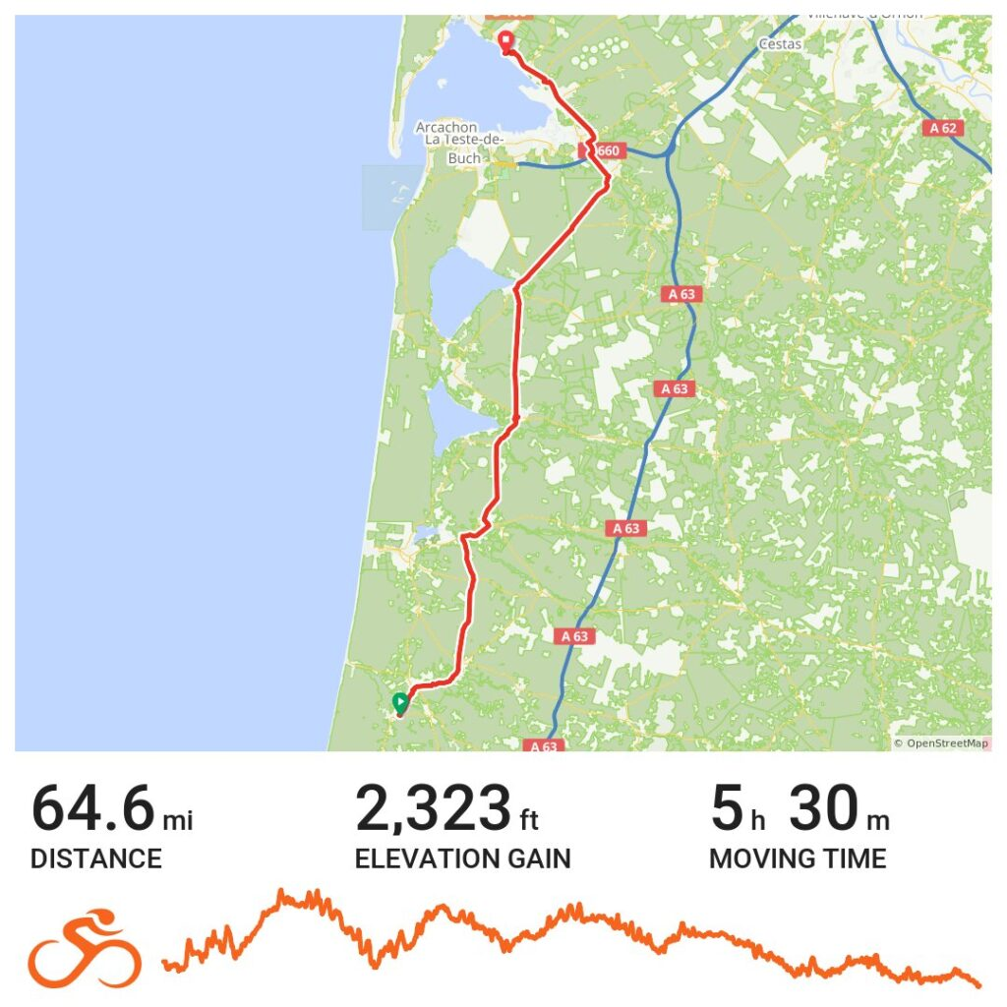

Day 11 – to the Medoc
Andernos siiting as it does about 30 miles from Bordeaux on the Bay of Arcachon is a popular holiday resort, offering sandy beaches and boating facilities. Capfun are an international resort operator specialising in camping but they have a hotel at Andernos called L’Oceane with a restaurant attached.
There’s a very efficient team on reception who speak English and soon gave me a key and directed me to my room which was, unfortuately up two flights of stairs, not much fun with my heavy bags. The main bugbear, however was that they had no undercover bike storage and very little security for them, although they do have constant video surveillance. I locked the bike as best I could and hoped for the best. Of course it rained overnight so I had a wet saddle when I retrieved the bike this morning. The room was quite spacious with an enormous double bed and good shower so no complaints on that front. I paid for a good breakfast including eggs, ham and cheese and you could take as much as you wanted. In total it was the most expensive night I have had on this trip.
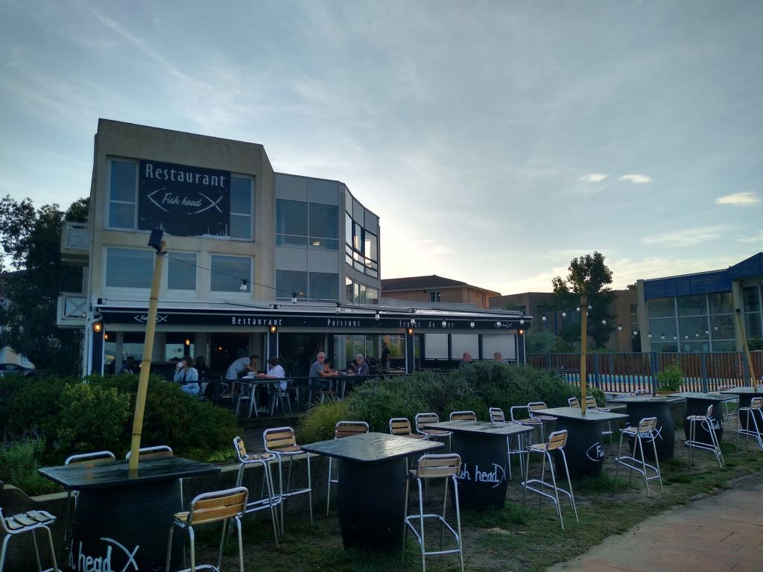
I got away at 0938 and bumbled through the town for a while
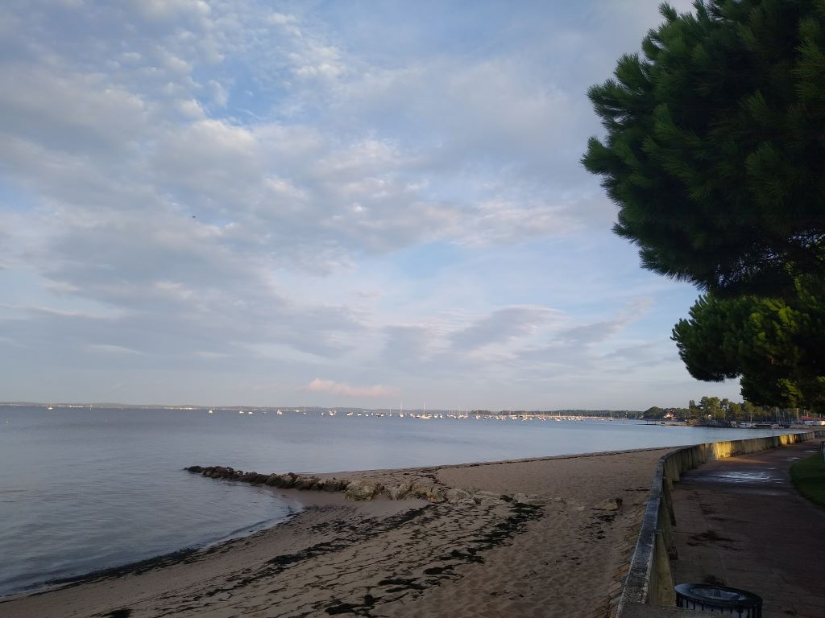
before heading back to the cycle route that I left last night that continues north to the Medoc peninsula which is bounded on one side by the Atlantic Ocean and the other by the Garonne estuary and river. The area by the Garonne is the most famous wine growing region in western France with all the highest quality Bordeaux vineyards producing wine, some of which sells for thousands of pounds a bottle.
The area I was travelling through, however is given over to forestry as I mentioned last night. Miles and miles and miles of it.
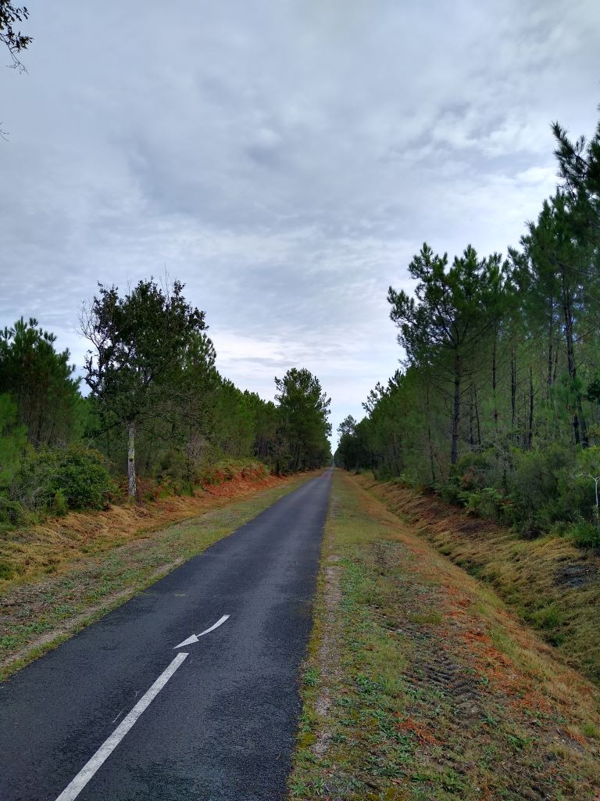
I shouldn’t complain too much. I was cycling most of the day on flat well tarmacced track with no vehicular traffic but, it does get a little tedious. The only time you see cars is when the track crosses roads and generally cyclists have the right of way. You are also fairly hemmed in by the forest which gives no views. Occasionally I came across areas that had been felled and some that had been replanted so it was not all high forest.
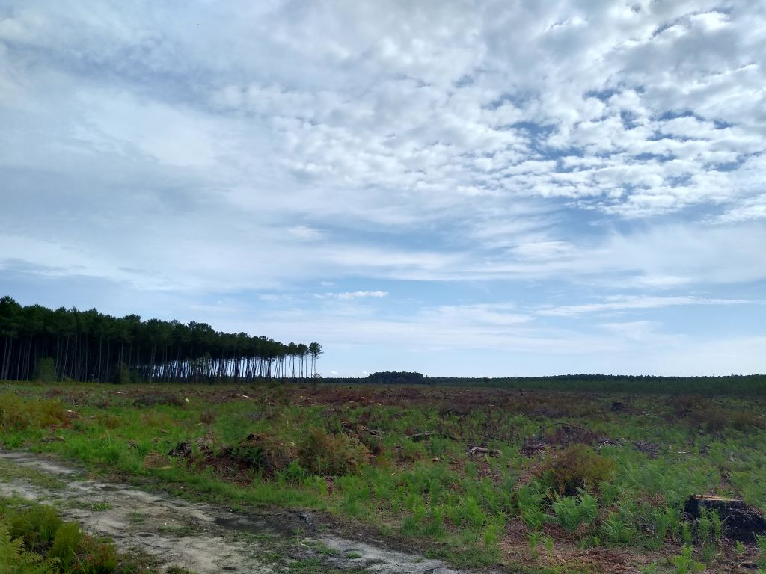
The weather was good for cycling, enough cloud to keep the temperature down and stop sunburn although I always wear long sleeves to protect my arms.
I passed by the large inland lakes that have been left behind when their outlet to the sea has been silted up and sand-dunees have formed. I investigated the Etang de Lacanau which is home to small boats.
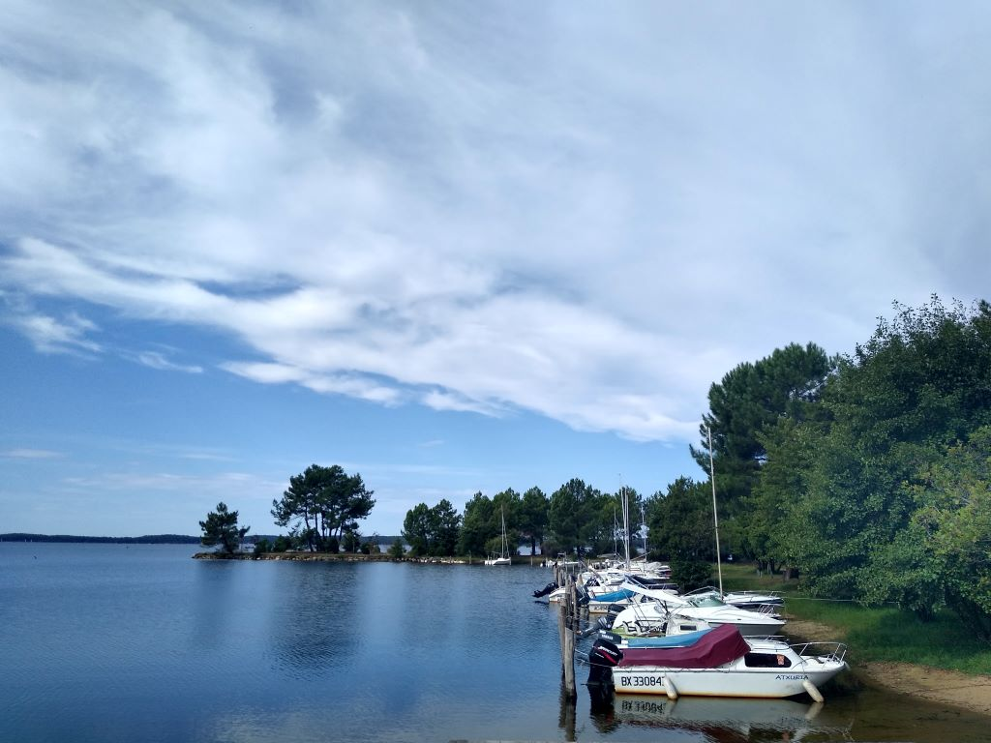
and this took me off my planned route to the extent that I had trouble getting back onto it and ended up doing a bit of cross-country. Fortunately the ground was quite firm and I didn’t have the problems with sand that I experienced yesterday.
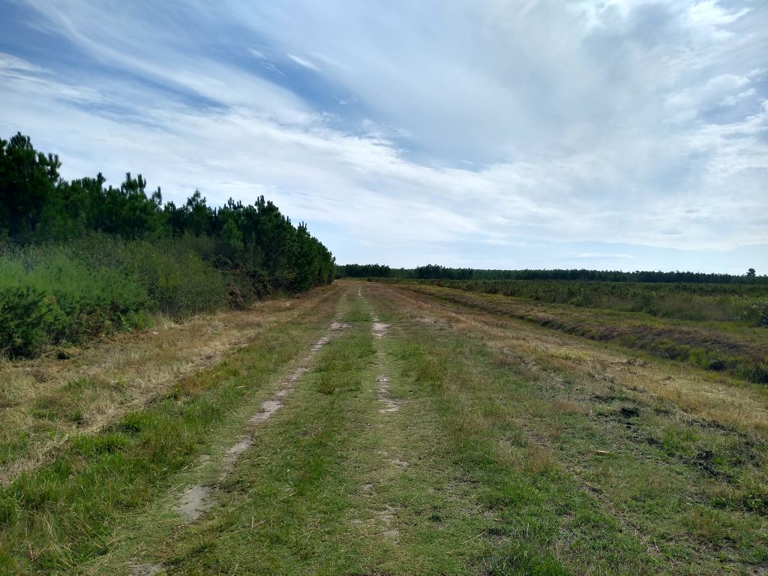
Once back on track the scenery changed gradually. Suddenly there was a lot more mixed woodland and the vegetation changed
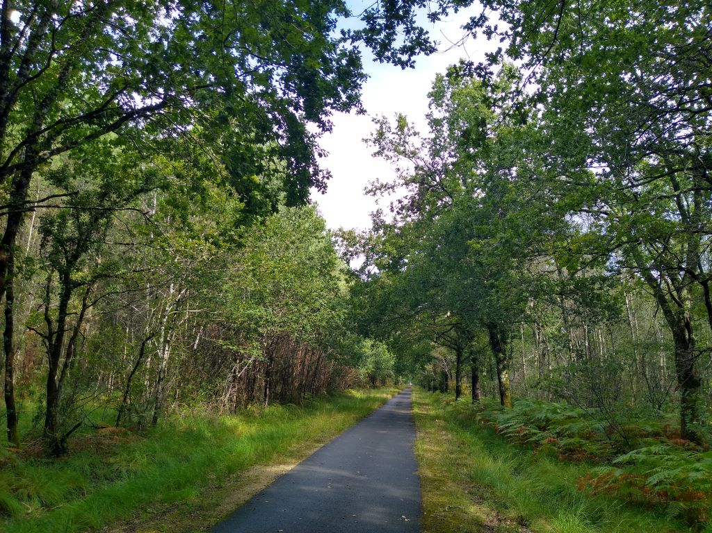
I was now by-passing the Lac d’Hourtin. It is much bigger than Lacanau but I couldn’t see it. It was getting on for lunchtime and I was about half way into the journey when I reached the town of Hourtin but I couldn’t find anywhere suitable for the midi so kept going with a view to eating tonight instead. I saw a sign to Hourtin plage so thought I would investigate. A winding cycle path took me up and down and took me over the biggest climb of the day!
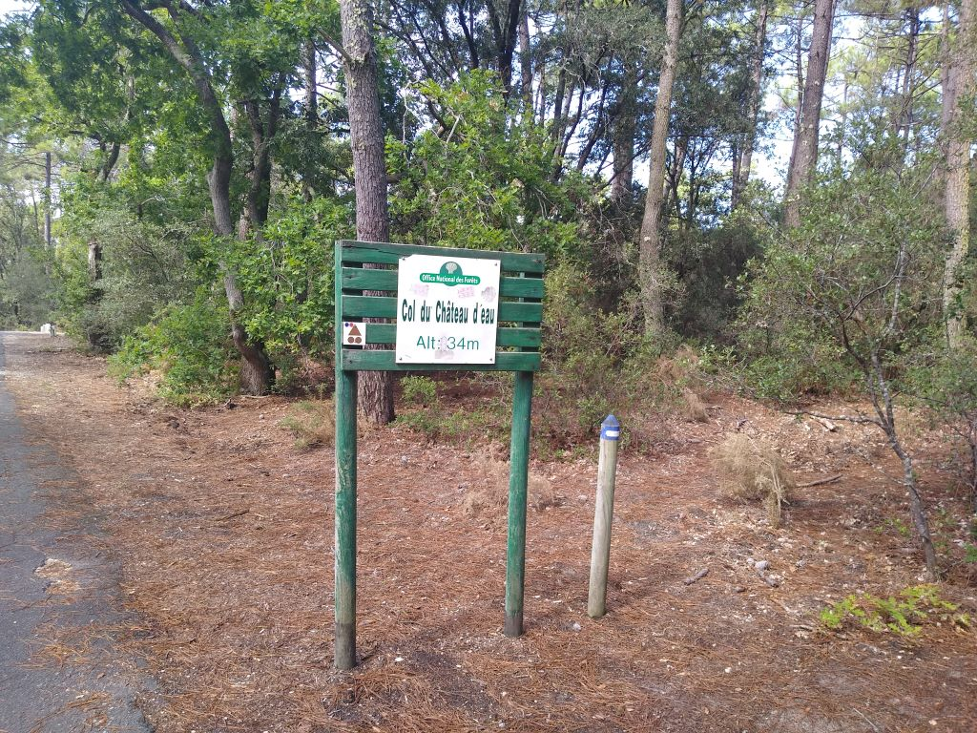
The beach at Hourtin is backed by tall sand dunes and there were several families enjoying the weekend sun
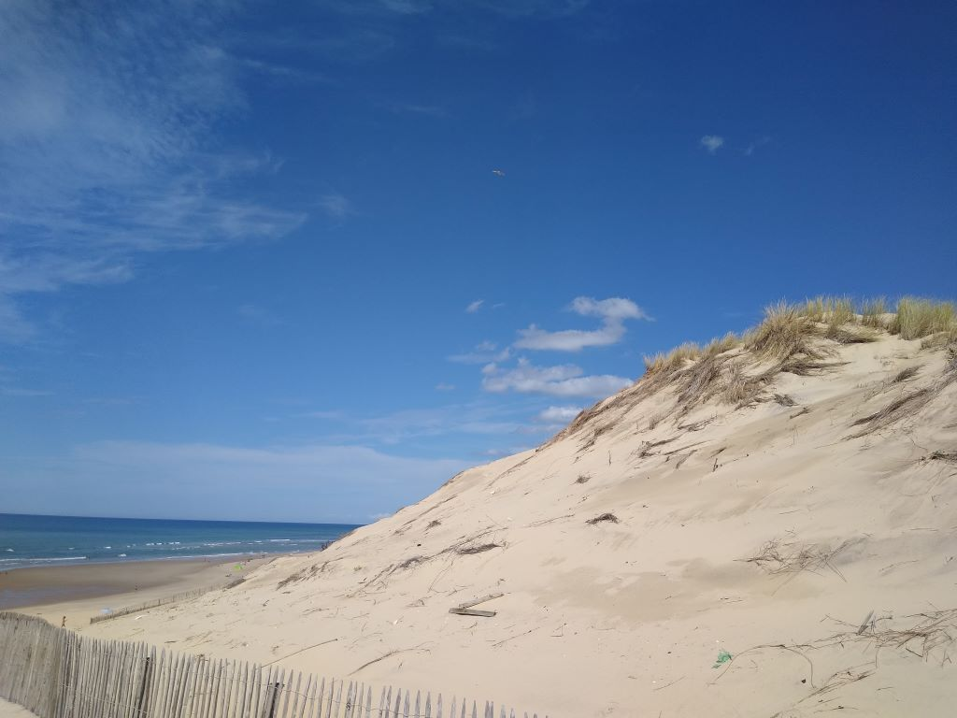
I made my way back to the cycle path which continued to Montalivet-les-Bains, running alongside the grandly named Avenue de L’Europe. In town I spotted an Aldi and stopped to buy a bottle of wine which I am enjoying as I write this, some apple juice to slake the immediate thirst and some chocolate cakes to see my through to supper. As I stopped Rita went haywire, I think because my phone decided to turn on battery saving without being asked. As a result the map from then on is nonsensical and overstates the mileage covered which, I think was about 63 in total and not 80 as shown.
I also ran out of cycle tracks and had to join main roads, although they weren’t busy. It was strange having dedicated cycle tracks all day and then, with ten miles to go not even having marked cycle lanes.
The beach at Montalivet was busy with cars parked along the road for about 5 miles. I didn’t investigate: it would have been a trudge through the dunes to get to the sea and one beach is much like another. There are huge campsites and trailer parks along this coast which must do wonders for the local economy.
The last ten miles were a bit of a slog to reach Soulac-sur-Mer where I am staying the night before crossing the Gironde estuary tomorrow morning. The town looks busy and I shall investigate later when I go looking for food.
Day 12 – Ferry cross the Marais
Soulac-sur-Mer was looking busy when I pitched up at La Dame de Coeur a bar with rooms. There was trotting racing on the box and plenty of punters interested in the outcome. I arrived at 1650, ten minutes before the official book in time and everyone seemed busy so I hung around until the town clock struck five and then introduced myself to William, the barman and one of the family proprietors. It took him a lot of poking at the computer screen to recognise me and then produce a bill for my night’s stay but, eventually, I paid a few cents over 70 euros for B&B and was shown my room and told to leave my bike in the hallway.
I did the usual and then went down for a large beer (8 euros) before wandering into town to look for some food. There were several restaurants on the seafront doing good business
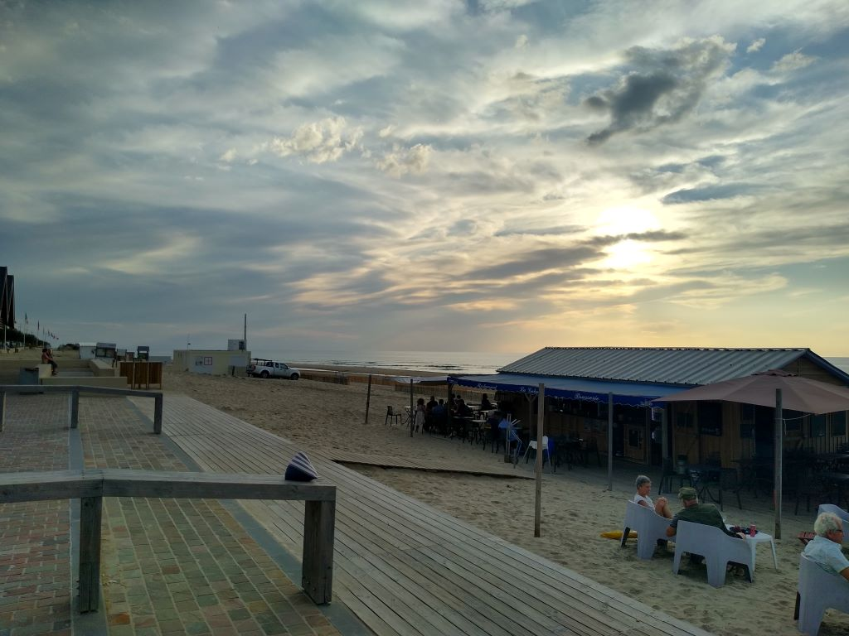
but I opted for Le Station, a couple of streets back and had a seafood salad as a starter and then an excellent dish of perfectly cooked bream with risotto and vegetables. The Clafoutis to finish was disappointing but I felt well fed as I went back to write the blog and drink the bottle of wine I’d bought earlier.
Breakfast this morning was served by, I guess, William’s mother and was the usual french croissant, pain au chocolat and bread with butter and jam and a glass of orange and a cup of tea. No meat or cheese on offer.
I had about 30 minutes to ride to the Bac du Verdon-sur-Mer which is where the ferry departs the Haut Medoc bound for Royan on the other side of the Gironde estuary. I made this ferry trip 8 years ago when I cycled down to the Med and back, only then I cycled up the east coast of the Medoc past all the fabulous vineyards that have given the wines of Bordeaux such world renown. I was pleasantly surprised to join a piste cyclable in Soulac that took me all the way to the ferry and I was there in plenty of time for the 1015 departure.
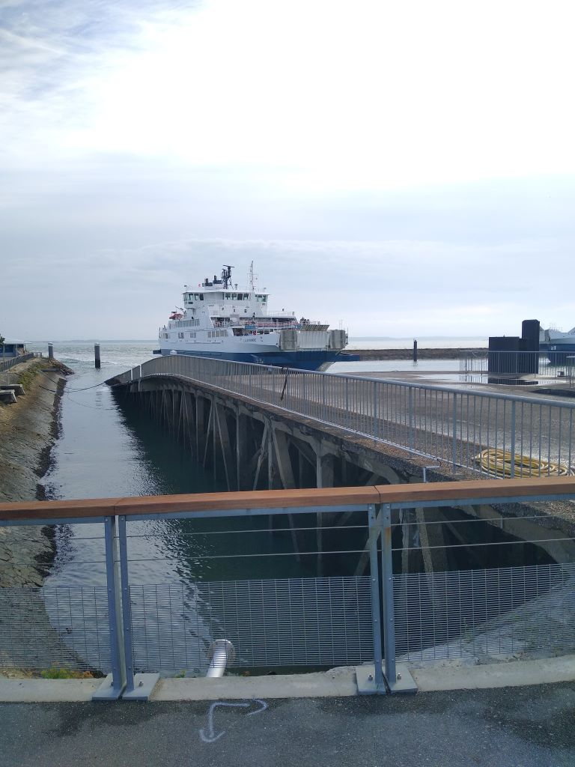
Boarding is simple: you pay 5 euros and are given a ticket which you show to a matelot who scans it and lets you through. There is a pedestrian route to keep you away from the cars and you put your bike in a designated space – no hassle. At the other end you simply join the traffic leaving the ferry and cycle away. Amazingly I found my route immediately, took a couple of pics
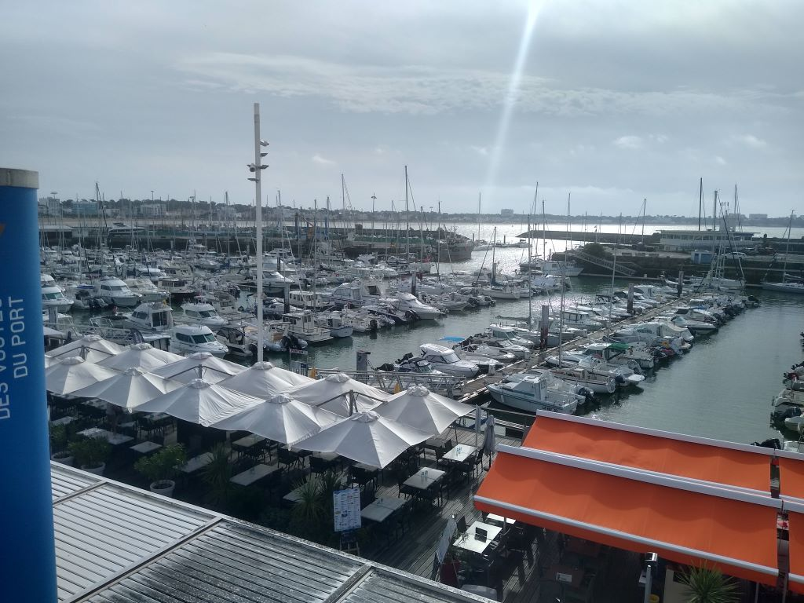
and was through Royan and out into the country within twenty minutes. The navigators were behaving well and I was changing direction regularly on minor roads as I made for the Marais, the marsh area behind the sand dunes. The estuary of the Seudre river that disgorges into the sea just south of the Ile d’Oleron is the perfect breeding ground for shellfish, particulary oysters and as you pass the ponds that fill and empty with the tide you are offered degustation. My route took me past L’Eguille at the very top of the estuary, and I made my way towards the inland marsh that is characterised by a geometry of canals and waterways, each with a road of sorts beside it. I took much the same route for the first part of the journey as I had in 2015. The road surfaces were rough, varying from worn tarmac to dirt-track and I had about ten miles of them.
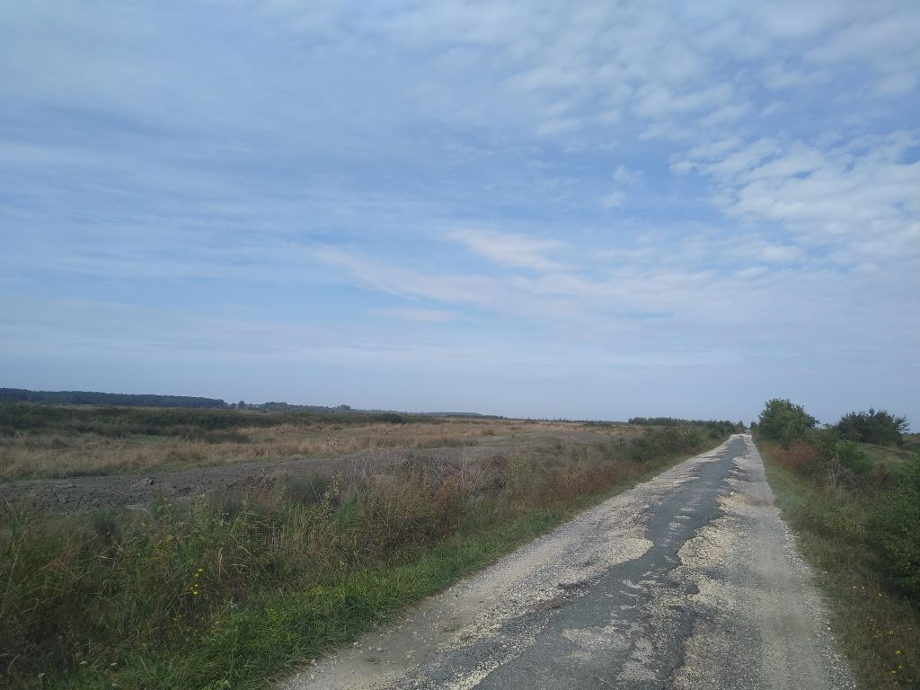
I cycled with one foot out of the cleats so I could put down if I hit anything too horrible but all was well until the hard road ran out
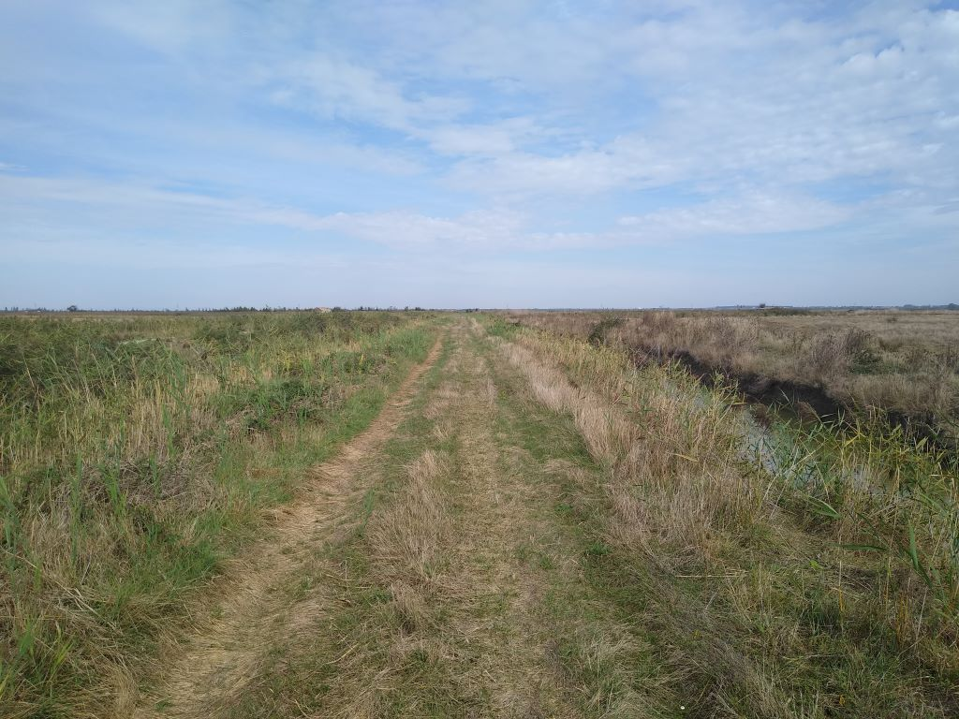
and I found myself on the wrong side of a canal for a couple of miles until I found a bridge (of sorts) to take me back onto something easier
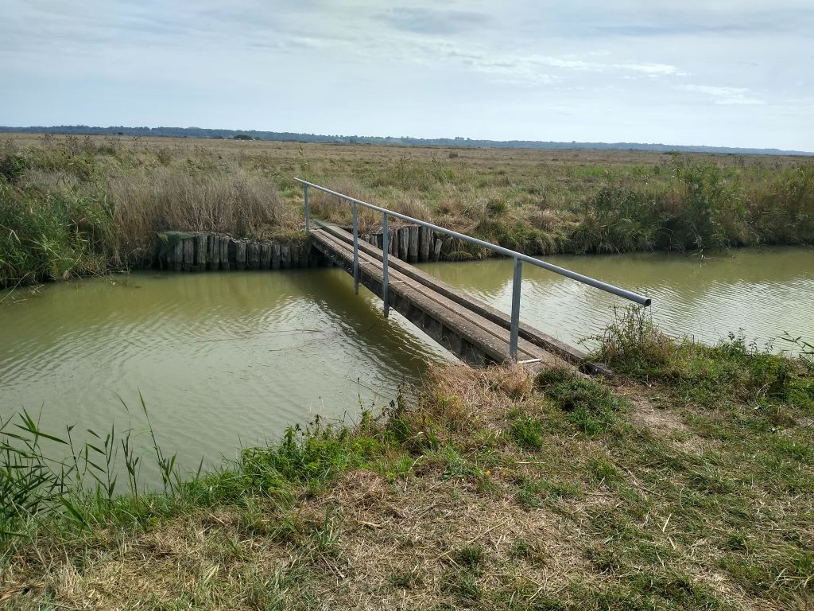
Eventually I found myself on a canal towpath, not tar but easy cycling to the village of Saint Martin about 35 miles into the journey.
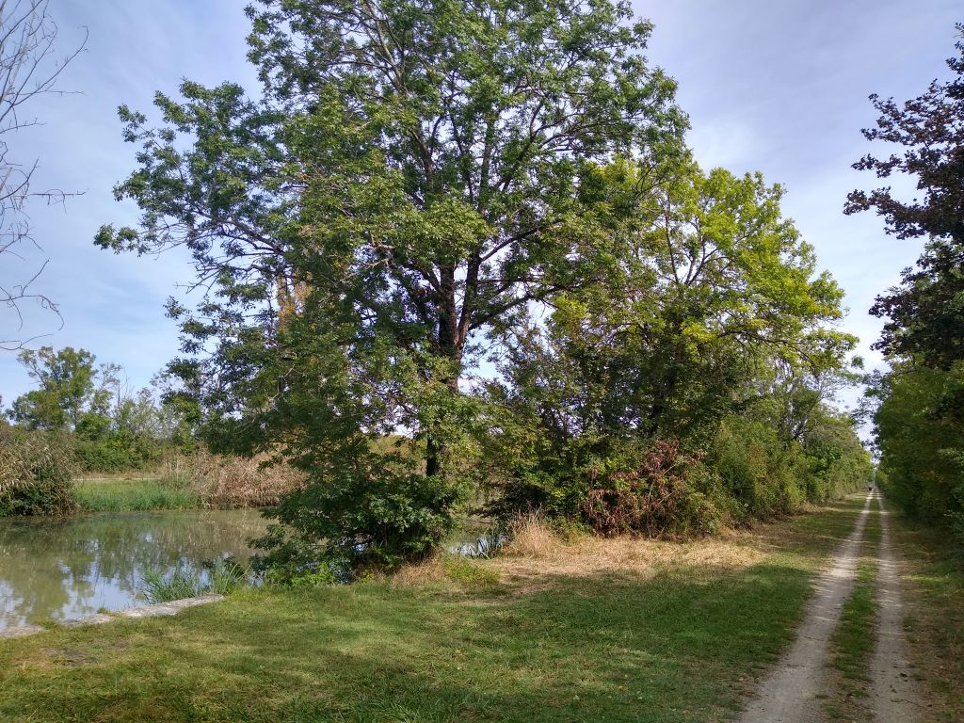
A couple of miles further on, apparently in the middle of the countryside, I was suprised to see what looked like (and indeed was) a transporter bridge. The last one of these I had seen was in Newport on my circumnavigation of Wales. Aparently it was built in 1900 to take traffic across the Charente river at Rochefort, whilst allowing shipping to proceed upstream, and was abandoned in 1967 when a vertical lift bridge (that’s what remains in the foreground of the picture) took its place. This in turn was superseded by the Martrou road viaduct which is how I crossed the river (and got the picture). Shortly before it was due to be demolished, the transporter bridge was declared a national monument, has been restored with EC funding and is now in daily use, chiefly as a tourist attraction
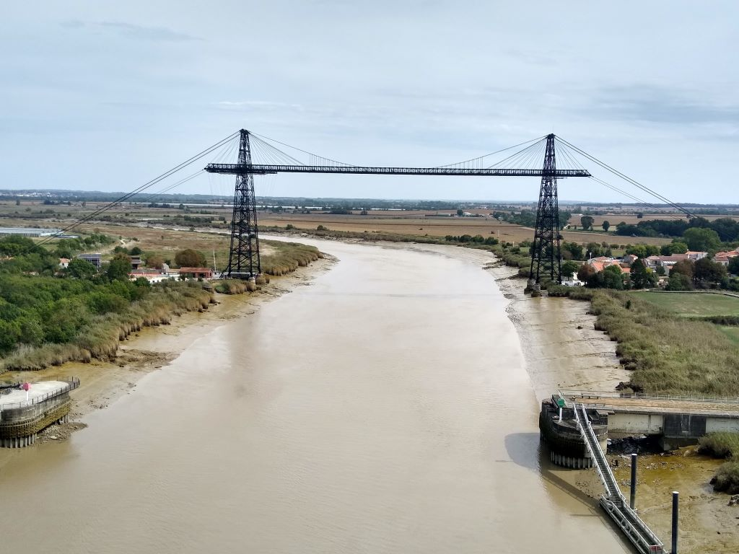
Just the other side of the viaduct I turned across the traffic and found myself on a cycleway with a sign showing 38kms to my destination. I stopped to eat a couple of oranges that I had in my pannier, pleased at how easy the journey had been. The rest of the way was an assortment of cycle tracks, many beside main roads but easy cycling until I reached the seafront just south of La Rochelle. The navigators took me through the back streets to the door of the Premiere Classe hotel where I am staying the night, just as the thunder started rolling in the distance.
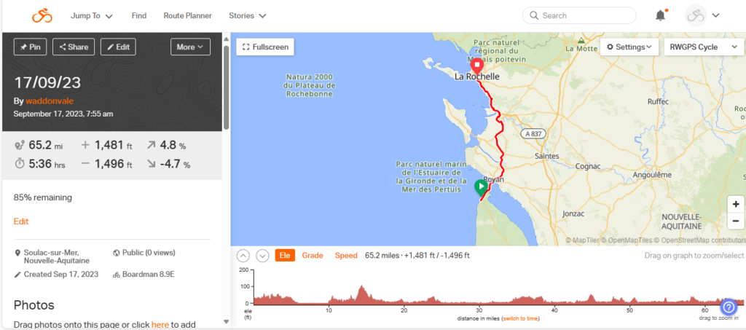
Day 13 – Vendee venture
I arrived at the Premiere Classe hotel in La Rochelle just before the thunder, which was fortunate as it also brought a significant amount of rain. I was booked in by an English speaking man who informed me that there was nowhere in the hotel for my bike but I could leave it outside in the car park that is shared between the PC hotel and its sister Kyriad Hotel. So that is what happened. At least here the bike racks are bolted to the ground but I’m far from happy leaving my only means of transport so vulnerable.
I’ve done a bit of research into the Louvre Hotel Group that was the parent company for Tulip Inns (4 star) Kyriad (3 star), Campanile (2/3 star) and Premiere Classe( 2 star) and find that they are now Chinese owned. So Premiere Classe is actually at the bottom of the range – not as Premiere as the name suggests: – I would put them on a par with Travelodge in the UK. The room I booked has a double bed with a single bunk bed above it and a well designed shower room. There is a drink and food machine in ther lobby and it’s cheap and cheerful. I will take issue with the idea that they can’t provide shelter for bikes in that there were areas around the stairwell that could perfectly easily have been used and I shall make that point with them. Apparently 25 % of PC Hotels are franchised but I don’t know whether this one was.
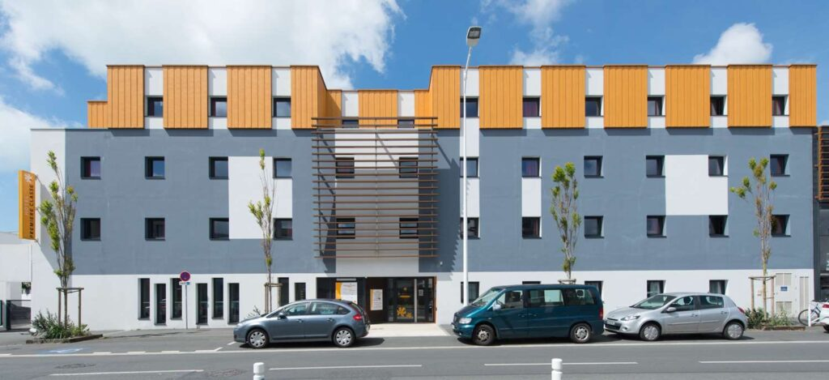
The bed was comfortable and the shower superb. There was air conditioning in the room that dried my clothes overnight, and was easy to control, unlike many hotel systems that seem to have a mind of their own. It was pleasing to have enough towels for the potential occupants despite the fact that I was there on my own. When I wash my cycling kit I wring it out as best I can, and then wrap it in a towel and squeeze even harder: that normally results in something that dries overnight when hung up. There were plenty of electric sockets and adequate lighting for writing the blog, ‘though I have to say that most of it was done lying on the bed watching England beating Japan at rugby -they’re going to have to better than that to progress past the quarter-finals but, it must be said, the last time France hosted the Coupe de Mondiale in 2007, England had similar problems and were still the beaten finalists.
Being a Sunday night I was somewhat fearful that food would be a problem. I’d missed the midi but alongside the hotel was a Del Arte Italian restaurant so that’s where I ended up. Del Arte are owned by a French Group but their ethos is very much Italian and I had a starter of toasted breads with various toppings (bread could have been better and lacked toasting but the toppings were good) and followed with a linguine carbonara which was excellent. A 50 cl beer, which seems to cost between 7 and 10 euros in any bar/restaurant, gave a bill of 35 euros. It was interesting that I was served by a waiter who was being trained and his mentor was certainly putting him through his paces – good to see.
There was little else to see in the area so I retired to write the blog and watch the rugby.
Breakfast was ok, the usual french selection but cheese and meat available. Croissants were second rate but I had my fill and was on the road by about 0915 – total bill for B&B a reasonable 73 euros.
My cycling gloves are getting very grubby and the seams are splitting. I washed them last night and was appalled to see the colour of the water. I thought I’d replace them and found the local Decathlon who now operate in the UK but are a French group (largest sporting goods retailer in the world|) who sell cycle gear at reasonable rates. Their branch in La Rochelle is right on the edge of the city and the navigators took me there past the central harbour
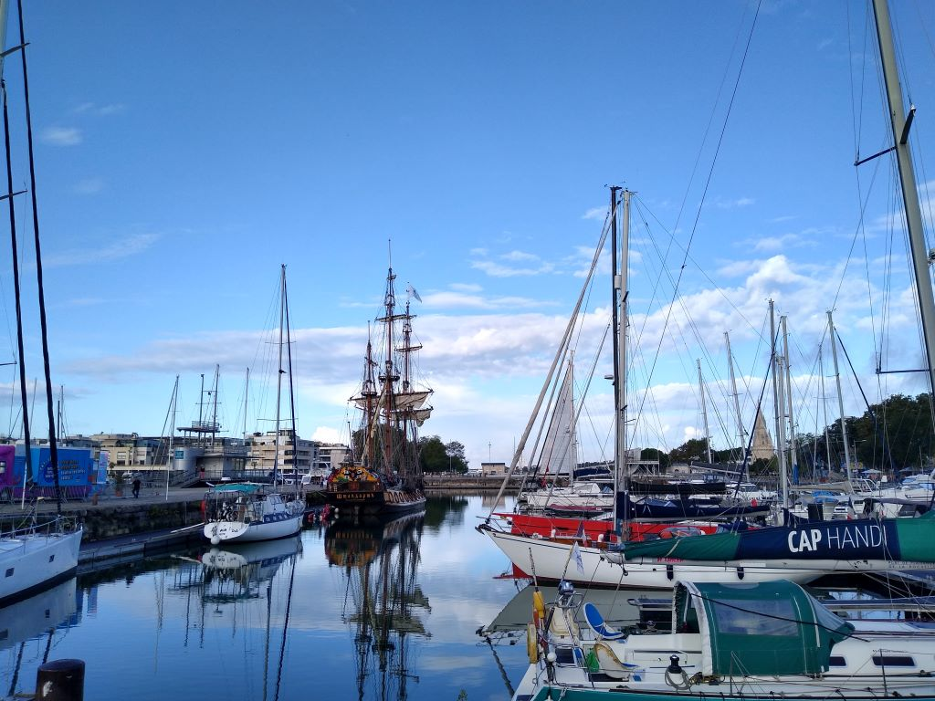
La Rochelle is famous for being the starting point of many round the world yacting events. The Vendee Globe, the hardest non stop single-handedrace around the world actually starts and finishes at Les Sables d’Olonnes, just up the coast and was won in 2016-17 by Frenchman Armel le Cleach in an astonishing 74 days and a few hours – caps Phineas Fogg.
I left the city and was straight into the well farmed countryside, lots of big fields and harvested maize and grains.
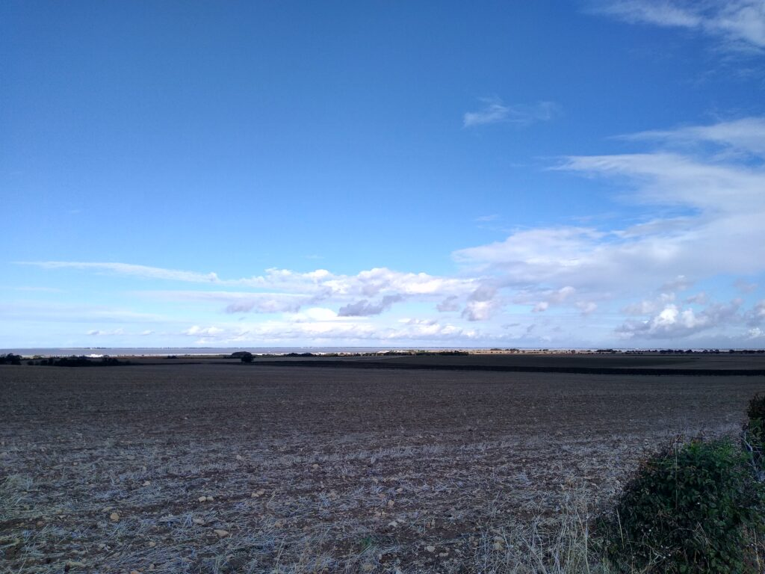
My route took me north about five miles inland from the coast. I could see the Isle de Re that juts out into the Bay of Biscay but I kept going, needing to make progress towards my date with the ferry at St Malo. Lots of villages whose name I didn’t know and will quickly forget passed by and was heading back into the Marais, marsh country with deep ditches and dodgy tracks. I was enjoying the cycling, lots of changes of direction and not knowing what is around the next corner makes it interesting.
The Sevre Niortaise river forms the boundary between Charente Maritime and the Vendee, the Department in which I was to spend most of the day. A few miles inland from the sea are some locks that canalise the river, though it was hard to see to whose benefit.
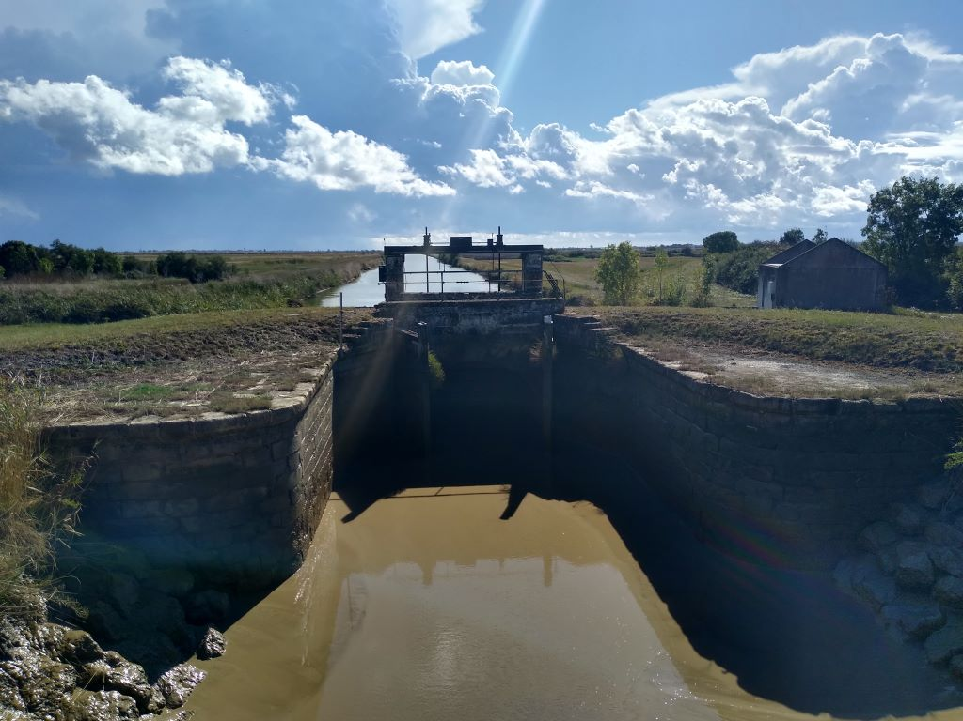
and shortly after the ancient bridge of Brault which has been rebuilt for cyclists like me!
I now needed to join a busy main road taking me four miles north. I didn’t know what to expect but a cycle track has been formed to keep me and my kind off the road. Unfortunately it is only packed sand which makes for interesting riding especially as the wind was blowing strongly in my face and the odd pocket makes you slip and slide.
Once through that it was tarmac all the way. About half way I hit Lucon a substantial settlement with several restaurants and I stopped for the midi at L’Eldorado, essentially a pizza house but serving a menu du jour for 14 euros. I picked chicken and rice followed by a Tirimasu that I could have sworn was trifle, but none the worse for it. A small beer took the bill to 18 euros.
Lunch did nothing for my lethargy and the head wind was dispiriting but there was little traffic so no excuse for slacking. The weather was threatening and 20 miles short of my destination the rain started, at first just a few drops which soon went. and then I rounded a bend and went off in the wrong direction past an open barn that would have afforded complete shelter and retraced my steps, the heavens opened. Too late to get back to the barn I put on my rain jacket and sheltered as best I could under a friendly oak tree. Trees are great shelter for maybe five minutes, after that they become a dripping liability and so I got wet.
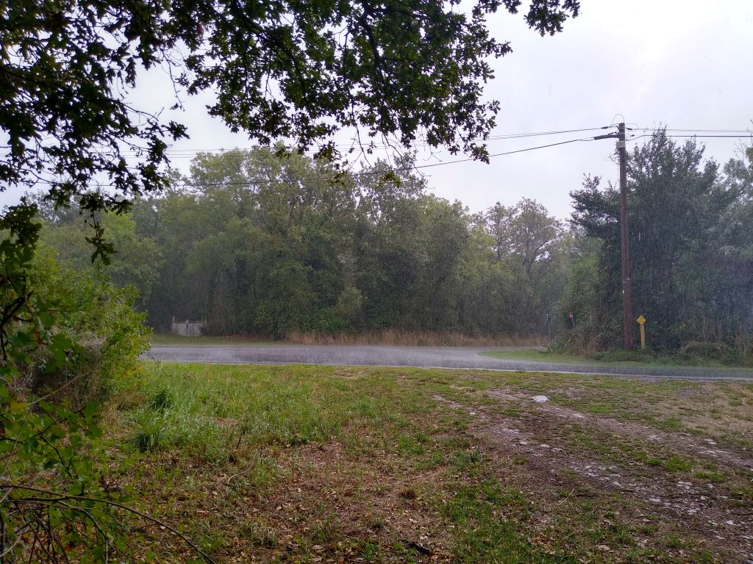
Never mind, it’s only water and soon dries out once the sun comes out, as it did. I was now in very different country. Suddenly there were substantial vineyards and smaller fields surrounded by hedges.
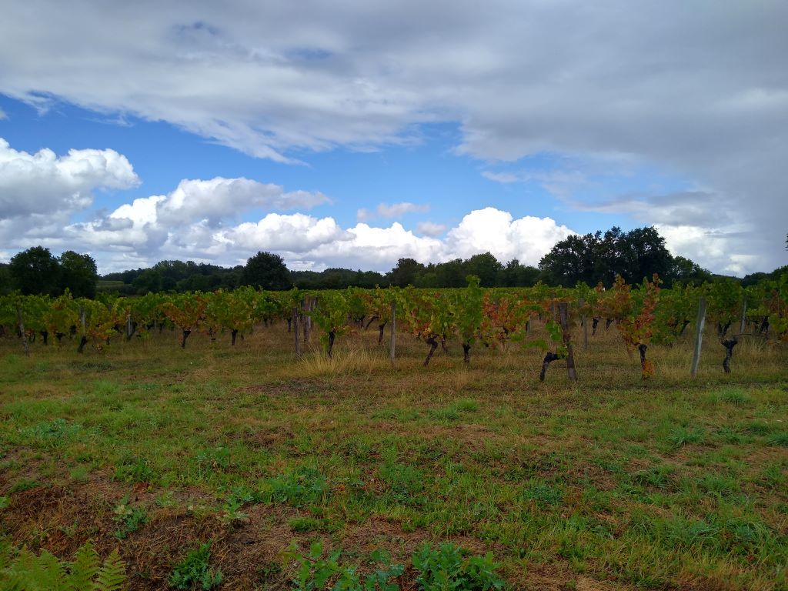
It’s a layman’s observation but when I passe through the great vineyards of the Medoc the vines were always on top of a small hill, as the road dropped there were no vines. And so it was here, vines on top of the hill, grass and maybe sunflowers below. Presumably this is what is meant by terroir. Anyway I was now into a roller coaster ride- not great gradients but enough to make me push the button.
Five miles short of my destination I turned onto a grass pathway alongside the rive Yon. It was easy going with a few puddles from the earlier rain but no slipping and sliding.
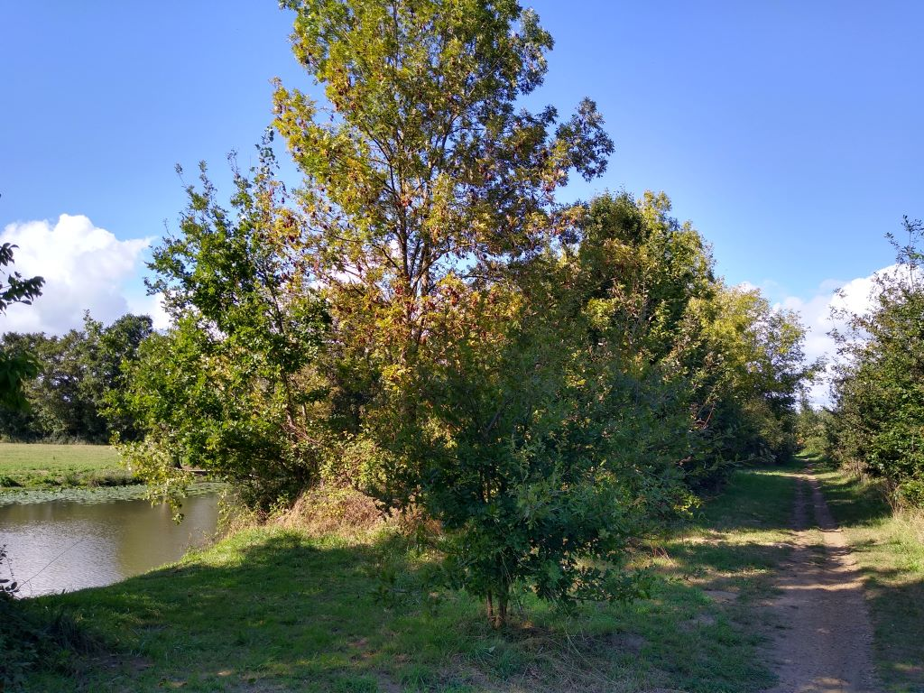
the sun had come out again which helped and I was soon on the outskirts of La Roche-sur-Yon, the principal town of the Vendee region, where I was to spend the night. My route took me past the most upmarket Lidl I have ever seen. There were escalators in and out and it was about twice the size of any I have ever been to. I bought a bottle of wine and some oranges for tomorrow and carried on, frustratingly taking several wrong turns but eventually ended up at the Marie Stuart Hotel, opposite the railway station.
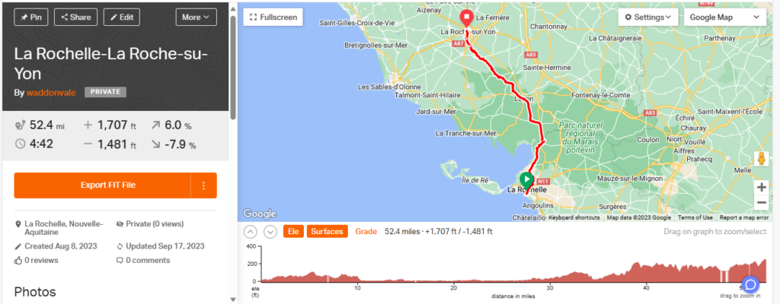
Day 14 – To Bretagne, but not Grand Bretagne (yet)
The Marie Stuart hotel in La Roche-sur-Yon is an even stranger experience than it appears on its Booking.com webpage. I still have no idea why someone would base the entire theme of a French hotel in 21st century Vendee on a 16th century historic loser who was both Queen of France and Scotland, but that is the case. It is an old building with a staircase that seems to be on its last legs and creaks and groans like a three master rounding Cape Horn. There is tartan on every surface and the bar seems to have every whisky ever produced. It is opposite the train station and I pitched up at about 4 pm to find a lady “hiding” behind the reception desk. She was not very welcoming and had trouble finding my name on the list of guests for the night, despite the fact that, when I looked at the computer screen, it was at the top. I asked her if she had a place for my bike and she said “non” which was a bit perplexing as I had been told when I booked that there would be. However she said something in French that I couldn’t quite follow but sounded like “but there’s a room round the back where you can leave it in”. Anyway I unloaded the panniers ready to take them upstairs and she showed me down a twisting corridor to the ubiquitous conference room where my bike spent a safe and secure night.
My room on the first floor was spacious but very old-fashioned with a mish mash of furniture including a bed with a canopy.
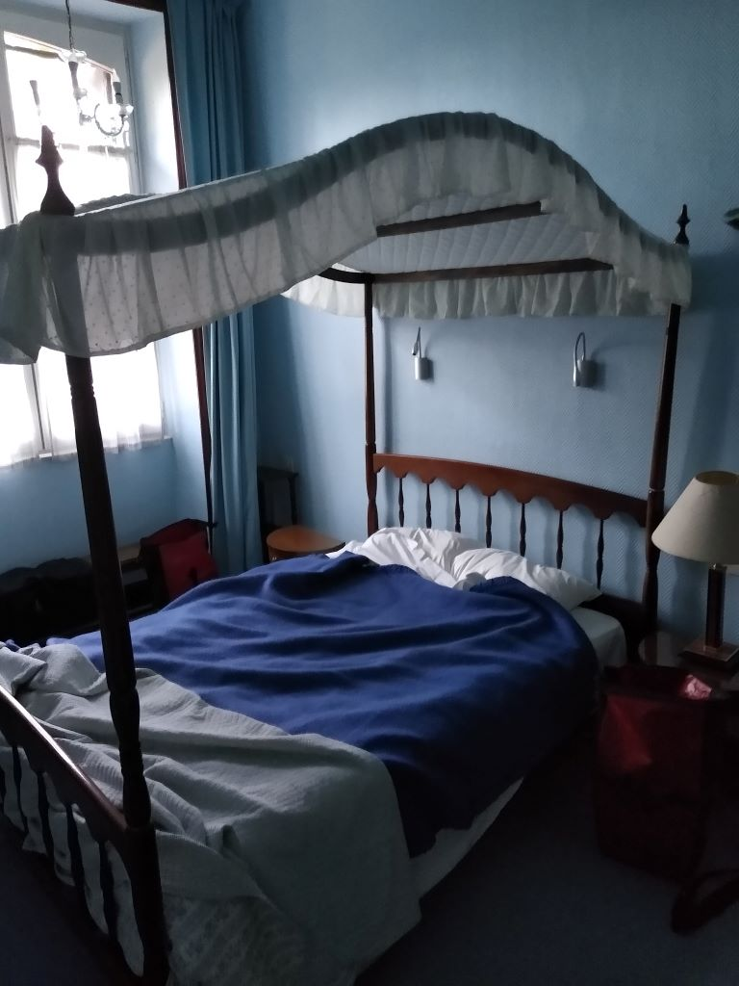
Curiously this was a godsend in that I was able to hang my washing on proper coat hangers – not those dreadful modern ones that can only be used in the wardrobe ( except I’ve worked out a crafty way of hanging them off a bungee so they can be put in front of a window)- and hook them over the bed canopy in front of the window. Job done successfully with dry washing by the morning. The shower took a long while to produce hot water but eventually I got myself clean.
Despite having eaten lunch, I was intrigued by the menu which included Scotch Eggs, and Angus Beef so had a bowl of Cullen Skink which was very good. There were about ten diners, not all of whom were staying at the Hotel so I guess the restaurant has a bit of a reputation.
After wishing my daugter Kate a very happy bithday, the morning breakfast was the usual French but with additional yoghurt, saucisson and 4 rather fine local cheeses: I enjoyed it and was packed and ready to ride by 0912. I paid the bill to a charming older Frenchman who spoke good English and asked me where I was going. When I told him I was aiming to ride “cent ou peut etre cent dix kilometres” he smiled and wished me luck saying he couldn’t comtemplate it. He had the look of a man with advanced cancer so I wouldn’t doubt it. I had about half a mile of cycle lane beside the road before the navigators told me to take a heavily graffited underpass beneath the railway
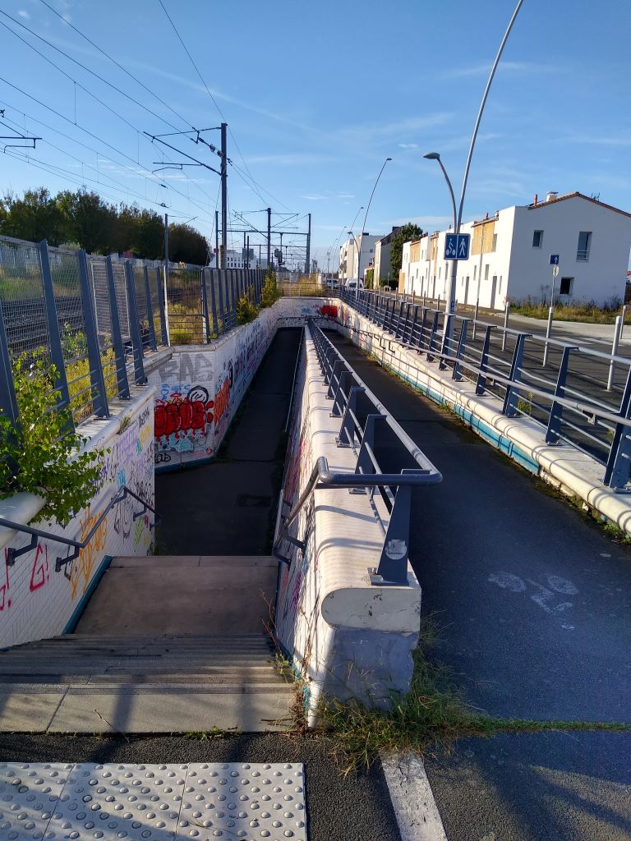
Emerging the other side I found myself on a well surfaced cycle path (another old railway line) which I followed for the best part of ten miles passing a very well equipped tennis club/academy on the way
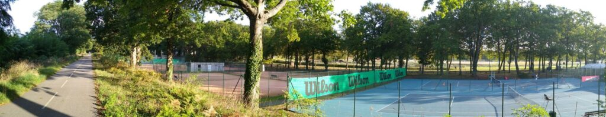
The path ended at Aizenay but from then on the roads were mainly quiet and traffic free making for enjoyable cycling in the watery sunshine. The rain of the previous day and night had freshened conditions and I was glad of my long sleeved base layer.
The landscape was changing subtly. To start with big open fields of maize
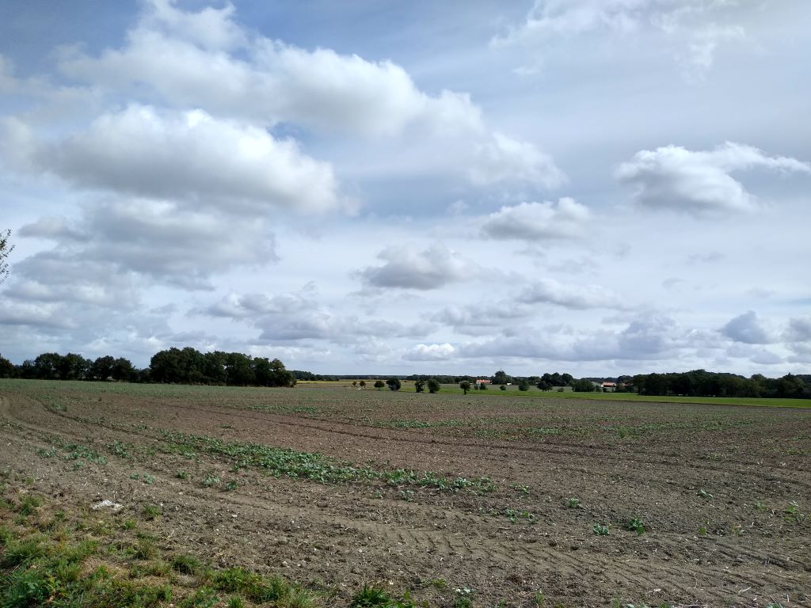
and already harvested crops giving way to smaller fields with high hedges and the occasional vineyard on top of a hill. The road switchbacked but scarcely enough to warrant the motor and I stopped to wait for a local train ( imagine such rolling stock on South Western railways)
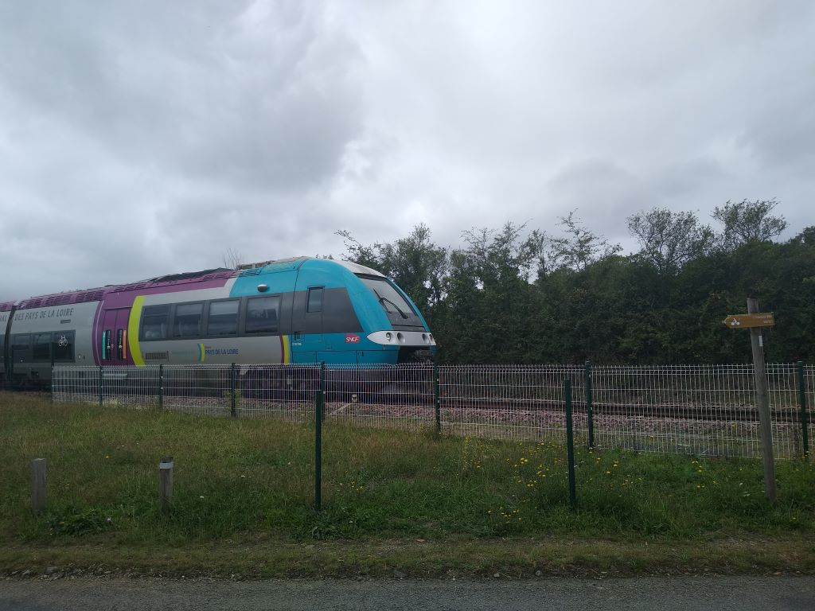
I was heading for the Loire river, at over 1000 kms the longest in France which, I imagined, formed the boundary between the Vendee and Brittany (Bretagne). Apparently not as the road sign at Port Saint Pere a good seven miles south of the river informed I was already in Bretagne. ,I had it in mind that I would get to the river by 2pm and, sure enough, just as it began spitting with rain ( it came to nothing), I reached Le Pellerin on the dot. There is a ferry that plies back and forth from 0620 to 2030 every day. It’s free to all vehicles with a weight limit of 3.5 tonnes.
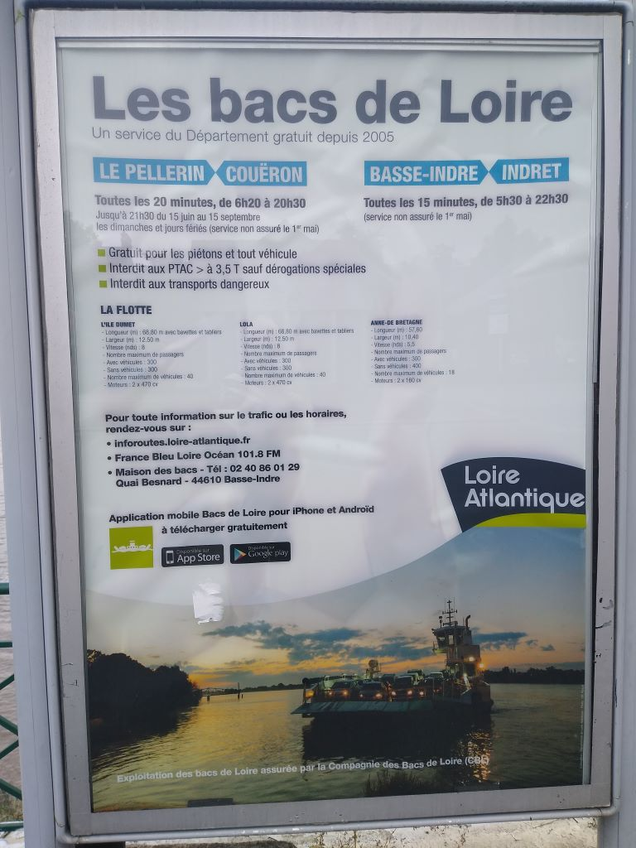
I arrived just as it was leaving the south bank and took some pictures waiting for its return. There is considerable skill in countering the tide so that the ferry docks in the right place without faltering. I walked my bike down the ramp which was about as steep as it gets because it was low tide, but there was a considerable rip that kept the skipper on his toes.
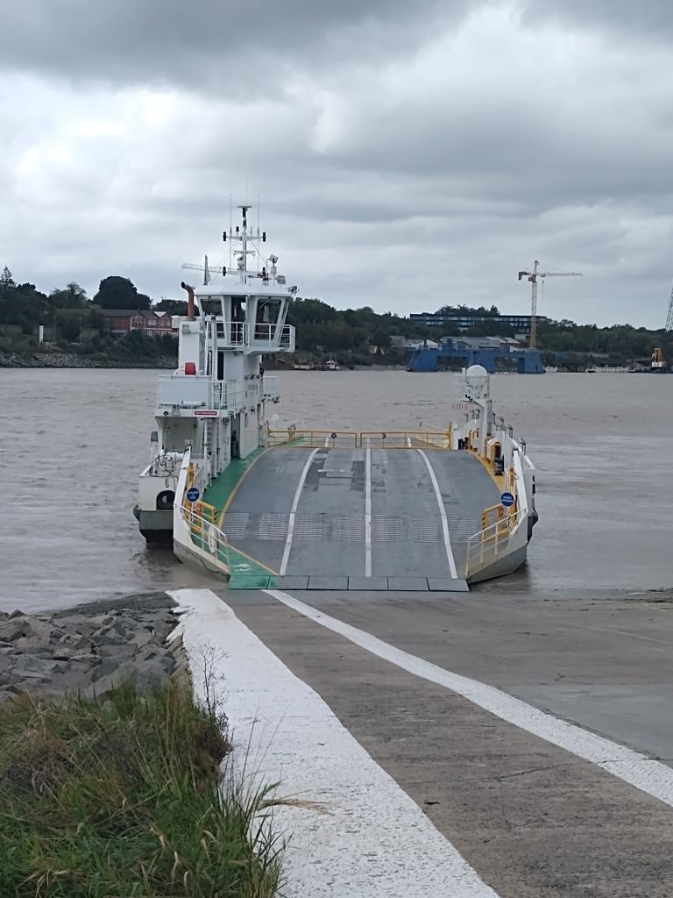
Once across I followed the navigators who took me down the flood plain of the river through countryside that reminded me of the Somerset Levels. My objective was now only about 15 miles away and there was very little climbing to be done. However I joined a main road without a proper cycle lane and experienced some dodgy moments with fast travelling lorries before arriving in Savenay. I’d already sussed out that there was an Intermarché at the end of town for my bottle of wine
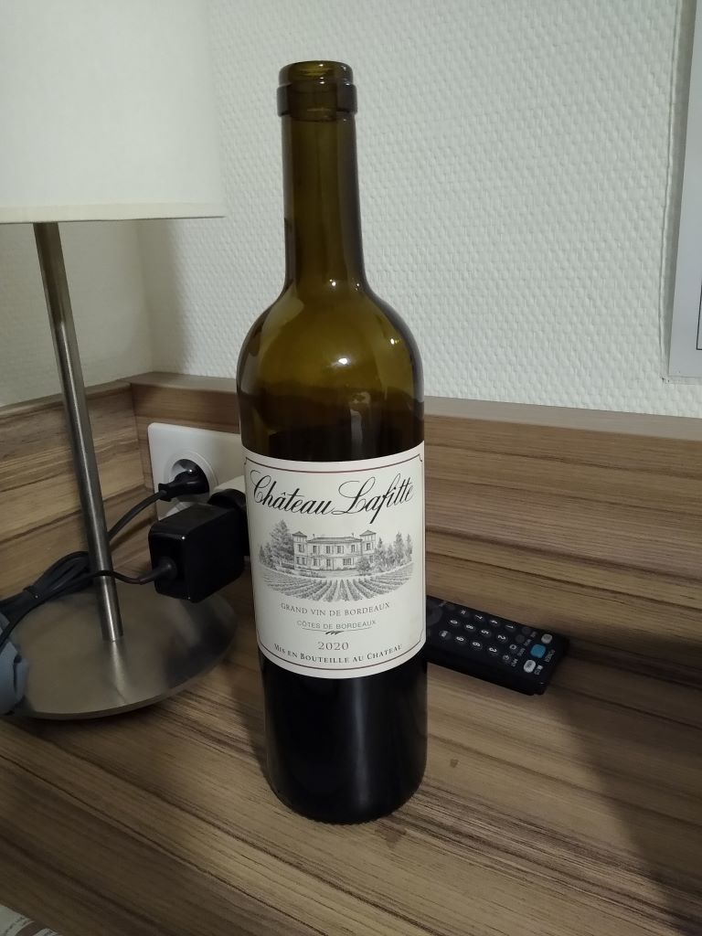
I couldn’t run to the Lafite Rothschild (£1000 + a bottle) but this was a very acceptable alternative. A plus to my visit was that I found a WD40 spray to sort out the creaking sound each time I turn the pedals. It’s something to do with the interaction of the frame and the bottom bracket but a spray of WD40 or even a dose of wet weather seems to sort it out. Anyway a quick spray at the supermarket gave me a wonderfully quiet ride for the last half mile of the journey to Le Chene Vert (The Holm Oak), a Logis Hotel/Restaurant in the midle of Savenay.
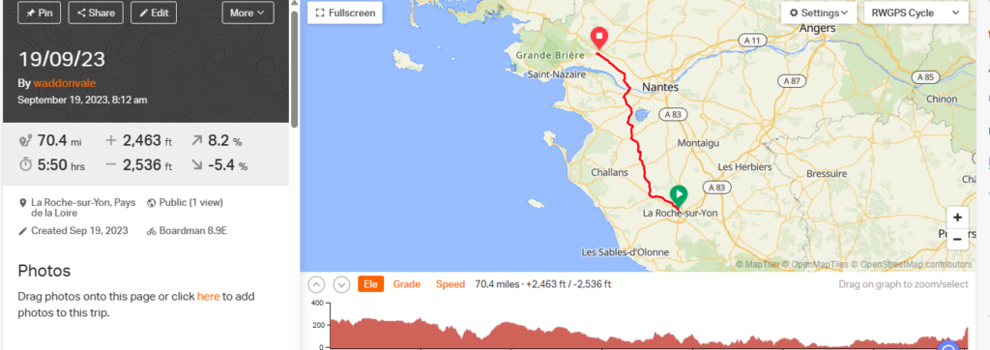

Day15 – Blowin’ in the wind
Savenay is a small town between Nantes and St Nazaire. It has a population similar to Gillingham, Dorset but not much of interest in the town. I stayed at Le Chéne Vert a Logis Hotel which I had booked direct: Booking.com are a great help to travellers like me but their charges are such that most hotels will do a cheaper deal if you go to them direct. Its a conundrum: I feel a bit of a fraud searching though Booking and then going direct, but a deal’s a deal. The Hotel is in the town centre and I was greeted with a big smile by Landlord Jerome when I pitched up at about 4.30 having been shopping at the Intermarché on the outskirts. I’d missed the Midi so ate in the Hotel restaurant. First a large Blonde beer in the bar and then to the restaurant where was a menu for 28 euros. ,As I hadn’t eaten any yet on this trip I decided to start with Foie Gras which was a 5 euro extra – it was excellent – thank you goose. I followed up with hake and vegetables, beautifully cooked in a rich butter sauce and finished with a sumptuous chocolate mousse. A very good meal that was perfectly balanced.
This morning, breakfast was help yourself to yoghurt, bread and pastries with some cheese and ham available. Orange juice and breakfast tea completed a satisfactory meal and I was packed and away at about 0920. The Wednesday morning market was in full swing with produce stalls and the usual mish mash of clothing. Leisure suit Larry was in fine voice conducting a draw and persuading the ladies who shop to pick the numbers. I didn’t gather what it was all about but there was probably some charity involved.
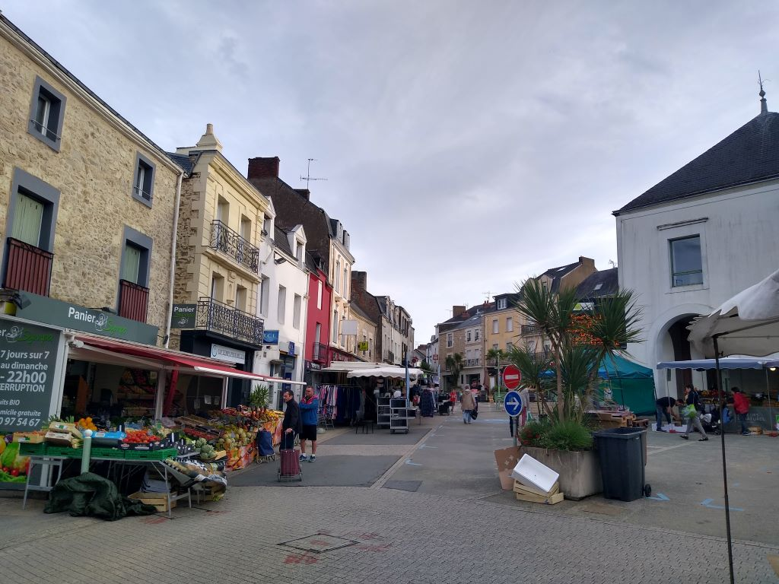
I left by the same road, down the hill and past the Intermarché and out into the countryside under the main road from Nantes to St Nazaire. Within four miles I came across a Route Barrée sign. This is the third I have encountered and bitter experience tells me when they say it’s closed IT IS. In the UK you can usually get past a road closed sign with a bike but not in France. I consulted the map on the phone and got it wrong first time which meant that I had to retrace my route not once but twice. Eventually I found my way round it and hit a wide road with little traffic so made good progress to Pontchateau and out into the countryside.
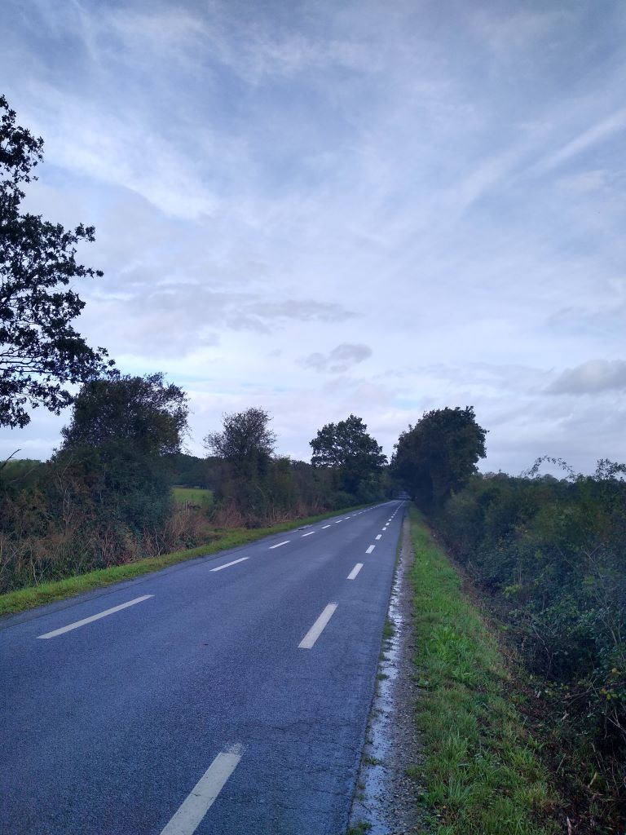
The roads here are marked strangely as you can see from the photo: there are cycle lanes both sides but that leaves little room for cars, so I think the protocol is that cars drive in the cycle lane until they come across a cyclist who takes precedence. As you can also see there had been a heavy rain storm which I missed completely. The trees were dripping and there was standing water but I hadn’t donned a jacket.
Shortly I crossed La Vilaine river by the Pont du Cran swing bridge
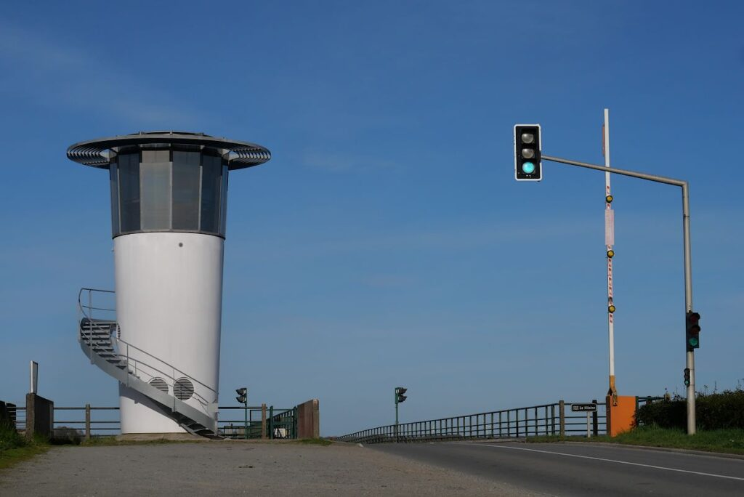
It’s not a long river and has been heavily canalised but there are few crossing points. Fortunately noone was trying to pass up or down the river when I was there and I followed a truck and a couple of cars at high speed.
I came across this strange building on a crossroads. I think it may have been a windmill, now converted to a dwelling
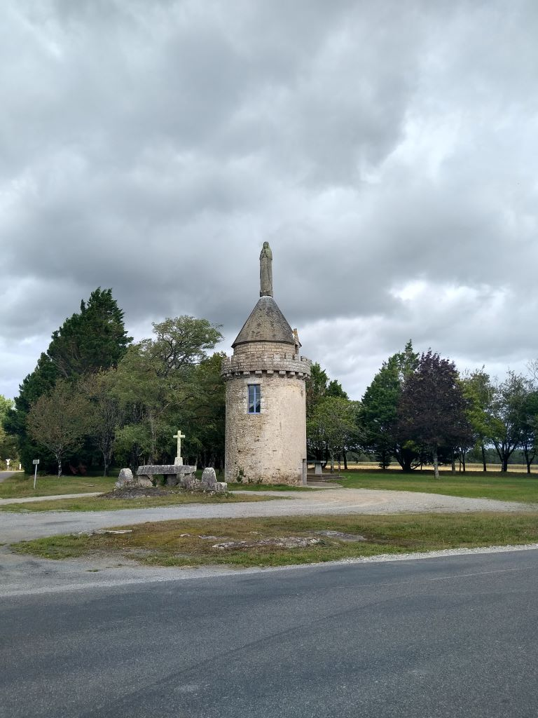
The road dropped quickly and it was hard to believe that I had climbed so high to have such a fast descent – almost Pyrennean. I emerged into much more open countryside
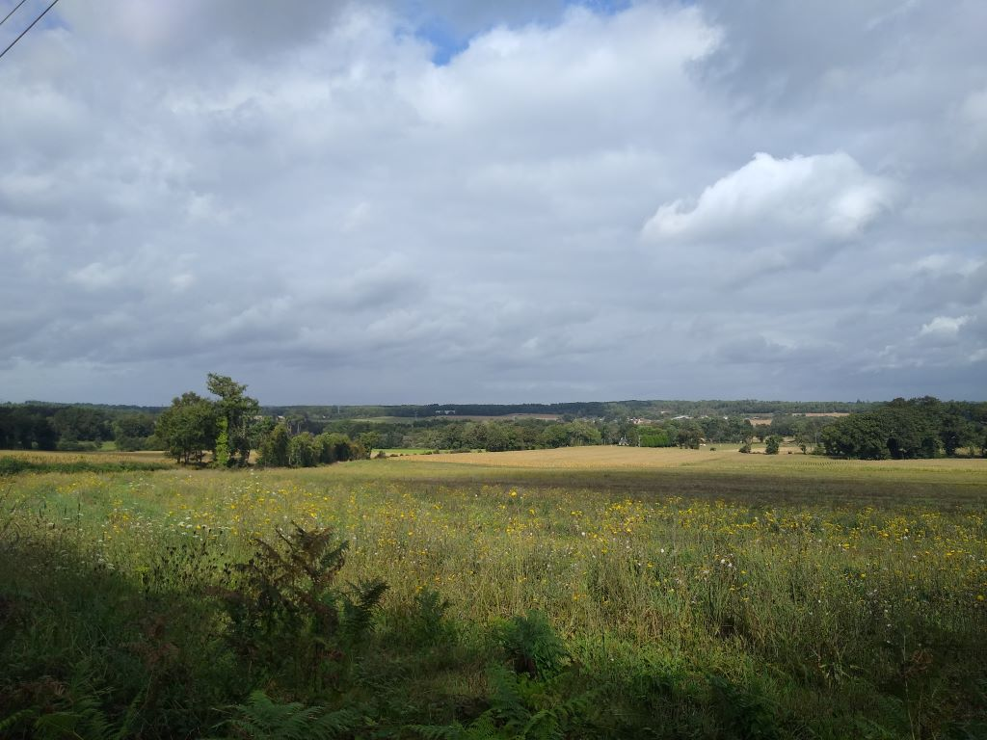
I carried on through a couple of small towns, enjoying the variety of scenery and the ups and downs of the road. It was about lunchtime and I was on the lookout for somewhere for the Midi when I came belting down a hill and saw what looked like the perfect spot, La Ciboulette, open tous les jours……….. sauf Mercredi! This was where I hit the Oust river and a cycle path that was to take me on for a further 20 miles. It was not tarmac at this point although it became so later but the surface was good and easy to ride
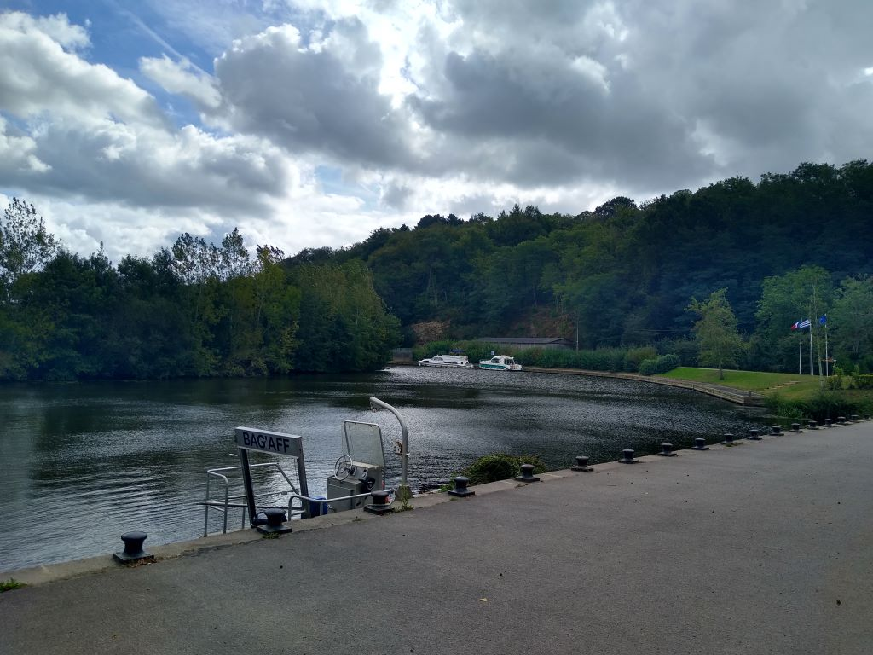
This is the Canal Nantes a Brest, the canalised Oust river. Apparently Napoleon Bonaparte became somewhat pissed off that the perfidious Brits were blockading Brest and not allowing him to supply either the garrison or his Atlantic Fleet who were confined to barracks. So he threw a huge amount of man-power, including prisoners-of-war and convicts at building a canal that could supply Brest from inland. By the time it was completed Napoleon had died on St Helena and the railways took most of the freight between the two cities. Now it is a pleasant route for pleasure boats with locks beautifully decorated with flowers where there is a change of level.
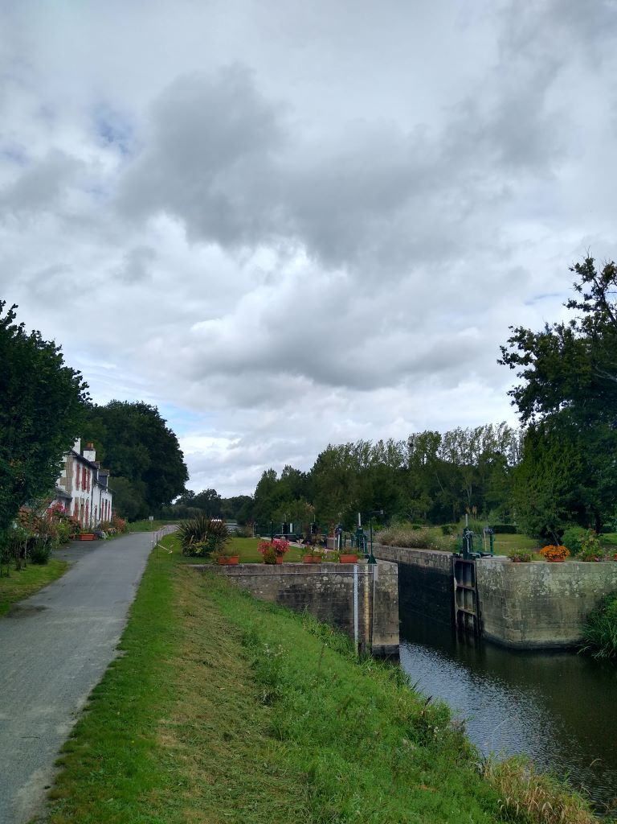
The wind had started blowing hard, I believe the fag end of a hurricane that was sitting out in mid-Atlantic and causing some pretty horrible weather in the UK. However it was largely beside or behind me but I did feel a bit vulnerable when I left the shelter of trees and felt myself heading for the canal.
40 miles into the journey I spotted a bridge across the river to St Martin-sur-Oust and, on the other side the Ruaudaie restaurant and cider house. As it was only 1.30 I parked the bike and went in. There were plenty of people enjoying what was mainly a Galette menu. There was no Menu du Jour so I opted for a small beer and a Savoyarde Galette which was onions, potatoes and lardons with some lettuce leaves and tomatoes. It was very good and for about 10 euros good value and filling.
Onwards in the ever strengthening wind which had blown up to about 40mph. At one point an oak had shed a limb and was being cleared away and sawn into lengths. The now tarmac track was covered in beech mast, acorns and chestnuts so there was a satisfying crunch under my tyres and the occasional pistol crack as I went over an acorn but when cyclists came towards me I had to slow down, not sure where the wind would blow me.
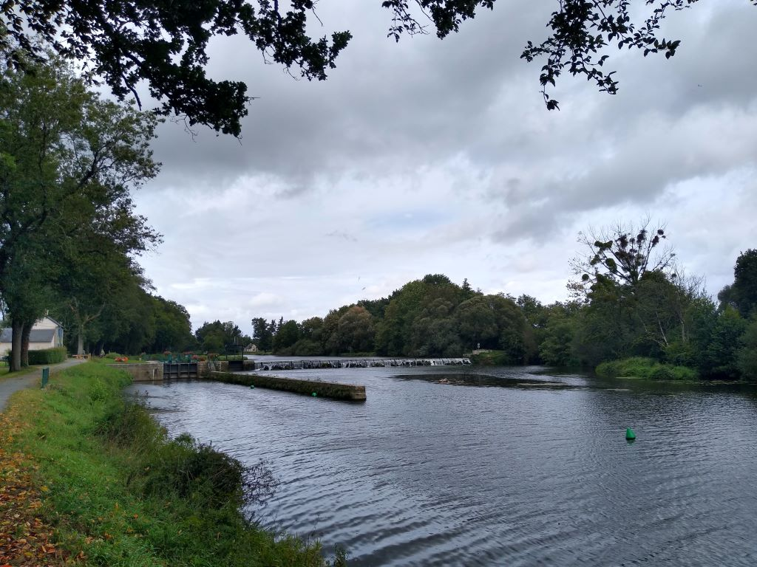
I finally left the river/canal about 6 miles from my destination. It had been an interesting ride. I’m not usually keen on canal towpaths as the surface can be so iffy but this was excellent and it is nice to be away from cars.
However no sooner had a left the canal path then I arrived on another piste cyclable, an old railway line which took me all the way to the centre of Ploermel, my destination
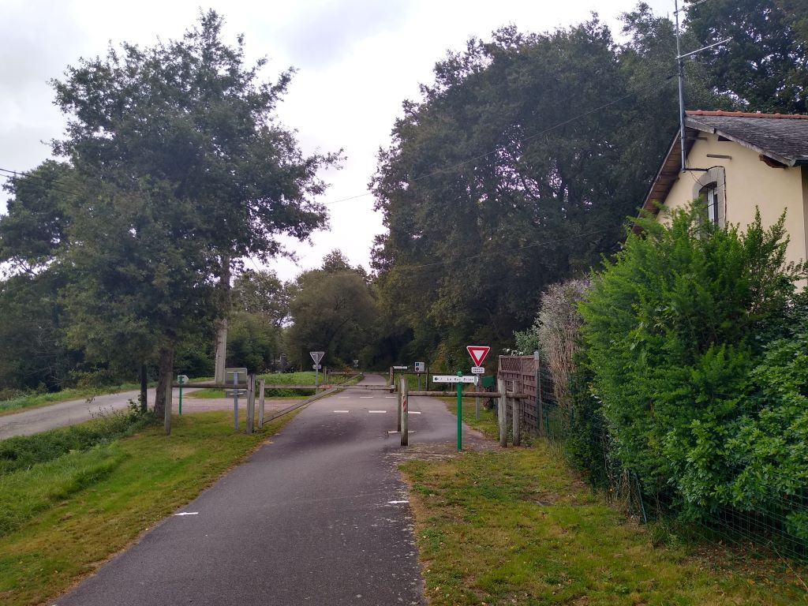
I found Le Thy, another bar-restaurant similar to Le Chene Vert and was booked in and bike safely housed in an outbuilding by 4.30. It was one of the shorter rides of my Grande Balade and, amazingly, I had escaped the rain all day.
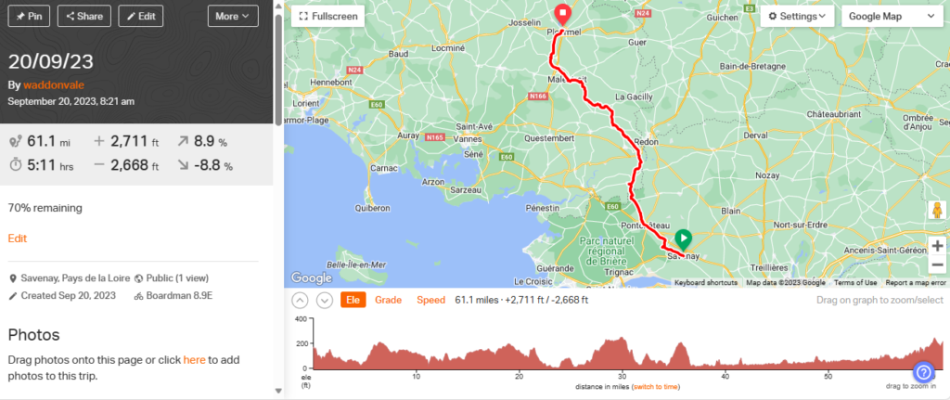
Day 16 – Finished with France
Ploermel sounds to me as though it should be in Belgium or Holland but it’s slap bang in the middle of Brittany. Le Thy, which is where I stayed the night is a bar with rooms over and when I arrived Madame was busy managing all aspects. There was trotting racing showing on the box and a fair number of drinkers. Eventually she had a moment to grab some keys to the beer store which is where my bike spent the night and told me that I was to occupy the Klimt room. She and her husband are clearly fans of art and have named their rooms after their favourites from Edward Hopper to Van Gogh. My room was very large and had Klimt paintings on the wall. Otherwise the furniture was “distressed”. The bed was a double with foam mattress, the first I’ve slept on this trip and the bathroom had a bath with a shower mixer which worked moderately well. Proper coat hangers so I was able to hang the washing in front of the window where it dried well overnight. Madame was not offering any food but said there were lots of places in town. My Galette at lunchtime had filled me quite well so I didn’t bother with a meal as such but went out and bought a bottle of wine and some saucisson which I consumed whilst blogging.
By the time I got back to the hotel it was raining hard and I was glad I had taken my Puffa jacket, the first time I’ve worn it this trip. When I tried to go on-line I couldn’t get a connection, so went down with my computer and they logged me onto their private network which operated well and didn’t drop out at all. It kept raining most of the night and It was quite chilly this morning. Breakfast was french with no cheese or ham and my tea was served in a large bowl. I was ready to go at 0830 so set off up yet another old railway line, with some old rolling stock to prove its origin.
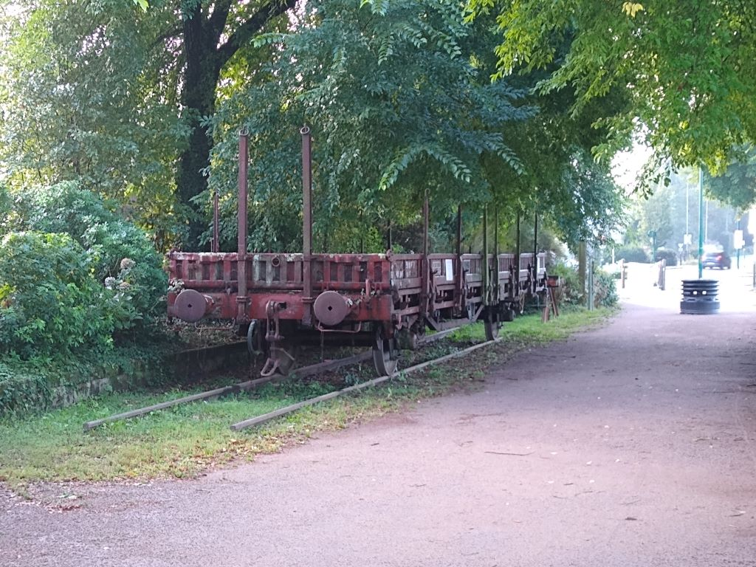
This voie took me no less then 14 miles to Saint Lery, having to slow to cross roads en route, but it was a good way to start the day. The air was fresh after the overnight rain and I almost stopped to don a coat but kept going, knowing the weather forecast was for rain about lunchtime.
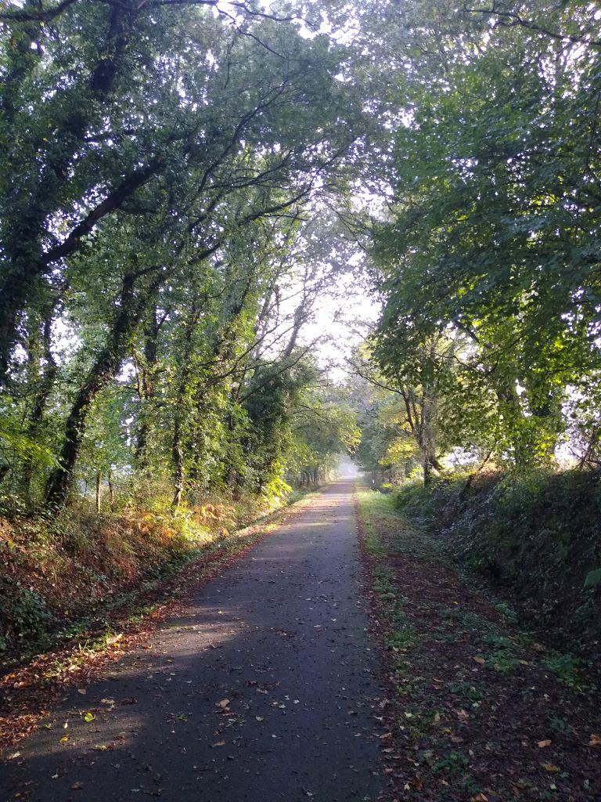
The wind and rain had brought down beech mast, acorns and chestnuts and I had a job steering my way through the piles of seed in places. I glimpsed this out of the corner of my eye and went back to take a picture. Presumably the industrious arachnid had produced this since the wind and rain of yesterday.
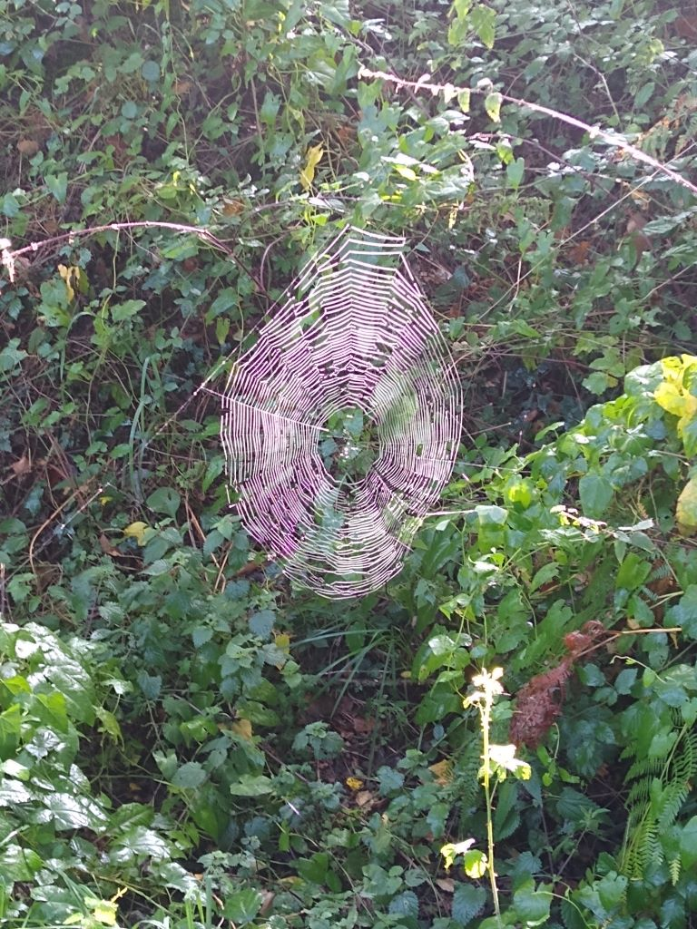
Even when the cycle path ran out I was on quiet back roads winding through well farmed fields of maize and stubbles, in some of which the Oilseed rape was already well established. I started being diverted off the road and onto headland tracks. It was not too hard although a bit slippery in places
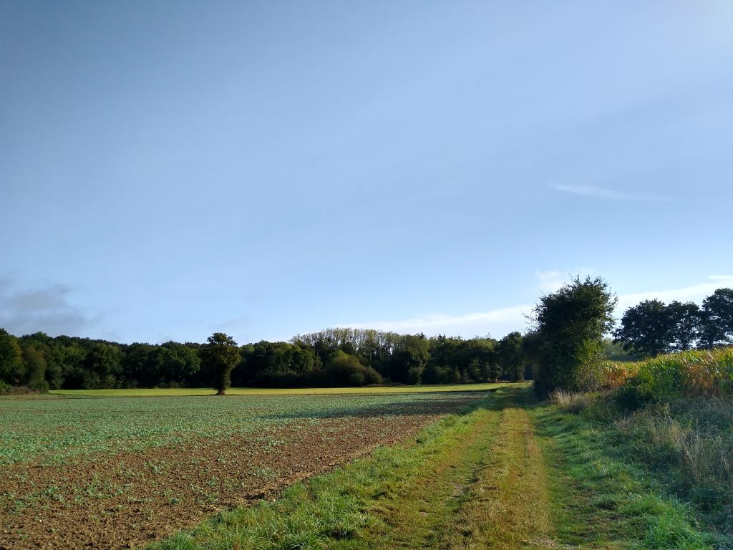
At Gael I passed a water tower. If you’ve got to have a concrete monstrosity to ensure you have a supply of water then try and make it more beautiful.
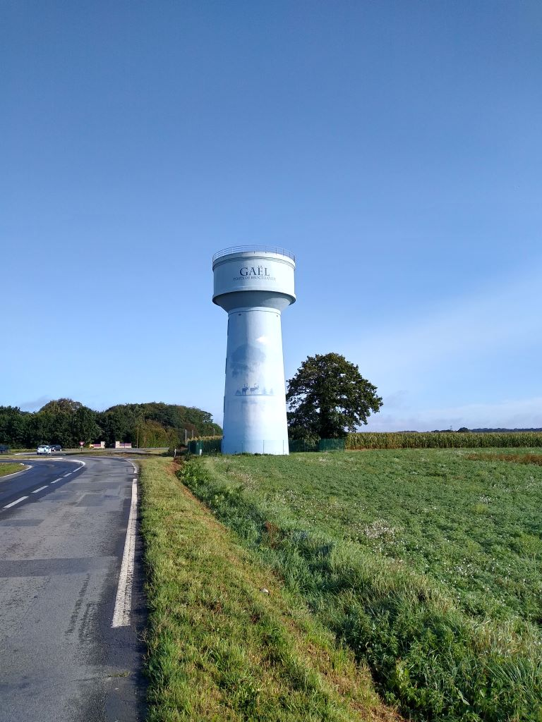
I was about half way when the weather Gods frowned on me and it started raining steadily. I stopped and put on two jackets and my overshoes and kept going. A lot of the roads I was now following weren’t tarmacced but neither were they very slippery so I just put my head down and went for it, getting wetter by the minute. I must have done about ten miles before the rain eased up but the byways I was on became worse. Fancy being faced with this?
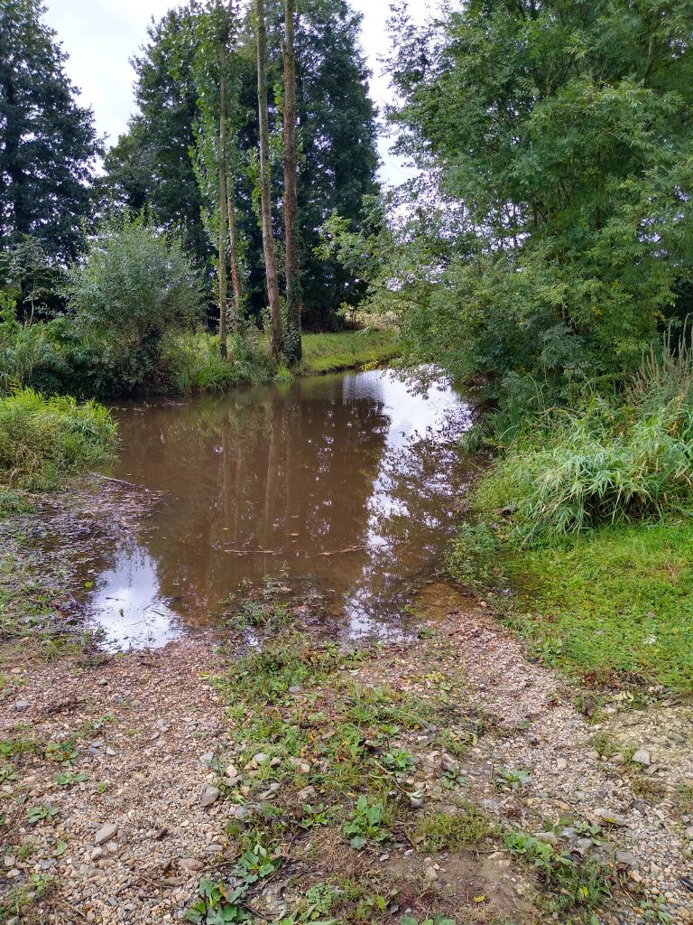
Fortunately I spotted a path to one side over a very narrow stone slab bridge and managed to get across.
At the substantial town of Dinan I was directed around the outskirts through trading estates and kept away from the worst of the traffic and then I was back onto another six or so miles of cycle track before the most exciting/worrying bit of the journey, crossing the Rance on the barrage with no cycle lanes and no way of getting off. It was interesting and I was mighty glad when I reached the top of the substantial hill that leads up from the river. I had no chance of stopping to take pictures but here’s one from t’internet.
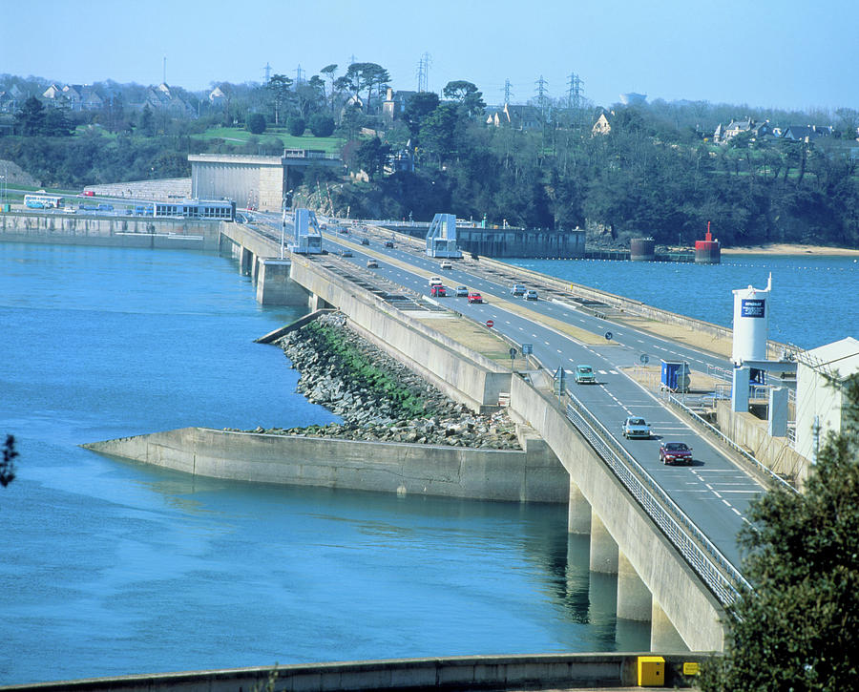
The barrage has been producing electricity from the tides since 1966. It seems amazing to me that we haven’t managed anything similar in the UK. It’s not for want of trying: there have been several schemes put forward on the Severn estuary but they all seem to founder on ecological grounds. Although there have been downsides on the Rance with silting of the river the high construction costs have been recovered and electricity is produced at roughly half the cost of nuclear energy.
I stopped to collect mself before carrying on for the last couple of miles of my journey to the Ibis budget Hotel where I shall stay for a short night as I have to be away by 0615 to book in for the Condor Ferry to Poole that sails at 0730. The bike is in the hotel garage along with another dozen or so Brit bikes who are taking a ferry to Portsmouth a bit later than me. I’ve picnicced tonight on chicken and 1664 and will grab breakfast on the ferry.
It’s been a generally enjoyable trip with no major problems. Nothing has broken and there have been no punctures (that’s probably asking for at least one tomorrow on my way home from Poole) The trip up west coast was a bit of a slog but I haven’t had a day that didn’t provide some enjoyment. Brittany would be a worthwhile destination for the future, taking a bit more time and taking in sights instead of just cycling.
